Isaiah

The Book of Isaiah presents God as the sovereign ruler of history who confronts sin, exposes false security, and calls His people to repentance. Addressed primarily to Judah and Jerusalem, the book opens with sharp accusations against religious hypocrisy, injustice, and moral decay. Ritual worship continues, but it is empty because it is disconnected from righteousness. Isaiah repeatedly warns that political alliances, military strength, wealth, and idols cannot save. Judgment is certain, not because God is weak, but because He is holy. The fall of nations—including Judah’s coming devastation—is portrayed as the direct result of pride and rebellion against God’s rule.

Alongside judgment, Isaiah consistently holds out hope. Central to the book is the promise that God will preserve a faithful remnant and ultimately restore His people. This restoration is not merely national but moral and spiritual. Isaiah describes a future in which Zion is renewed, justice is established, and peace replaces violence. The prophet emphasizes that salvation comes not through human effort but through trust in the LORD. God alone directs history, raises and removes rulers, and fulfills His purposes despite human failure. These themes are reinforced through visions of God’s holiness, His absolute authority over the nations, and His power to redeem what appears lost.

A defining feature of Isaiah is its forward-looking vision of redemption through a divinely appointed servant. This figure suffers, bears guilt, and brings healing and righteousness to many. Isaiah links personal repentance, national restoration, and global renewal into a single redemptive plan. The book concludes with a picture of final judgment and final renewal: the wicked are removed, the faithful are comforted, and God dwells with a restored people. From beginning to end, Isaiah balances warning with promise, exposing sin honestly while pointing to lasting hope grounded in God’s faithfulness, justice, and mercy.
Isaiah 1

Opening Scripture Quote (KJV)
“The vision of Isaiah the son of Amoz, which he saw concerning Judah and Jerusalem in the days of Uzziah, Jotham, Ahaz, and Hezekiah, kings of Judah.”

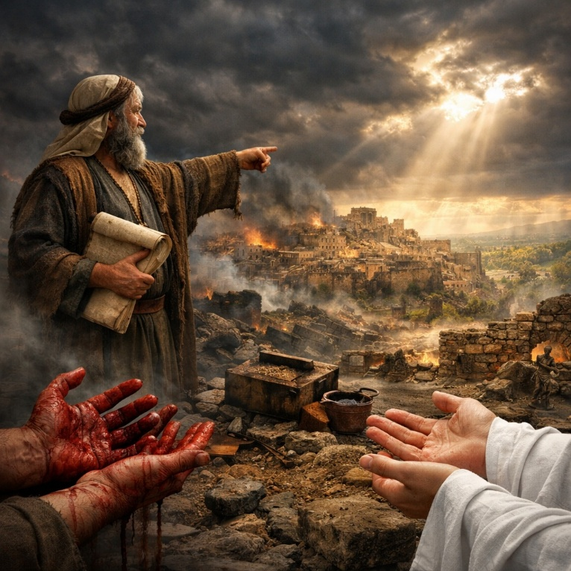
Isaiah 1 opens as a formal charge against Judah and Jerusalem. The chapter presents God as a wronged father and ruler addressing a rebellious people who know Him yet refuse to live accordingly. Their religious activity continues—sacrifices, assemblies, and prayers—but it is exposed as hollow because it is disconnected from obedience and justice. The nation’s condition is described as diseased and wounded from head to foot, reflecting moral collapse rather than mere political trouble. The land is desolate, cities are burned, and Jerusalem stands isolated, spared only by God’s restraint.

The core accusation centers on hypocrisy. God rejects their offerings, incense, and appointed feasts, not because worship itself is wrong, but because it has become a cover for injustice. Violence, oppression, and neglect of the vulnerable define daily life. The command is clear and practical: stop doing evil, learn to do good, seek judgment, relieve the oppressed, judge the fatherless, and plead for the widow. True repentance is presented not as emotion or ritual, but as a decisive change in behavior aligned with righteousness.

The chapter then shifts to a conditional appeal. God invites the people to reason with Him, offering forgiveness and restoration if they are willing and obedient. Sin is described vividly—deeply stained—but not beyond cleansing. The promise of blessing contrasts sharply with the warning of destruction: obedience leads to abundance; rebellion leads to judgment. Isaiah 1 closes by returning to Jerusalem’s fall from faithfulness. Once a city of justice, it has become corrupt, its leaders self-serving and its society polluted. Yet even here, judgment has a redemptive purpose. God declares His intent to purge corruption and restore righteousness, ending with a vision of a city renewed by justice rather than ritual.

Isaiah 2

Opening Scripture Quote (KJV)
“The word that Isaiah the son of Amoz saw concerning Judah and Jerusalem.”

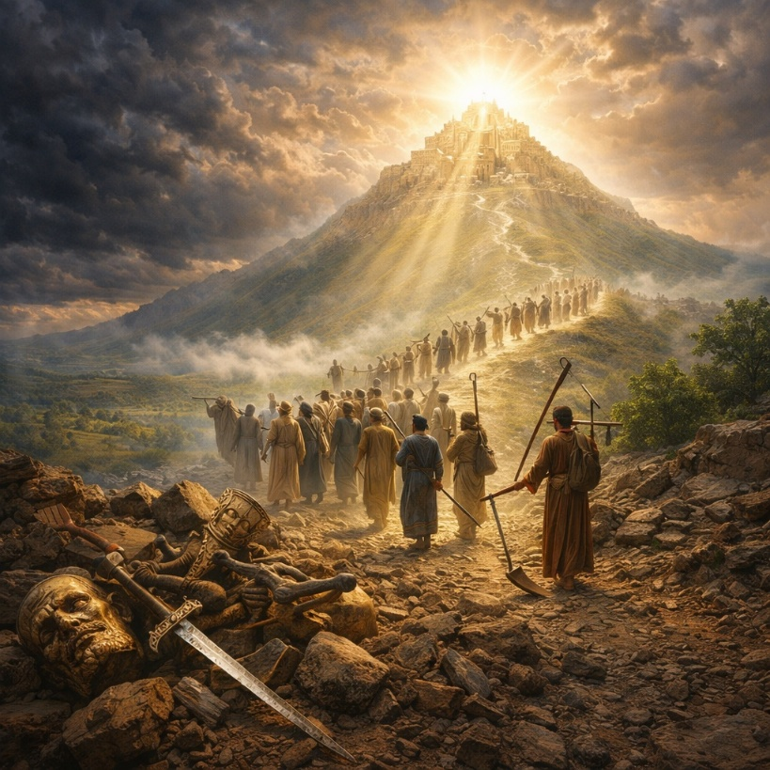
Isaiah 2 opens with a future vision that contrasts sharply with Judah’s present corruption. In “the last days,” the mountain of the LORD’s house is lifted above all others, becoming the spiritual center of the world. Nations stream toward it willingly, seeking instruction rather than conquest. God’s law goes forth from Zion, and His word from Jerusalem, establishing divine authority over human affairs. This vision portrays a world reordered by God’s truth, where instruction replaces ignorance and submission replaces rivalry.

From this rule flows peace. International conflict ends because God Himself judges between nations. Weapons of war are transformed into tools for cultivation, symbolizing a complete reversal of human priorities. Military training and violence are no longer necessary. The vision is not symbolic idealism but a declaration of God’s ultimate intention for history. Isaiah then turns this future hope into a present demand, urging the house of Jacob to “walk in the light of the LORD.” The promised future becomes the standard by which current behavior is judged.

The tone shifts abruptly to rebuke. Judah has abandoned trust in God and filled itself with foreign practices, superstition, wealth, military power, and idols. Human pride dominates every level of society. Isaiah announces the coming “day of the LORD,” when everything exalted by man will be brought low. Kings, warriors, fortified cities, ships, and idols alike will be humbled. People will attempt to hide from God’s presence, casting away their idols in fear. The chapter closes with a blunt conclusion: mankind is not worthy of trust. Human power is temporary and fragile. Only the LORD is exalted, and only He is reliable. Isaiah 2 therefore holds together a sweeping vision of future peace and a severe warning against present pride.

Isaiah 3

Opening Scripture Quote (KJV)
“For, behold, the Lord, the LORD of hosts, doth take away from Jerusalem and from Judah the stay and the staff, the whole stay of bread, and the whole stay of water,”
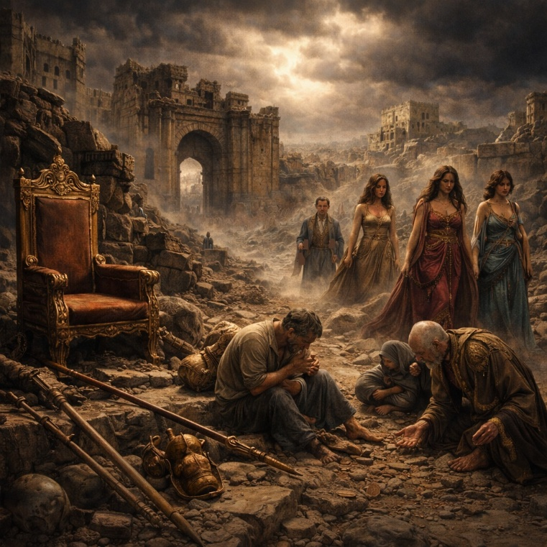
Isaiah 3 describes the collapse of Judah’s social and political order as an act of divine judgment. God removes the “stay and the staff,” meaning every source of stability the people rely upon. Leadership fails at every level: warriors, judges, prophets, elders, craftsmen, and counselors are all taken away or rendered ineffective. In their place, the nation is left with inexperience and incompetence. Authority becomes unstable, and social order breaks down. The result is public confusion, disrespect, and disorder, where people oppress one another openly and honor is no longer recognized.

The chapter highlights failed leadership as both a cause and a consequence of judgment. Children rule over adults, and the unfit grasp for authority out of desperation rather than calling. People refuse leadership roles because responsibility has become a burden rather than an honor. Isaiah emphasizes that this collapse is self-inflicted: Jerusalem has brought it upon itself through rebellion, arrogance, and open sin. Their words and actions openly defy God, and they show no shame. The righteous suffer alongside the wicked, but Isaiah makes a clear distinction—those who do right will ultimately be rewarded, while those who do evil will face the consequences of their actions.

The final section turns to a sharp condemnation of Jerusalem’s leaders and elite women, exposing pride, exploitation, and moral decay. The leaders are accused of crushing the poor and enriching themselves at the expense of the vulnerable. The women of Zion are portrayed as haughty, obsessed with appearance, luxury, and status. Isaiah announces that their beauty will be replaced with humiliation, scarcity, and loss. Symbols of wealth and refinement are stripped away, replaced with mourning and desolation. The chapter ends with a city emptied of strength, its gates sitting in grief as men fall by the sword and society lies broken. Isaiah 3 presents judgment not as random destruction, but as the inevitable unraveling of a society that has rejected justice, humility, and responsibility.
Isaiah 4

Opening Scripture Quote (KJV)
“And in that day seven women shall take hold of one man, saying, We will eat our own bread, and wear our own apparel: only let us be called by thy name, to take away our reproach.”


Isaiah 4 opens in the aftermath of judgment described in the previous chapter. The social devastation is so severe that women greatly outnumber men, reflecting the loss caused by war and collapse. Marriage, once a position of honor and provision, becomes a plea for protection and identity. The verse captures humiliation and desperation, not romance. It is the visible consequence of national judgment—reproach, insecurity, and the stripping away of normal social order.

The chapter then turns sharply from ruin to hope. Isaiah introduces “the branch of the LORD,” a figure associated with renewal, beauty, and fruitfulness. After devastation, God Himself becomes the source of restoration. The survivors in Jerusalem are described as holy, not because of merit, but because they have been purified. Judgment has removed corruption, leaving a remnant cleansed by divine action. The emphasis is not on numbers, power, or prosperity, but on holiness and belonging. Life continues because God preserves it.

The closing verses describe God’s renewed presence among His people using imagery drawn from the wilderness journey. A cloud by day and fire by night rest over Mount Zion, signaling protection, guidance, and divine approval. God creates a covering—a shelter from heat, storm, and danger. Unlike earlier chapters where worship was rejected, here God Himself establishes a dwelling of peace and safety. Isaiah 4 presents judgment as purposeful rather than final. Destruction clears the way for purification, and purification leads to restored communion. The chapter is brief but pivotal: from shame to glory, from exposure to covering, from survival to sanctified renewal.
Isaiah 5

Opening Scripture Quote (KJV)
“Now will I sing to my wellbeloved a song of my beloved touching his vineyard. My wellbeloved hath a vineyard in a very fruitful hill:”
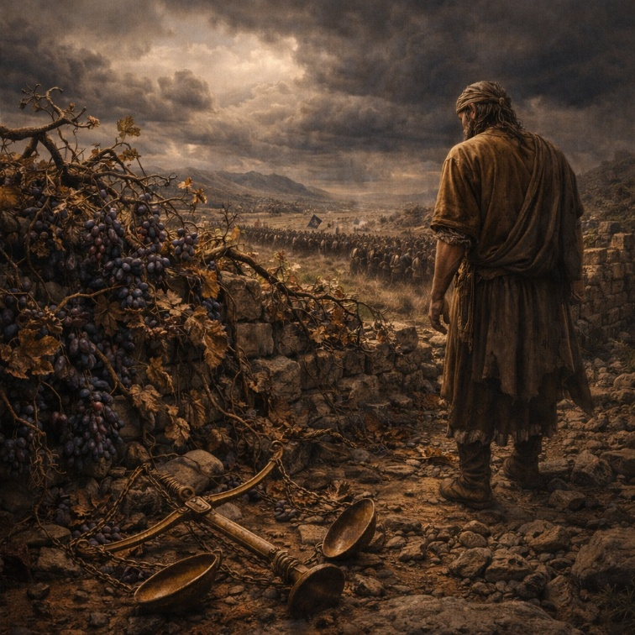
Isaiah 5 opens with a poetic parable known as the song of the vineyard. God is portrayed as a careful owner who plants a vineyard in fertile ground, clears it of stones, builds protection, and expects good fruit. Instead, the vineyard produces wild grapes—worthless and bitter. The imagery represents Judah, a people given every advantage yet failing to live rightly. God asks what more could have been done, making clear that the fault lies not with His care but with their response. Judgment follows: protection is removed, the vineyard is left to ruin, and what was once cultivated becomes overgrown and desolate.

The chapter then delivers a series of pronounced “woes,” exposing specific sins that explain the vineyard’s failure. These include greed that consumes land and neighbors, drunkenness that dulls moral awareness, arrogance that mocks God, moral confusion that calls evil good and good evil, pride in human wisdom, and corruption that rewards the wicked while denying justice to the innocent. Isaiah emphasizes that these behaviors are not private flaws but societal patterns that rot the nation from within. Because the people refuse to understand God’s work and dismiss His law, judgment is unavoidable.

Isaiah concludes by describing the coming consequences. The land becomes barren, people are taken captive, and death expands its reach. God’s holiness is upheld as human pride is brought low. Foreign nations are summoned as instruments of judgment, arriving swiftly and relentlessly. Darkness replaces light, and distress fills the land. The chapter reinforces a central message of Isaiah: privilege without obedience leads to ruin. God is patient and just, but He will not protect injustice indefinitely. Isaiah 5 stands as a clear warning that moral failure, when cultivated and defended, leads to national collapse and divine judgment.

Isaiah 6

Opening Scripture Quote (KJV)
“In the year that king Uzziah died I saw also the Lord sitting upon a throne, high and lifted up, and his train filled the temple.”

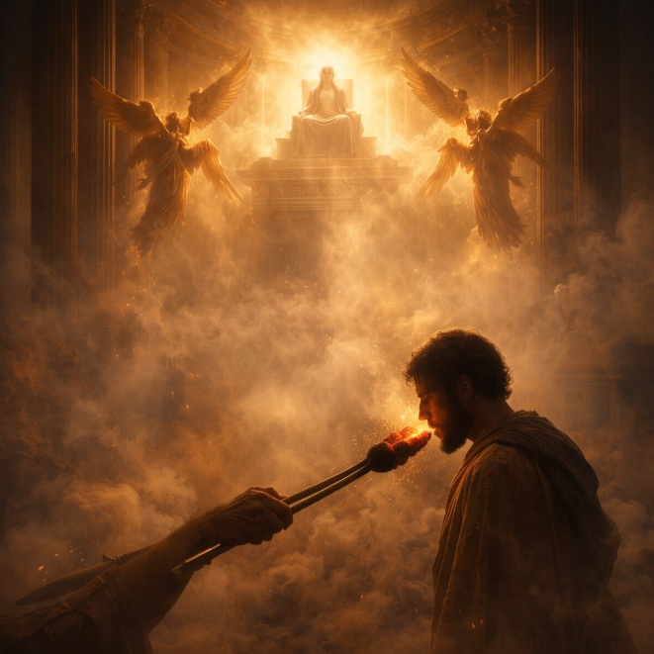
Isaiah 6 records the prophet’s personal calling and provides a foundation for the entire book. The chapter opens with a vision of the LORD enthroned in the temple, exalted above all earthly authority. Seraphim surround Him, proclaiming His holiness, and their voices shake the foundations of the temple as it fills with smoke. The scene emphasizes God’s absolute holiness, power, and otherness. This vision comes at a moment of national uncertainty—the death of King Uzziah—highlighting that while earthly kings fall, the LORD reigns unchallenged.

Confronted with God’s holiness, Isaiah becomes acutely aware of his own sinfulness and the corruption of his people. He declares himself undone, recognizing that he is unclean and lives among an unclean nation, yet has seen the King. In response, one of the seraphim touches Isaiah’s lips with a live coal from the altar, symbolizing cleansing and forgiveness. His guilt is removed, not by effort or ritual, but by God’s gracious action. Only after this purification is Isaiah able to hear God’s voice and respond. When the LORD asks, “Whom shall I send?” Isaiah willingly answers, “Here am I; send me.”

The commission Isaiah receives is sobering. He is sent to proclaim God’s message to a people who will hear but not understand and see but not perceive. His preaching will expose hardened hearts rather than immediately bring repentance. Judgment is certain: cities will be laid waste, the land emptied, and the people removed. Yet the chapter does not end in despair. Isaiah is told that a remnant will remain, compared to a holy seed within a felled tree stump. Even through devastation, God preserves the source of future restoration. Isaiah 6 therefore establishes the pattern of the book—holy God, sinful people, necessary judgment, and enduring hope rooted in God’s sovereign purpose.

Isaiah 7

Opening Scripture Quote (KJV)
“And it came to pass in the days of Ahaz the son of Jotham, the son of Uzziah, king of Judah, that Rezin the king of Syria, and Pekah the son of Remaliah, king of Israel, went up toward Jerusalem to war against it, but could not prevail against it.”

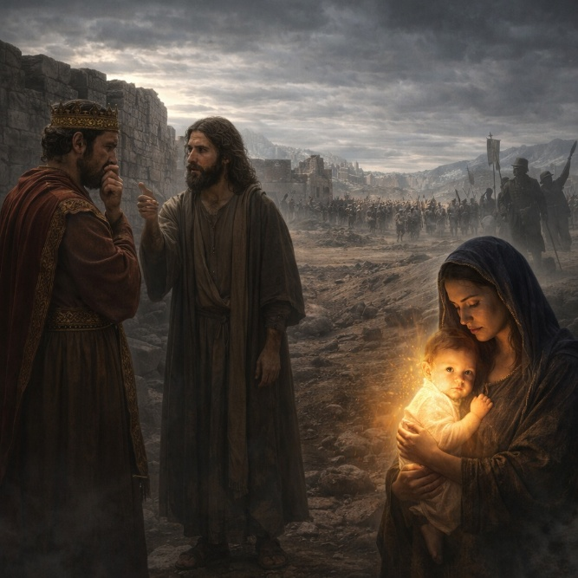
Isaiah 7 is set during a moment of political crisis for Judah. King Ahaz faces a military threat from a coalition of Syria and the northern kingdom of Israel. Fear grips the royal house and the people, described as hearts shaking like trees in the wind. Into this atmosphere of anxiety, God sends Isaiah with a message of reassurance. The threat will not succeed, not because Judah is strong, but because God has determined its limits. The attacking kings are reduced to temporary actors whose plans will fail. Judah’s survival depends not on strategy or alliances, but on trust in the LORD.

God directly addresses Ahaz through Isaiah, urging him to remain calm and firm in faith. The central warning is simple and severe: if Ahaz does not believe, he will not be established. God even invites Ahaz to ask for a confirming sign, offering assurance of divine faithfulness. Ahaz refuses, disguising unbelief as humility. His refusal exposes a deeper issue—he prefers political calculation over reliance on God. This false piety provokes a broader declaration that extends beyond Ahaz personally to the entire house of David.

The chapter then introduces the sign God gives regardless of Ahaz’s refusal. A child will be born, called Immanuel, meaning “God with us.” Before this child reaches maturity, the immediate threat from Syria and Israel will be removed. Yet the sign carries a double edge. While it confirms God’s presence and protection, it also signals coming judgment. Because Ahaz trusts foreign powers instead of God, Judah will experience hardship brought by Assyria—the very nation Ahaz looks to for help. The land will suffer devastation, scarcity, and humiliation. Isaiah 7 therefore presents faith as the dividing line: trust in God leads to stability, while fear-driven reliance on human power brings long-term ruin. The chapter closes with a sobering picture of a land stripped down, illustrating the cost of rejecting God’s assurance.

Isaiah 8

Opening Scripture Quote (KJV)
“Moreover the LORD said unto me, Take thee a great roll, and write in it with a man’s pen concerning Mahershalalhashbaz.”
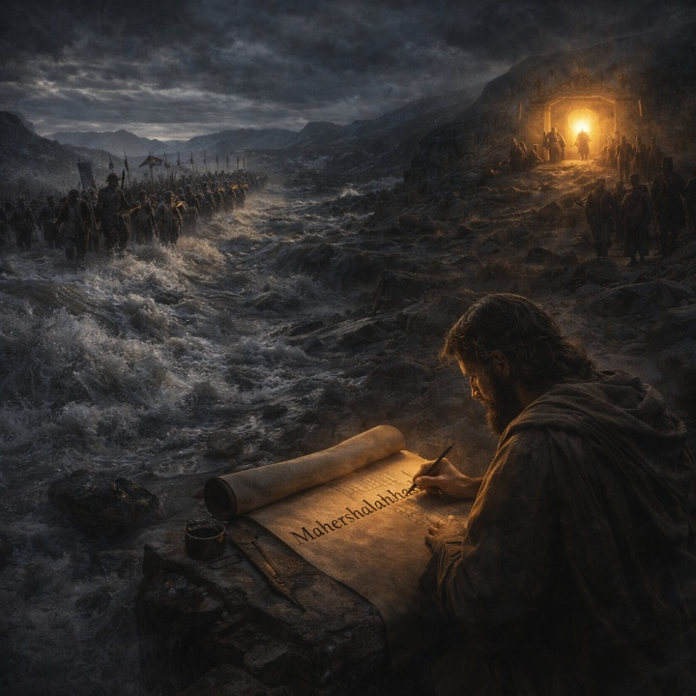
Isaiah 8 continues the theme of looming judgment but sharpens its focus on trust and loyalty. God instructs Isaiah to record a prophetic name—Maher-shalal-hash-baz—signaling that swift plunder and rapid spoil are coming. The birth of this child becomes a living sign: before the child can speak, the riches and power of Syria and Israel will be carried away by Assyria. The immediate threat facing Judah will be removed, but not because of Judah’s faithfulness. God is acting according to His purpose, not human merit.

The chapter then exposes Judah’s deeper failure. The people have rejected “the waters of Shiloah that go softly,” a picture of God’s gentle and steady provision. Instead, they fear human enemies and seek security in political strength. As a result, Assyria—initially a tool of deliverance—will become an overwhelming flood, reaching even to Judah’s neck. The nation will survive, but barely. God is present (“God is with us”), yet His presence does not cancel the consequences of fear-driven choices. Protection and judgment unfold side by side.

Isaiah shifts from national warning to personal instruction. He is told not to share in the people’s fear or conspiratorial thinking. The LORD alone is to be feared and regarded as holy. For those who trust Him, He is a sanctuary; for those who reject Him, He becomes a stone of stumbling. The chapter condemns turning to occult practices and false guidance, insisting that truth must be measured by God’s revealed word. Those who reject it will walk in darkness, distress, and despair. Isaiah 8 closes by drawing a clear dividing line: security comes only from trusting God’s word. Fear of man leads to confusion and ruin, while reverence for the LORD anchors those willing to listen.

Isaiah 9

Opening Scripture Quote (KJV)
“Nevertheless the dimness shall not be such as was in her vexation, when at the first he lightly afflicted the land of Zebulun and the land of Naphtali, and afterward did more grievously afflict her by the way of the sea, beyond Jordan, in Galilee of the nations.”


Isaiah 9 opens with a decisive shift from darkness to hope. Regions that had suffered invasion, loss, and humiliation are promised light. The people who walked in darkness are described as seeing a great light, signaling divine intervention where despair once dominated. This change is not gradual or political; it is an act of God that reverses gloom and fear. Joy replaces oppression, compared to the celebration of harvest or victory after battle. The instruments of violence and domination are broken, emphasizing that deliverance comes from God, not human strength.

The center of the chapter introduces a royal figure whose rule defines this new era. A child is born, a son is given, and authority rests upon him. His reign is described through titles that emphasize wisdom, power, care, and permanence. His government brings peace without end, upheld by justice and righteousness. Unlike human rulers whose power fades or corrupts, this reign is enduring and divinely established. The promise is anchored in God’s commitment, not human worthiness. The transformation of society flows directly from the character of this ruler and the certainty of God’s purpose.

The chapter then returns to warning. Despite God’s acts, the people persist in pride and stubbornness. Leaders mislead, corruption spreads, and discipline is ignored. Each act of judgment is followed by the refrain that God’s anger is not turned away. Internal division weakens the nation further, and injustice consumes it from within. The chapter closes with a sobering reminder: mercy rejected leads to deeper judgment. Isaiah 9 therefore holds together two realities—unstoppable hope grounded in God’s promised ruler, and unavoidable judgment for persistent arrogance. Light has dawned, but responsibility remains. The people are accountable for how they respond to what God has revealed.

Isaiah 10

Opening Scripture Quote (KJV)
“Woe unto them that decree unrighteous decrees, and that write grievousness which they have prescribed;”
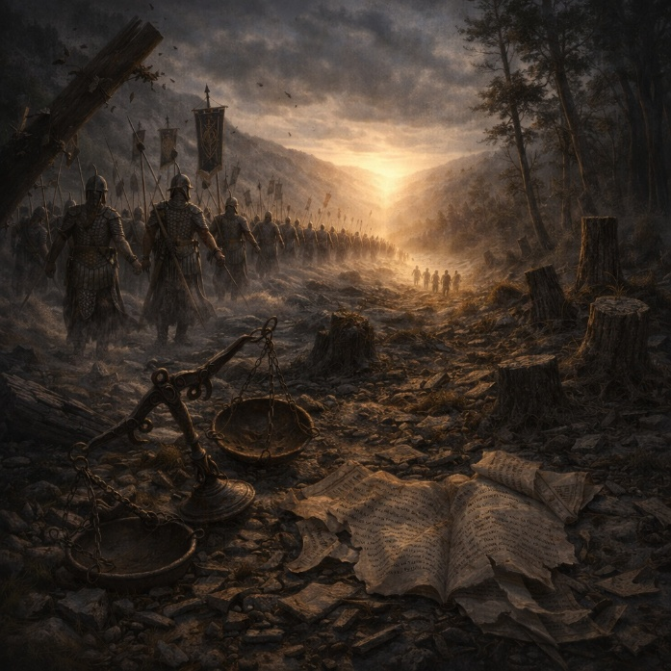
Isaiah 10 opens with a sharp condemnation of unjust leadership. Those in power use laws and policies to oppress rather than protect, robbing the poor, exploiting the helpless, and preying on widows and orphans. God makes clear that such injustice is not hidden or tolerated. Judgment is inevitable, and when it comes, wealth, position, and influence will offer no refuge. The chapter frames injustice not as a social flaw but as rebellion against God’s order, with consequences that cannot be avoided.

The focus then shifts to Assyria, the dominant world power of the time. God identifies Assyria as the instrument of His judgment against a corrupt nation, yet Assyria itself does not recognize this role. Instead, it acts out of arrogance, conquest, and self-glory. The king of Assyria boasts in his strength, wisdom, and success, believing his victories are self-made. Isaiah exposes this pride as absurd: an axe cannot boast against the one who swings it. Assyria is powerful only because God allows it to be. This section emphasizes God’s sovereignty over nations—He uses them for His purposes, yet still holds them accountable for their motives and excesses.

The chapter then turns toward hope and restoration. God declares that Assyria’s power will be broken, and its dominance will not last. A remnant of Israel will survive—not through alliances or force, but through renewed trust in the LORD. This remnant theme underscores that judgment is not annihilation; God preserves a faithful core through whom His purposes continue. Isaiah closes with vivid imagery of the Assyrian advance toward Jerusalem, followed by its sudden collapse. The final message is clear: oppressive rulers fall, arrogant empires are cut down, but God remains in control. Isaiah 10 reinforces a central truth of the book—God governs history with justice, humbling pride while preserving those who rely on Him.

Isaiah 11

Opening Scripture Quote (KJV)
“And there shall come forth a rod out of the stem of Jesse, and a Branch shall grow out of his roots:”

Isaiah 11 opens with a promise of renewal rising out of apparent ruin. The house of David is pictured as a cut-down tree, yet from its stump a new shoot emerges. This figure is marked not by inherited power or political maneuvering, but by the Spirit of the LORD resting upon him. Wisdom, understanding, counsel, might, knowledge, and reverent fear of God define his character. His leadership is grounded in righteousness rather than appearances, and his judgments are fair, decisive, and just, especially toward the poor and oppressed.

The reign of this ruler transforms not only human society but the created order itself. Isaiah describes a world where violence and fear are undone at their root. Predators and prey live together in peace, and what was once deadly becomes harmless. These images convey the removal of hostility and corruption from creation, not through human reform, but through righteous rule. The earth is filled with the knowledge of the LORD as waters cover the sea, indicating that peace flows directly from widespread recognition of God’s authority and truth.

The chapter then expands outward to the nations. This ruler becomes a signal, or banner, drawing peoples from everywhere. God acts again to recover a remnant of His people from dispersion, gathering them from distant lands. Old hostilities between Israel and Judah are removed, and external enemies lose their power. The final imagery echoes a new exodus, with obstacles removed and a clear path prepared for God’s people to return. Isaiah 11 therefore presents a vision of complete restoration—right leadership, healed relationships, renewed creation, and unified people—rooted in God’s faithfulness to His promises.

Isaiah 12

Opening Scripture Quote (KJV)
“And in that day thou shalt say, O LORD, I will praise thee: though thou wast angry with me, thine anger is turned away, and thou comfortedst me.”

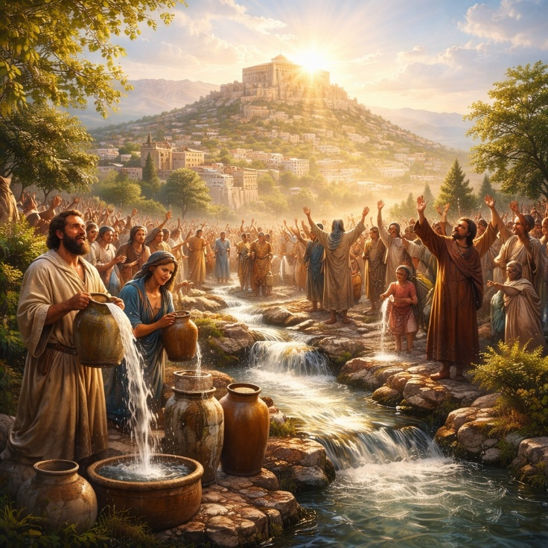
Isaiah 12 is a brief but complete song of praise that flows directly out of the restoration promised in the previous chapter. It is written from the perspective of a redeemed people looking back on God’s discipline and forward in gratitude. The chapter opens with thanksgiving that God’s anger has been turned away and replaced with comfort. Judgment is acknowledged as real and deserved, yet it is not the final word. Deliverance leads naturally to praise, showing that restoration produces worship rather than pride or forgetfulness.

The focus then shifts from relief to confidence. God Himself is declared to be salvation, removing fear and replacing it with trust. Strength and song are no longer found in human power or political security but in the LORD alone. The language echoes earlier acts of deliverance, presenting salvation not as a vague idea but as an experienced reality. Joy becomes the defining response, pictured as drawing water from wells of salvation—an image of abundance, refreshment, and ongoing provision rather than a single moment of rescue.

The final verses move outward from personal gratitude to public proclamation. The redeemed are called to declare God’s deeds among the nations, to make His name known, and to exalt Him openly. Praise is not meant to remain private; it is to be sung loudly and shared widely. Zion is addressed directly and urged to rejoice, not because of its own strength, but because the Holy One of Israel dwells in its midst. God’s presence among His people is the source of their joy and security. Isaiah 12 closes this section of the book by emphasizing that salvation leads to worship, worship leads to witness, and all glory belongs to God. The chapter stands as a calm and confident response to deliverance, balancing humility, joy, and proclamation.

Isaiah 13

Opening Scripture Quote (KJV)
“The burden of Babylon, which Isaiah the son of Amoz did see.”


Isaiah 13 is a prophetic declaration of judgment against Babylon, presented as a divine burden revealed to Isaiah. The chapter opens with God summoning instruments of judgment, calling warriors and armies to carry out His purpose. Though human forces are described, the emphasis is clear: this judgment originates with the LORD of hosts. The coming invasion is portrayed as vast, organized, and unstoppable, demonstrating that even the greatest powers of the world move only at God’s command. Babylon, a symbol of strength, pride, and dominance, is placed under divine scrutiny.

The prophecy then shifts to the emotional and physical impact of the coming judgment. Fear, anguish, and terror spread as the day of the LORD approaches. Human confidence collapses; strength fails, and hearts melt. The imagery is intense and cosmic—heavens tremble, the earth shakes, and the order of the world appears to unravel. This language communicates that the judgment is not merely political but moral and universal in scope. God declares that He will punish the world for evil and the wicked for their iniquity, bringing human arrogance to an end. Babylon’s downfall becomes an example of God’s opposition to pride and cruelty wherever they are found.

The chapter concludes by describing the total devastation of Babylon. Once-glorious and admired, it will be overthrown like Sodom and Gomorrah, never to be inhabited again. Its cities will become desolate, avoided by travelers, and overtaken by wilderness. This is not temporary defeat but lasting ruin. The prophecy underscores that no empire, no matter how powerful, is secure when it exalts itself against God. Isaiah 13 establishes a central biblical theme: God governs history, raises nations, and brings them down according to His justice. Babylon’s judgment serves as a warning that human power, wealth, and pride cannot withstand divine judgment when righteousness is rejected.

Isaiah 14

Opening Scripture Quote (KJV)
“For the LORD will have mercy on Jacob, and will yet choose Israel, and set them in their own land: and the strangers shall be joined with them, and they shall cleave to the house of Jacob.”


Isaiah 14 begins with a promise of restoration following judgment. The LORD declares that He will again show mercy to Israel and bring them back to their land. The people who once ruled over them will lose their power, and the roles of oppressor and oppressed will be reversed. This restoration is presented as an act of divine choice rather than human achievement. After a long period of suffering and forced labor, Israel is promised rest. The opening verses establish that judgment does not cancel God’s covenant purposes, and that mercy remains central to His dealings with His people.

The chapter then moves into a taunt directed at the king of Babylon, spoken by a restored Israel. The ruler who once struck nations and ruled with cruelty is now brought low. His fall brings relief not only to people but to the earth itself, which is described as being at rest. The king’s power is exposed as temporary and fragile. Even in death, he is mocked, having lost the honor he claimed in life. The imagery emphasizes humiliation: the mighty ruler lies among the dead, stripped of glory, remembered not as a savior of nations but as a destroyer.

A central portion of the chapter describes the pride that led to Babylon’s downfall. The king is portrayed as one who sought to exalt himself above the heavens and make himself like the Most High. This ambition ends in complete reversal, as he is cast down instead of lifted up. The contrast highlights a recurring biblical theme: pride leads to ruin, while God alone determines authority and position. The chapter closes by extending judgment beyond Babylon to Assyria, affirming that God’s purposes are fixed and unstoppable. What He has planned will stand, and no power can turn it aside. Isaiah 14 reinforces God’s sovereignty over nations, the certainty of justice, and the assurance that oppression will not endure forever.

Isaiah 15

Opening Scripture Quote (KJV)
“The burden of Moab. Because in the night Ar of Moab is laid waste, and brought to silence; because in the night Kir of Moab is laid waste, and brought to silence;”

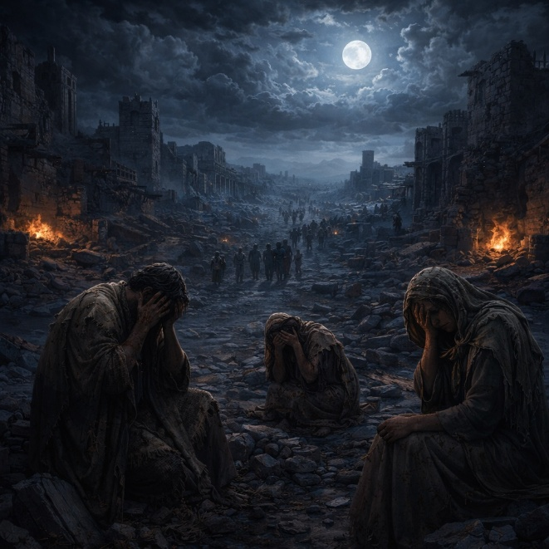
Isaiah 15 is a lament announcing sudden and total devastation upon Moab. The chapter opens with the shock of destruction arriving by night, emphasizing its speed and completeness. Moab’s key cities are laid waste without warning, and the land is thrown into mourning. The response is immediate and emotional: people go up to their high places to weep, heads are shaved, beards are cut, and sackcloth is worn. These actions reflect public grief and desperation rather than repentance. The chapter presents Moab as overwhelmed, unable to defend itself against the coming calamity.

The lament spreads across the land as Isaiah traces the path of sorrow through Moab’s towns and highways. Crying echoes from city to city, and even the armed men are described as weeping, showing that strength and courage have failed. The imagery emphasizes movement—fleeing, wailing, and wandering—indicating a population in panic and displacement. Moab’s pride, implied elsewhere in Scripture, is here contrasted with helplessness. The nation that once stood secure is reduced to lamentation, and no refuge within its borders offers relief.

The chapter concludes by extending the devastation to Moab’s borders and beyond. Waters are filled with blood, and even those who escape the initial destruction face further judgment. The language conveys inevitability: there is no safe path, no hidden stronghold, and no lasting escape. Isaiah 15 does not explain the moral reasons for Moab’s judgment in detail; instead, it focuses on the emotional and physical reality of collapse. The chapter functions as a stark portrayal of divine judgment experienced on the ground—cities ruined, people broken, and a land consumed by grief. Isaiah’s lament underscores that national security and prosperity cannot stand when God’s judgment falls.

Isaiah 16

Opening Scripture Quote (KJV)
“Send ye the lamb to the ruler of the land from Sela to the wilderness, unto the mount of the daughter of Zion.”

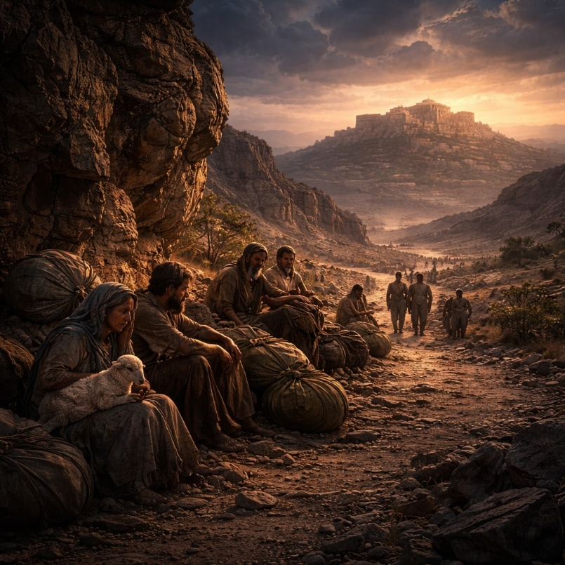
Isaiah 16 continues the oracle concerning Moab, shifting from lament to counsel and appeal. The chapter opens with a call for Moab to send tribute, symbolized by a lamb, acknowledging authority and seeking protection. Moab’s people are pictured as displaced and vulnerable, like birds scattered from a nest, forced to flee their land. The language reflects desperation and dependence, showing a nation stripped of pride and security. The request is clear: Moab seeks refuge and stability beyond its own borders, having lost the ability to stand on its own.

The prophecy then turns toward Judah, urging the extension of shelter and protection to the refugees. Moab pleads for concealment, mercy, and relief from the oppressor. The text highlights the moral weight of how the vulnerable are treated in times of crisis. At the same time, a broader hope is introduced: a throne will be established in mercy, characterized by faithfulness, justice, and righteousness. This vision contrasts sharply with Moab’s pride and instability. It presents a model of leadership grounded not in domination but in truth and equity, offering a glimpse of ordered rule amid regional collapse.

The chapter concludes by returning to Moab’s downfall and explaining why judgment remains unavoidable. Moab’s long-standing pride is named as the root issue—arrogance, self-exaltation, and resistance to correction. Because of this pride, Moab’s joy, productivity, and celebration are cut off. Vineyards fail, harvest songs cease, and the land grows silent. Even as compassion is expressed for Moab’s suffering, the judgment is confirmed and given a clear time frame. Isaiah 16 holds tension between mercy and justice: sympathy for suffering, but firmness against pride. The chapter reinforces that relief and stability cannot be secured apart from humility and righteousness, and that pride ultimately undermines any refuge a nation seeks to build.

Isaiah 17

Opening Scripture Quote (KJV)
“The burden of Damascus. Behold, Damascus is taken away from being a city, and it shall be a ruinous heap.”


Isaiah 17 announces judgment against Damascus and extends its reach to the northern kingdom of Israel, showing how closely their fates are tied. The chapter opens with the shocking declaration that Damascus will cease to exist as a city and become ruins. This collapse is not portrayed as gradual decline but as decisive removal. Alongside Damascus, the cities of Israel are also emptied and weakened. What once appeared fortified and secure is reduced to desolation, emphasizing that political alliances and military strength cannot prevent God’s judgment.

The imagery then shifts to describe what remains after judgment. Israel is compared to a harvested field or an olive tree after beating—only a few berries left at the top branches. This picture communicates severe loss but not total annihilation. A remnant survives, small and fragile, yet still present. The reduction exposes the emptiness of Israel’s misplaced trust. Strong cities, foreign alliances, and cultivated defenses fail because God was forgotten. The chapter identifies the core problem plainly: Israel relied on what it built and planted while neglecting the God who formed and protected them.

The final section introduces a turning point. In the aftermath of loss, people are described as finally looking to their Maker and turning away from idols. Altars to false gods lose their appeal, and attention returns to the Holy One of Israel. Yet the chapter closes by reaffirming judgment against the nations that threaten God’s people. Though they roar like seas and rush like floods, they are rebuked and driven away, vanishing like chaff before the wind. The contrast is sharp: nations rise loudly but fall quickly; God remains steady and unmatched. Isaiah 17 teaches that forgetting God leads to collapse, while even severe judgment can redirect attention back to the One who gives life and security. The chapter balances warning with restraint, devastation with survival, and judgment with the quiet possibility of restoration.

Isaiah 18

Opening Scripture Quote (KJV)
“Woe to the land shadowing with wings, which is beyond the rivers of Ethiopia:”

Isaiah 18 addresses a distant and powerful land known for swift movement and far-reaching influence, likely associated with regions beyond the Nile. The chapter opens with a warning directed toward this land, described with vivid imagery of wings, rivers, and speed. Envoys travel by water, carrying messages across great distances, reflecting political ambition and international reach. The scene conveys urgency and confidence, yet the tone signals that human initiative and diplomatic activity do not determine outcomes. God, not nations, governs the course of history.

The focus then shifts from human action to divine observation. The LORD declares that He will quietly watch from His dwelling place, attentive but not hurried. This pause is significant: while nations act, plan, and move, God remains still, allowing events to mature fully. The imagery of harvest is introduced—growth reaching its peak before being cut down. Just as vines are pruned at the proper moment, judgment comes at the appointed time, not before and not late. Human power rises, but it does so under divine oversight and limits.

The chapter concludes with a dramatic reversal. What appeared strong and impressive is suddenly removed, left exposed to birds and beasts. Yet the final note is not destruction alone but redirection. A gift is brought to the LORD of hosts, to Mount Zion, from the very land first addressed. The distant nation that once moved confidently on its own terms is now depicted as acknowledging God’s authority. Isaiah 18 emphasizes that God does not rush judgment, does not compete with human power, and does not need intervention to rule. He observes, acts decisively at the proper time, and ultimately draws even distant nations into recognition of His sovereignty.

Isaiah 19

Opening Scripture Quote (KJV)
“The burden of Egypt. Behold, the LORD rideth upon a swift cloud, and shall come into Egypt: and the idols of Egypt shall be moved at his presence, and the heart of Egypt shall melt in the midst of it.”

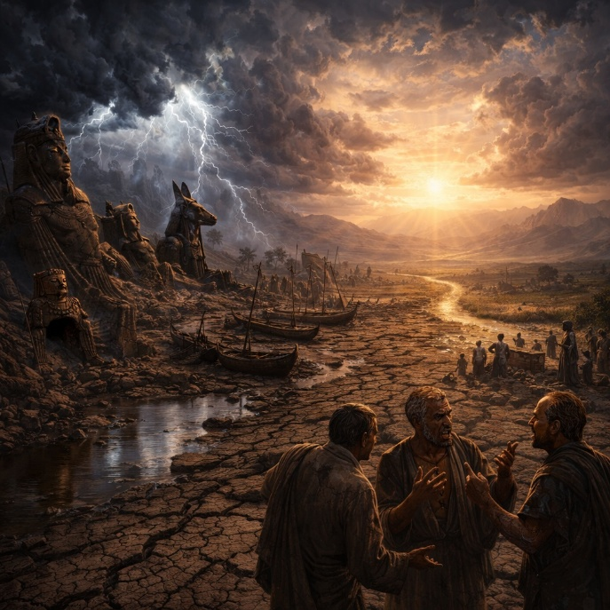
Isaiah 19 pronounces judgment against Egypt, portraying the LORD as personally entering the nation to confront its false security. The chapter opens with internal collapse rather than foreign invasion. Civil strife, confusion, and failed leadership weaken Egypt from within. Wisdom fails, counselors give poor advice, and long-trusted religious practices are exposed as powerless. The imagery stresses that Egypt’s instability is not accidental but directed; God disrupts what the nation relies upon to show that idols, tradition, and human wisdom cannot preserve order or peace.

The judgment deepens as Egypt’s natural and economic foundations are struck. The Nile, the source of life and prosperity, dries up, and with it agriculture, fishing, and industry collapse. Workers despair, livelihoods vanish, and national confidence erodes. Political leadership is mocked as foolish and ineffective, unable to understand what God is doing. Egypt, once feared and admired, becomes weak and afraid. Even Judah becomes a source of dread, not because of military threat, but because Egypt recognizes that Judah’s God is actively shaping events. Fear replaces pride as Egypt realizes it is subject to a power beyond its control.

The final section of the chapter introduces a surprising reversal. After judgment and fear, Egypt is shown turning toward the LORD. Altars are raised, vows are made, and God responds not with destruction but healing. Egypt cries out, and God sends a savior and defender. The chapter closes with a vision of reconciliation once thought impossible: Egypt, Assyria, and Israel joined together in worship and blessing. God names Egypt “my people,” Assyria “the work of my hands,” and Israel “mine inheritance.” Isaiah 19 moves from collapse to restoration, showing that God’s purpose is not merely to humble nations, but to draw them into acknowledgment of His rule. Judgment exposes false foundations, but mercy reveals God’s ultimate aim—order, healing, and unity under His authority.

Isaiah 20

Opening Scripture Quote (KJV)
“In the year that Tartan came unto Ashdod, (when Sargon the king of Assyria sent him,) and fought against Ashdod, and took it;”
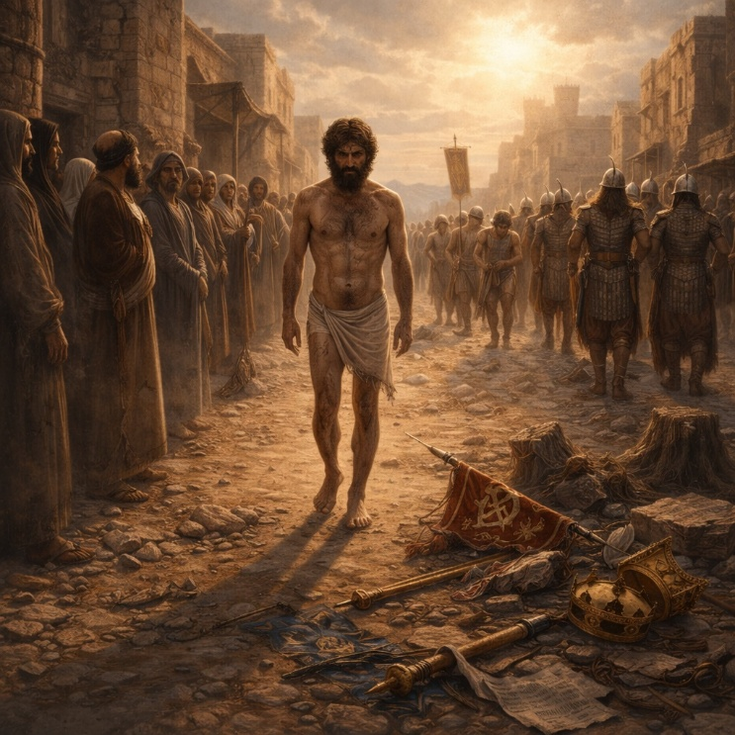
Isaiah 20 records one of the most unusual prophetic actions in the book. God commands Isaiah to remove his sackcloth and sandals and to walk naked and barefoot as a sign. This public act is not symbolic theater for its own sake but a deliberate, visible warning. Isaiah lives this sign for three years, demonstrating the message God intends to communicate. The chapter is rooted in a concrete historical moment: Assyria’s growing dominance and the political temptation for Judah to seek protection through alliances with Egypt and Ethiopia.

The sign explains the message. Just as Isaiah walks exposed and humiliated, so Egypt and Ethiopia—the powers Judah hopes will provide security—will be led away by Assyria as captives. Young and old alike will be marched off naked and barefoot, disgraced and powerless. What Judah views as strong and reliable allies will prove helpless. God makes clear that trusting in these nations is misplaced. Military strength, political reputation, and regional influence will not withstand Assyria’s advance because God has determined the outcome.

The chapter ends with a sobering conclusion directed at Judah. When Egypt and Ethiopia fall, Judah will be left exposed for having relied on them. The people will realize too late that their confidence was false. Isaiah 20 is brief but pointed: it strips away illusions of security and forces a choice. Dependence on human power leads to shame and disappointment. Trust in the LORD is not abstract belief but a practical decision about where safety is truly found. The chapter reinforces a recurring theme in Isaiah—God alone controls history, and alliances formed in fear will ultimately collapse.

Isaiah 21

Opening Scripture Quote (KJV)
“The burden of the desert of the sea. As whirlwinds in the south pass through; so it cometh from the desert, from a terrible land.”
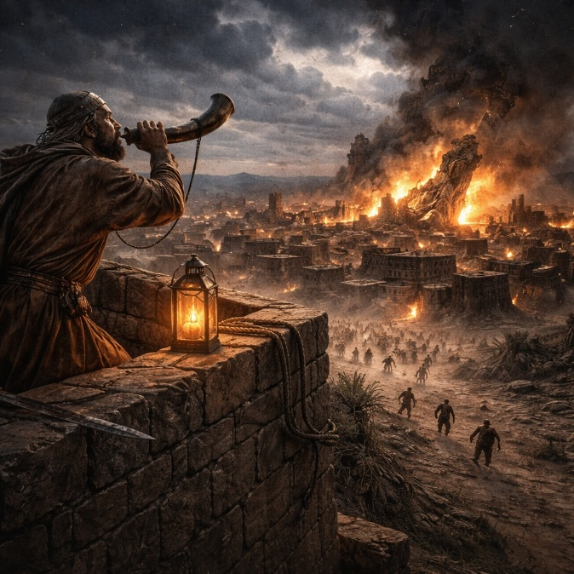
Isaiah 21 presents a series of prophetic burdens describing the sudden collapse of proud powers and the anxiety that accompanies approaching judgment. The chapter opens with a vivid vision focused on Babylon. Isaiah describes overwhelming dread and turmoil as judgment advances like a violent storm from the desert. The scene is filled with tension—feasting turns to panic, confidence dissolves into fear, and the prophet himself is shaken by what he sees. Babylon, a symbol of power and luxury, is caught unprepared, revealing how quickly human security can vanish.

The vision then narrows to the moment of Babylon’s fall. Watchmen are stationed to observe events as they unfold. When the report finally comes—“Babylon is fallen, is fallen”—it confirms that the empire’s idols and defenses have collapsed together. What appeared invincible is shattered in a single stroke. The message emphasizes that God’s judgment is decisive and final. Babylon’s downfall is not accidental or gradual; it is the result of divine determination. The crushing of idols underscores that false gods cannot protect those who trust in them.

The chapter then turns briefly to Edom and Arabia, expanding the scope of judgment. Edom is pictured as anxiously asking how long the night will last, receiving an ambiguous answer that offers neither comfort nor clarity. Arabia’s traders and warriors are shown fleeing, their strength diminished and their glory fading within a year. These short oracles reinforce a consistent theme: nations that rely on power, wealth, or military skill cannot escape God’s oversight. Isaiah 21 as a whole portrays a world on edge, where watchmen wait, alarms sound, and empires fall suddenly. It calls attention to the fragility of human pride and the certainty of God’s word.

Isaiah 22

Opening Scripture Quote (KJV)
“The burden of the valley of vision. What aileth thee now, that thou art wholly gone up to the housetops?”
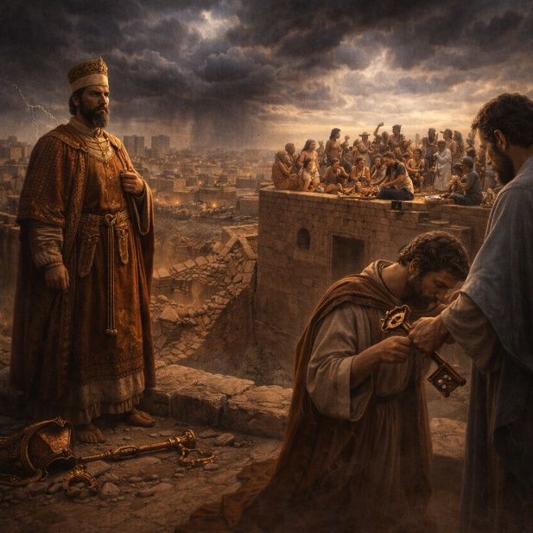
Isaiah 22 delivers a sharp rebuke to Jerusalem at a moment when seriousness and repentance should have marked the city. Instead of humility, the people respond to impending danger with noise, celebration, and denial. The city is described as full of confusion—leaders flee, defenses fail, and fear spreads—but the people refuse to face the spiritual cause of the crisis. Rather than turning to the LORD, they seek distraction and temporary relief, ignoring the warning signs of judgment unfolding around them.

Isaiah exposes the deeper problem: misplaced confidence. Jerusalem prepares militarily, strengthening walls, securing water supplies, and counting weapons, yet fails to look to the One who designed and governed the city from the beginning. Their planning is thorough, but it is entirely God-less. The chapter emphasizes that practical action without repentance is not faith but defiance. God had called for weeping, humility, and reflection, but the people responded with feasting and fatalism—“let us eat and drink; for tomorrow we shall die.” This attitude seals their guilt. Isaiah declares that such sin will not be purged away, underscoring the seriousness of hardened refusal.

The chapter then narrows from national failure to individual accountability. Shebna, a proud official, is condemned for self-exaltation and misuse of authority. God announces his removal and replacement by Eliakim, a servant characterized by stability and responsibility. Eliakim is described as a secure peg in a sure place, entrusted with authority for the good of others. Yet even this hope is tempered—no human leader is permanent. Isaiah 22 closes by reminding the reader that reliance on status, systems, or leaders ultimately fails. True security lies only in obedience to the LORD. The chapter stands as a warning against empty confidence and a call to sober, God-centered response in times of crisis.

Isaiah 23

Opening Scripture Quote (KJV)
“The burden of Tyre. Howl, ye ships of Tarshish; for it is laid waste, so that there is no house, no entering in: from the land of Chittim it is revealed to them.”
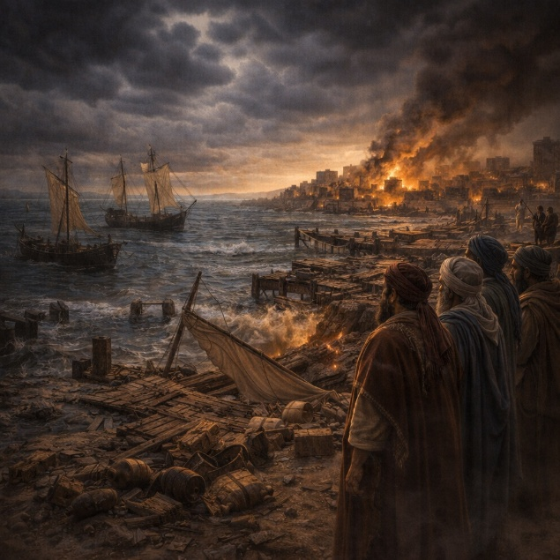
Isaiah 23 pronounces judgment on Tyre, the great Phoenician port city known for wealth, trade, and influence across the Mediterranean world. The chapter opens with shock and mourning as news spreads that Tyre’s commercial power has collapsed. Merchants, sailors, and trading partners are called to lament because the city that once dominated sea routes and enriched nations is suddenly silenced. Tyre’s strength lay not in armies but in economic reach, yet that strength proves fragile when God brings disruption.

The prophecy highlights how deeply Tyre’s commerce shaped the world around it. Its ships carried wealth between nations, and its profits sustained rulers and kingdoms. Because of this, Tyre’s fall ripples outward, unsettling Egypt, Tarshish, and distant coastal lands. Isaiah emphasizes that this collapse is not random or merely political. It is the LORD’s doing, intended to humble human pride. Tyre’s merchants are described as princes, revealing how wealth had elevated trade to a position of power and arrogance. God overturns this order, demonstrating that economic dominance is no more secure than military might.

The chapter closes with an unexpected turn. After a period of seventy years, Tyre will revive and return to trade, but with a changed purpose. Its profit will no longer be hoarded for self-glory but will ultimately serve the LORD’s purposes, providing provision rather than excess. Isaiah 23 thus balances judgment with restraint. Tyre is humbled, not erased. The message reinforces a consistent theme in Isaiah: wealth, like power, must not become an object of trust or pride. God alone determines rise and fall, and even restored prosperity remains accountable to Him.

Isaiah 24

Opening Scripture Quote (KJV)
“Behold, the LORD maketh the earth empty, and maketh it waste, and turneth it upside down, and scattereth abroad the inhabitants thereof.”


Isaiah 24 expands the scope of judgment from individual nations to the whole earth. The chapter portrays a complete unraveling of human society as God acts decisively against widespread corruption. No group is exempt—priests and people, masters and servants, buyers and sellers all experience the same collapse. Social order dissolves, land is devastated, and population is scattered. The reason is clear: humanity has broken God’s laws, violated His ordinances, and ignored the everlasting covenant. Moral disorder results in physical and societal ruin.

The chapter emphasizes loss and emptiness. Joy fades, celebrations cease, music stops, and cities fall silent. What once brought pleasure now brings bitterness. The earth itself seems to mourn under the weight of human guilt. Isaiah presents judgment not as chaos without purpose, but as the necessary outcome of sustained rebellion. Human pride and security systems—economic, cultural, and political—are stripped away. The world is left desolate, reduced to a remnant like olives left after harvest or grapes after gathering.

Yet even in this global devastation, hope is not erased. A small remnant lifts its voice in praise, glorifying the LORD from distant places. God’s sovereignty remains intact, and His glory is acknowledged even amid ruin. The chapter closes with a final vision of divine authority: the LORD reigns on Mount Zion and in Jerusalem, and His glory surpasses all earthly powers, even the sun and moon. Isaiah 24 establishes a key theme of the book—universal judgment paired with enduring kingship. The earth may shake and fall, but God’s rule stands firm, and those who honor Him are not forgotten.

Isaiah 25

Opening Scripture Quote (KJV)
“O LORD, thou art my God; I will exalt thee, I will praise thy name; for thou hast done wonderful things; thy counsels of old are faithfulness and truth.”

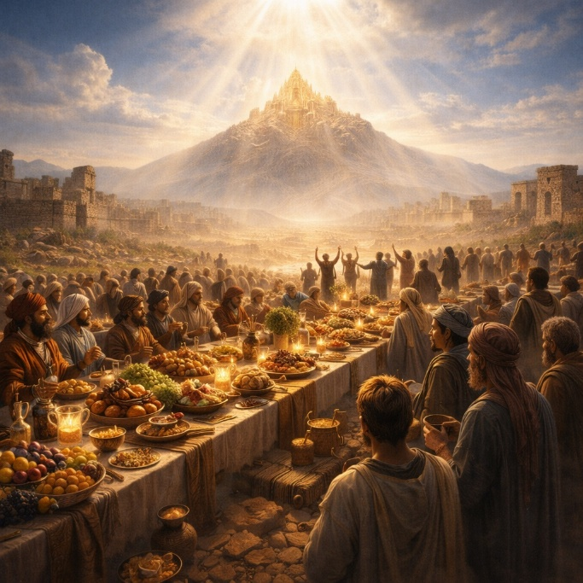
Isaiah 25 is a song of praise that follows the sweeping judgment described in the previous chapter. It opens with direct worship, acknowledging God’s sovereignty, faithfulness, and reliability. What God has planned from long ago is now seen as just and true. The chapter frames judgment not as chaos, but as the fulfillment of deliberate and righteous counsel. God is praised precisely because His actions are consistent with His character, even when they involve overturning human power.

The focus then turns to the downfall of oppressive cities and ruthless nations. Fortified strongholds are reduced to ruins, and once-dominant powers lose their ability to intimidate. As a result, the poor and needy find protection in God. He is described as a refuge from storms, heat, and violence. The imagery emphasizes shelter and relief, showing that divine judgment against the proud simultaneously becomes deliverance for the vulnerable. Strength built on cruelty collapses, while trust in God proves secure.

The chapter culminates in one of Isaiah’s most hopeful visions. God prepares a rich feast for all people on His mountain, symbolizing abundance, fellowship, and restored relationship. Death itself is swallowed up, tears are wiped away, and disgrace is removed. These acts are not temporary comforts but decisive reversals of humanity’s deepest losses. The people respond with joy, recognizing that the LORD they waited for has finally acted. The chapter closes by contrasting the salvation of those who trust God with the humiliation of the proud, represented by Moab brought low. Isaiah 25 stands as a declaration that God’s reign results in both justice and joy—judgment for arrogance, and lasting comfort for those who rely on Him.

Isaiah 26

Opening Scripture Quote (KJV)
“In that day shall this song be sung in the land of Judah; We have a strong city; salvation will God appoint for walls and bulwarks.”

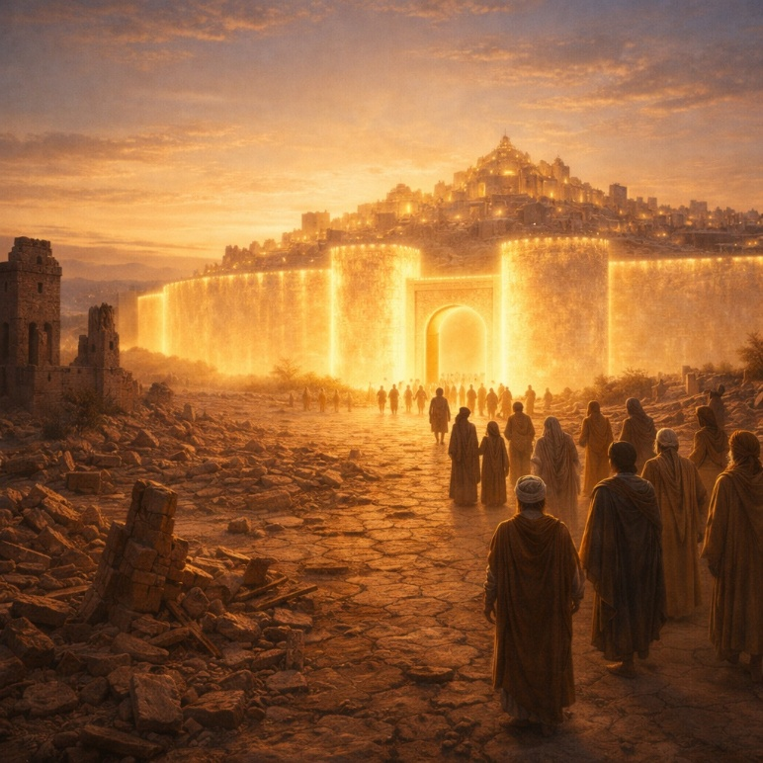
Isaiah 26 is a song of trust and confidence sung by a people who have come through judgment and now rest in God’s protection. The chapter opens by describing a strong city, not secured by walls or armies, but by salvation itself. Security comes from God’s faithfulness, not human defenses. Those who trust in Him experience stability and peace, while prideful nations are brought low. The contrast is clear: humility before God leads to safety, while self-exaltation ends in ruin.

The chapter emphasizes inner posture rather than external power. God grants perfect peace to those whose minds are steadfast because they trust Him. Human strength is exposed as unreliable and temporary, but the LORD is described as an everlasting rock. Even when God’s judgments are present in the world, their purpose is instructional—to teach righteousness. Yet Isaiah acknowledges a hard truth: many do not learn, even when discipline is visible. Mercy and judgment both reveal God’s character, but only the willing respond rightly.

Isaiah then turns to the experience of waiting. God’s people long for Him in the night and seek Him earnestly in distress. The chapter reflects the pain of oppression and the frustration of unrealized hopes, yet it refuses despair. God’s rule will ultimately bring life, not loss. The closing verses introduce a striking image of resurrection and restoration—death does not have the final word for those who belong to the LORD. The chapter ends with a call to quiet trust while judgment completes its work. God’s people are urged to wait patiently as wrongdoing is exposed and addressed. Isaiah 26 presents faith as steady endurance: trusting God not only in deliverance, but also in delay, confident that His justice and life-giving power will prevail.

Isaiah 27

Opening Scripture Quote (KJV)
“In that day the LORD with his sore and great and strong sword shall punish leviathan the piercing serpent, even leviathan that crooked serpent; and he shall slay the dragon that is in the sea.”

Isaiah 27 presents God’s decisive victory over forces that threaten order and life. The chapter opens with vivid imagery of the LORD confronting and defeating Leviathan, a symbol of chaos, oppression, and hostile power. This act establishes God’s supremacy: nothing that resists Him can endure. The message is not about myth but authority—God rules over what seems untamable. Judgment here is purposeful, clearing the way for restoration rather than existing as destruction for its own sake.

The focus then turns to God’s care for His people, portrayed as a carefully tended vineyard. Unlike earlier passages where the vineyard faced judgment, this one emphasizes protection and nurture. God watches over it continually, watering it and guarding it day and night. Wrath is restrained, not absent; it is measured and corrective. When resistance arises, it is confronted, yet the aim is reconciliation. The chapter underscores that discipline is designed to remove sin, not to erase the people themselves. God’s actions are deliberate, proportionate, and aimed at healing the relationship.

The final section widens the lens to national restoration. Israel’s exile and scattering are acknowledged as consequences of sin, but they are not the end of the story. Through measured judgment, guilt is purged, and idolatry is dismantled. The chapter closes with a powerful image of regathering: people are gathered one by one as a great trumpet sounds, calling them back to worship the LORD in Jerusalem. Isaiah 27 balances firmness and mercy—God destroys what corrupts, preserves what belongs to Him, and restores what has been scattered. The chapter reinforces a central theme of Isaiah: God’s judgment clears the ground for renewal, and His ultimate purpose is a purified people living under His protection.

Isaiah 28

Opening Scripture Quote (KJV)
“Woe to the crown of pride, to the drunkards of Ephraim, whose glorious beauty is a fading flower, which are on the head of the fat valleys of them that are overcome with wine!”

Isaiah 28 opens with a strong rebuke against Ephraim, the northern kingdom, using the image of a fading crown to describe pride, excess, and moral decay. Leaders are portrayed as intoxicated—not only with wine but with arrogance and false security. What they consider strength and beauty is already withering. God announces that this pride will be trampled underfoot by a coming force, and the once-celebrated capital will fall swiftly. The imagery emphasizes how quickly human confidence collapses when it is built on indulgence rather than wisdom.

The focus then shifts to Judah, where similar corruption has taken root. Priests and prophets stagger in confusion, unable to offer clear instruction. Isaiah portrays their spiritual immaturity with biting clarity: they mock God’s teaching as childish repetition, yet they themselves are incapable of understanding deeper truth. Because they reject clear instruction, God warns that they will hear His word through foreign tongues and harsh circumstances. Rest was offered, but they refused it. As a result, what should have brought stability will instead become a cause of stumbling.

The chapter concludes with a contrast between false security and true foundation. Judah’s leaders claim safety through deceptive alliances, calling them a covenant with death. God declares this refuge to be a lie that will fail under judgment. In contrast, He establishes a sure foundation in Zion—a tested and precious cornerstone that provides stability for those who trust it. Judgment is described as measured and purposeful, like a farmer who knows when and how to thresh without destroying the grain. Isaiah 28 closes by affirming God’s wisdom: His discipline is deliberate, His instruction precise, and His purposes reliable. Pride is exposed, false shelters collapse, but God’s foundation remains unshaken.

Isaiah 29

Opening Scripture Quote (KJV)
“Woe to Ariel, to Ariel, the city where David dwelt! add ye year to year; let them kill sacrifices.”
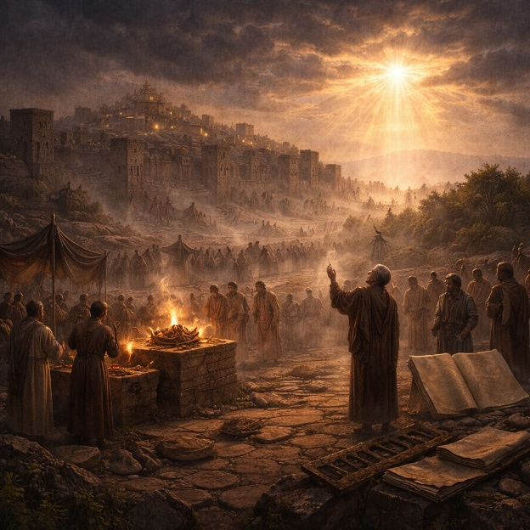
Isaiah 29 opens with a warning to Jerusalem, called “Ariel,” a city rich in religious tradition yet spiritually dulled. Despite regular sacrifices and observances, the city faces coming distress. God declares that siege, sorrow, and humiliation are approaching. Jerusalem will be brought low, speaking as from the dust, revealing that ritual activity alone does not secure God’s favor. The city’s confidence rests in habit rather than obedience, and judgment is portrayed as unavoidable because the people mistake outward religion for true devotion.

The chapter then exposes a deeper problem: spiritual blindness. God sends a condition of deep sleep upon the people, affecting prophets and leaders alike. Revelation becomes inaccessible—not because God is silent, but because the people are unwilling to hear. Wisdom fails, understanding disappears, and even the learned cannot grasp what is plainly before them. The people honor God with their lips while their hearts remain distant. Their fear of God is shaped by human tradition rather than genuine reverence. As a result, their plans collapse, and their attempts to hide intentions from God are exposed as foolish.

The chapter closes with a reversal of expectation. God announces that the current order will be overturned. The deaf will hear, the blind will see, and the humble will rejoice. Those who exploit, deceive, or scoff will be cut off. Wisdom will be restored to the simple, and understanding to those once confused. Jerusalem’s future is not erased but renewed. Shame gives way to understanding, and fear gives way to reverence rooted in truth. Isaiah 29 holds together judgment and hope: God confronts empty religion and hidden pride, yet promises restoration marked by clarity, justice, and renewed understanding for those who turn back to Him.

Isaiah 30

Opening Scripture Quote (KJV)
“Woe to the rebellious children, saith the LORD, that take counsel, but not of me; and that cover with a covering, but not of my spirit, that they may add sin to sin:”
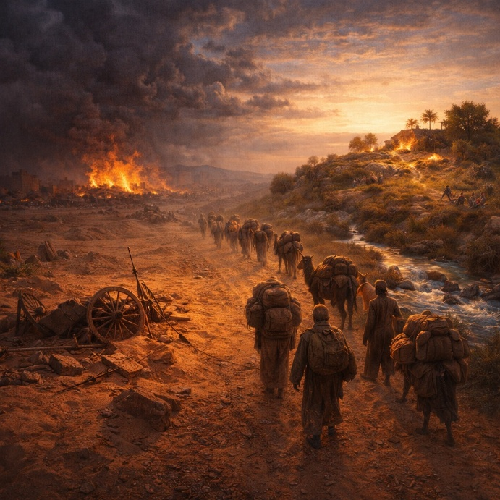
Isaiah 30 confronts Judah’s refusal to trust the LORD, focusing on its attempt to secure safety through an alliance with Egypt. God calls this policy rebellion, not prudence. The leaders plan carefully, send envoys through dangerous territory, and invest resources—yet they do so without seeking God’s counsel. Egypt is exposed as an empty promise: impressive in reputation, useless in reality. Judah’s strategy adds sin to sin by replacing reliance on God with political calculation.

The chapter then exposes a deeper spiritual problem. The people do not want truth; they want reassurance. They pressure prophets to speak smooth words and to avoid uncomfortable warnings. God responds by declaring that this rejection of instruction will bring sudden collapse—like a cracked wall that falls without warning. The result will be shame and helplessness, as the strength they trusted evaporates. Yet even here, God makes His desire clear: “in returning and rest shall ye be saved.” Quiet trust, not frantic action, is the path to security—but Judah refuses it.

The final section turns from rebuke to promise. God waits to be gracious, and His judgment is not abandonment. A time is coming when guidance will be clear, provision abundant, and deception removed. Idols will be cast aside, rain will nourish the land, and healing will replace affliction. God’s presence will be unmistakable, and His voice will direct His people in the way they should go. At the same time, the enemies of God’s people will face decisive judgment. Isaiah 30 therefore holds together warning and hope: human schemes fail, but God remains ready to restore. Trust determines the outcome—reliance on man leads to shame, while reliance on the LORD leads to renewal and peace.

Isaiah 31

Opening Scripture Quote (KJV)
“Woe to them that go down to Egypt for help; and stay on horses, and trust in chariots, because they are many; and in horsemen, because they are very strong; but they look not unto the Holy One of Israel, neither seek the LORD!”


Isaiah 31 continues the warning against Judah’s reliance on Egypt for protection. God condemns the decision to trust military strength—horses, chariots, and skilled horsemen—rather than seeking Him. Egypt’s power appears impressive, but it is ultimately human and fragile. The chapter stresses a fundamental contrast: God is not limited like man. When He acts, both the helper and the helped will fall together. Human alliances formed out of fear cannot override divine purpose.

The chapter then shifts to reassurance. God’s commitment to defend Jerusalem is compared to a lion standing over its prey—unmoved by threats or noise. In the same way, the LORD will stand firm over Mount Zion. His protection is deliberate and resolute, not hesitant or negotiable. Isaiah also uses the image of birds hovering to describe God’s shielding presence, emphasizing closeness and care. Deliverance will not come through negotiation or force, but through God’s direct intervention.

Isaiah calls the people to repentance, urging them to abandon idols and false securities. True deliverance requires turning back to the LORD in sincerity, not merely adjusting strategy. The chapter concludes with a clear outcome: Assyria, the looming threat, will fall—not by human sword, but by God’s action. Fear will overtake its leaders, and its power will dissolve. Isaiah 31 reinforces a central message of the book: safety comes from trust in God alone. Strength rooted in human systems collapses under judgment, but reliance on the LORD results in protection, deliverance, and peace.

Isaiah 32

Opening Scripture Quote (KJV)
“Behold, a king shall reign in righteousness, and princes shall rule in judgment.”

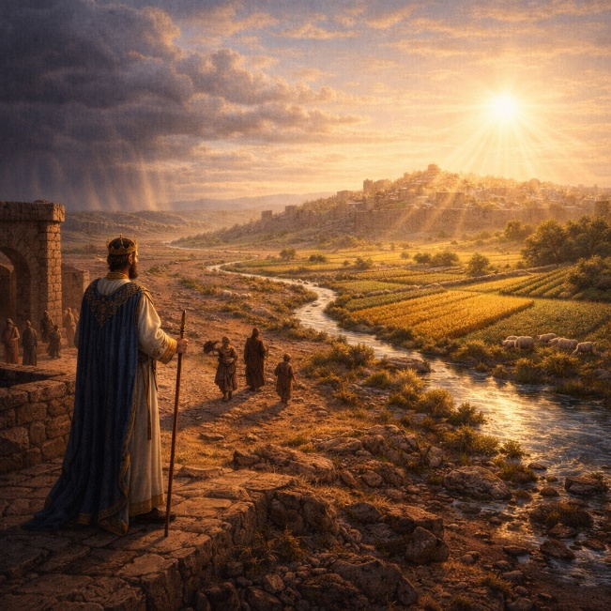
Isaiah 32 opens with a vision of just leadership. A righteous king and upright rulers transform public life, bringing clarity, protection, and fairness. Under this rule, people no longer live in fear or confusion. Leaders provide shelter like shade from heat and refuge from storms. Understanding replaces confusion, and truth is spoken plainly. The chapter presents good governance as a moral force that stabilizes society and benefits ordinary people, especially those previously neglected or misled.

The focus then shifts to moral discernment within the community. Foolishness and deception are exposed for what they are. Empty talk and selfish schemes no longer pass as wisdom. Those who exploit others or distort truth are named plainly, while generosity and integrity are honored. The message is practical: character matters, and righteousness has visible effects. When leadership and values align with justice, social order improves and trust grows.

Isaiah then addresses complacency, particularly among the comfortable and secure. A coming disruption is announced that will strip away false ease. Fields will fail, celebrations will cease, and confidence based on prosperity will collapse. This warning is not vindictive; it is corrective. The purpose is to awaken those who have mistaken stability for righteousness. The chapter’s final movement turns decisively toward hope. A dramatic renewal comes when God’s Spirit is poured out. Desolation gives way to fruitfulness, and wilderness becomes a productive field. Justice settles in, peace follows, and security becomes lasting rather than fragile. The chapter closes with a picture of quiet confidence: people dwell safely, labor fruitfully, and rest without fear. Isaiah 32 holds together warning and promise—complacency leads to loss, but righteousness and God’s Spirit produce peace that endures.

Isaiah 33

Opening Scripture Quote (KJV)
“Woe to thee that spoilest, and thou wast not spoiled; and dealest treacherously, and they dealt not treacherously with thee! when thou shalt cease to spoil, thou shalt be spoiled; and when thou shalt make an end to deal treacherously, they shall deal treacherously with thee.”

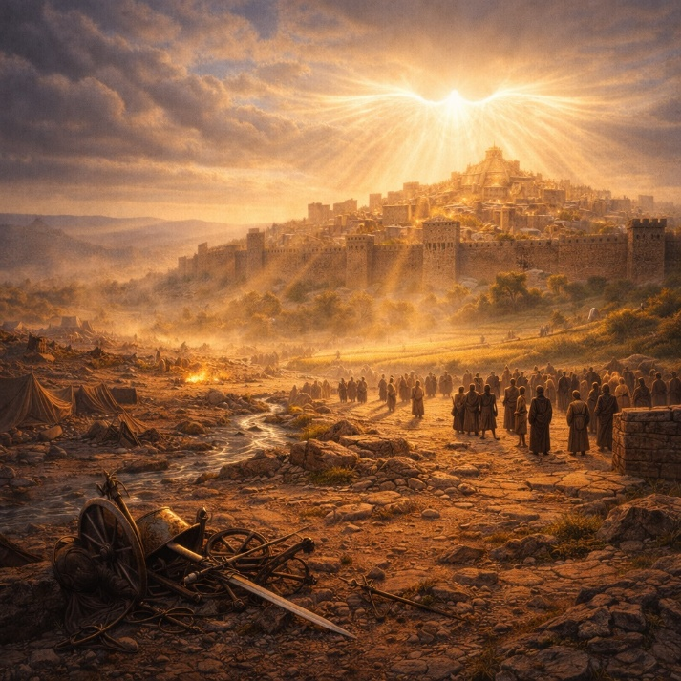
Isaiah 33 opens with a declaration of justice against the destroyer. Those who exploit others without provocation and break trust for gain are warned that the harm they inflict will return upon them. The chapter reflects a moment of crisis, where treachery and violence appear to dominate. In response, God’s people cry out for mercy and strength, acknowledging that deliverance must come from the LORD alone. The tone shifts from accusation to dependence as the community recognizes that human power cannot secure lasting safety.

The chapter then emphasizes God’s active intervention. When He rises, nations scatter and the plans of the violent collapse. The spoils of war are gathered not by the aggressor but by those once threatened. God is portrayed as the source of stability, wisdom, and salvation. True security is described not in military terms but in moral ones—those who walk righteously, speak honestly, reject corruption, and refuse violence will dwell safely. Fear gives way to confidence rooted in integrity and reverence for God.

The final section turns to a vision of restored Zion. Jerusalem is described as a secure and peaceful dwelling, no longer threatened by invading armies. Foreign oppressors fade from sight, and the city’s inhabitants experience forgiveness and healing. God Himself is portrayed as judge, lawgiver, and king, uniting authority, justice, and protection. The imagery closes with abundance and calm, replacing siege and terror. Isaiah 33 affirms that treachery is temporary, but righteousness endures. God’s presence transforms fear into peace and instability into lasting security for those who trust in Him.

Isaiah 34

Opening Scripture Quote (KJV)
“Come near, ye nations, to hear; and hearken, ye people: let the earth hear, and all that is therein; the world, and all things that come forth of it.”

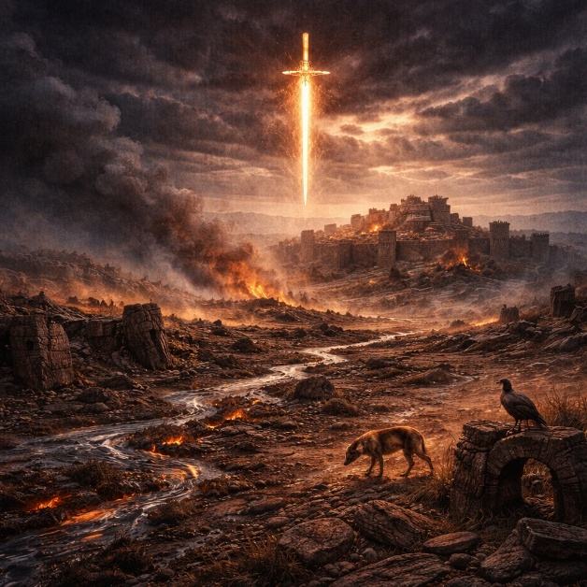
Isaiah 34 is a sweeping declaration of divine judgment directed not at a single nation but at all nations. The chapter opens with a global summons, calling the entire world to witness God’s verdict. What follows is a graphic portrayal of judgment as comprehensive, deliberate, and unavoidable. God’s wrath is described as fully measured, not impulsive, and it falls upon nations that have set themselves against His purposes. The language is stark: slaughter, devastation, and cosmic disturbance emphasize the seriousness of rebellion and the certainty of accountability.

The imagery intensifies as Isaiah focuses on Edom as a representative target of this judgment. Edom becomes a symbol of entrenched hostility and defiance. The land is transformed into a scene of total ruin—streams turned to pitch, soil to burning brimstone, and smoke rising continually. This is not temporary destruction but lasting desolation. The chapter stresses permanence: the land will not recover, and no one will pass through it again. The intent is clear—human pride and opposition to God ultimately result in irreversible collapse.

The chapter closes by emphasizing order and intention behind the devastation. This judgment is not chaos but fulfillment. God’s sword is described as filled and satisfied, underscoring completeness. The ruined land becomes a habitat for wild creatures, reinforcing the theme of abandonment and reversal. What was once inhabited, productive, and defended is now silent and empty. Isaiah 34 serves as a sobering counterbalance to promises of restoration elsewhere in the book. It affirms that while God restores the faithful, He also decisively judges persistent rebellion. The chapter establishes a firm moral boundary in Isaiah’s message: God’s justice is universal, thorough, and final, and no nation stands outside His authority.

Isaiah 35

Opening Scripture Quote (KJV)
“The wilderness and the solitary place shall be glad for them; and the desert shall rejoice, and blossom as the rose.”


Isaiah 35 stands in sharp contrast to the judgment of the previous chapter and presents a vision of complete restoration. Desolation gives way to renewal as the wilderness itself responds to God’s redemptive action. Dry land blossoms, barren places overflow with life, and joy replaces despair. This transformation is not limited to nature; it signals a reversal of fortune for God’s people. What was once marked by fear, loss, and weakness becomes a landscape of abundance, beauty, and celebration. The chapter establishes restoration as intentional and decisive, driven by God’s presence rather than human effort.

The focus then turns to human restoration. Those who were weak, fearful, or broken are strengthened and encouraged. God Himself comes to save, bringing justice against oppression and deliverance for His people. Physical healing accompanies this salvation: the blind see, the deaf hear, the lame walk, and the mute speak. These images communicate more than relief from suffering—they describe a full reversal of conditions that once excluded people from participation and hope. The renewed land is filled with water and life, reinforcing the idea that restoration reaches both body and environment.

The chapter concludes with a clear destination and path. A raised highway appears, set apart and safe, leading directly toward Zion. It is a road free from danger, reserved for the redeemed. No threat interrupts the journey, and no confusion misdirects travelers. Sorrow and sighing disappear as joy and gladness take their place. Isaiah 35 presents restoration as secure, visible, and lasting. It affirms that God does not merely remove judgment; He actively rebuilds what was ruined. The chapter closes this section of Isaiah with assurance: redemption results in joy, healing, and safe return, grounded entirely in God’s faithful action.

Isaiah 36

Opening Scripture Quote (KJV)
“Now it came to pass in the fourteenth year of king Hezekiah, that Sennacherib king of Assyria came up against all the defenced cities of Judah, and took them.”

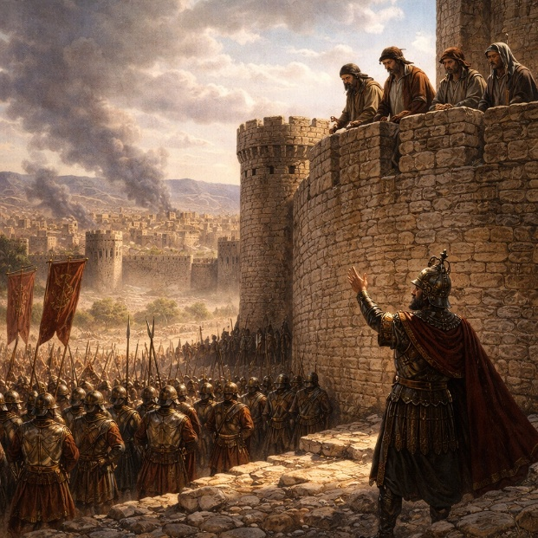
Isaiah 36 shifts the book from prophetic proclamation to historical narrative, placing the reader inside a moment of extreme national crisis. Assyria, the dominant military power of the age, has already overrun Judah’s fortified cities and now threatens Jerusalem itself. King Hezekiah’s reign is tested not by internal reform but by external pressure. The Assyrian army positions itself confidently outside the city, signaling that resistance appears futile. The setting establishes a stark imbalance of power: Jerusalem is isolated, outmatched, and vulnerable.

The central action of the chapter is psychological warfare. The Assyrian spokesman, the Rabshakeh, delivers a calculated speech designed to dismantle Judah’s confidence. He mocks reliance on Egypt, portraying it as a broken reed that cannot support weight. He then challenges trust in the LORD, twisting recent religious reforms into accusations of divine displeasure. Speaking loudly in the Hebrew language, he aims to instill fear directly in the people rather than negotiate quietly with officials. His message is blunt: surrender brings survival; resistance guarantees destruction. The speech blends truth, distortion, and intimidation, showing how power seeks to dominate not only territory but belief.

Hezekiah’s representatives respond with restraint, refusing to engage publicly or escalate the confrontation. They ask that the discussion remain diplomatic, but the Rabshakeh deliberately ignores the request, intensifying his threats and promises. He claims that no god of any nation has been able to resist Assyria and insists that the LORD is no different. The chapter ends without resolution, emphasizing tension rather than outcome. The officials return in silence, their clothes torn in grief, and report the words to Hezekiah. Isaiah 36 establishes the core conflict of the coming chapters: whether Judah will interpret reality through Assyria’s power or through trust in the LORD. The stage is set for a decisive answer to intimidation, fear, and distorted truth.

Isaiah 37

Opening Scripture Quote (KJV)
“And it came to pass, when king Hezekiah heard it, that he rent his clothes, and covered himself with sackcloth, and went into the house of the LORD.”

Isaiah 37 records the turning point in Judah’s crisis with Assyria. After hearing the threats delivered by the Assyrian spokesman, King Hezekiah responds not with strategy but with humility. He tears his clothes, dons sackcloth, and goes into the house of the LORD. Instead of answering intimidation with negotiation or force, he seeks divine counsel. He sends messengers to Isaiah, acknowledging Judah’s helplessness and asking for prayer. The chapter presents this moment as decisive: the crisis shifts from a military standoff to a spiritual appeal.

Isaiah delivers God’s response with clarity and authority. The LORD declares that the Assyrian king’s words are empty arrogance and that the threat against Jerusalem will fail. God announces that Sennacherib will hear a report, withdraw, and eventually fall by the sword in his own land. When Assyria sends another letter reinforcing its threats, Hezekiah brings it directly into the temple and spreads it before the LORD. His prayer openly acknowledges God’s sovereignty over all kingdoms and contrasts lifeless idols with the living God. Hezekiah asks for deliverance not merely for survival, but so that all nations may know that the LORD alone is God.

The chapter concludes with a detailed prophetic judgment against Sennacherib. God exposes the Assyrian king’s pride, reminding him that his power exists only by divine permission. Jerusalem will not be taken, and no arrow will enter the city. God promises to defend it for His own name’s sake. That very night, the Assyrian army is struck down, and the threat collapses without a battle. Sennacherib retreats in humiliation and later dies violently at home. Isaiah 37 demonstrates the contrast between human intimidation and divine authority. Power that mocks God collapses suddenly, while trust expressed in prayer results in decisive deliverance.

Isaiah 38

Opening Scripture Quote (KJV)
“In those days was Hezekiah sick unto death. And Isaiah the prophet the son of Amoz came unto him, and said unto him, Thus saith the LORD, Set thine house in order: for thou shalt die, and not live.”


Isaiah 38 shifts the focus from national deliverance to personal crisis. King Hezekiah, who has just witnessed God’s dramatic rescue of Jerusalem, now faces his own mortality. The message from the LORD is direct and final: prepare for death. Hezekiah responds not with argument or denial, but with deep personal prayer. Turning his face to the wall, he weeps and appeals to God, recalling his faithfulness and sincerity. The chapter highlights the raw vulnerability of a righteous leader confronted with the end of life, showing that even those who trust God deeply still experience fear, grief, and pleading.

God responds swiftly. Before Isaiah has even left the palace grounds, the LORD sends him back with a new word: Hezekiah’s prayer has been heard. Fifteen years will be added to his life, and Jerusalem will continue to be protected from Assyria. A confirming sign is given—the shadow on the sundial moves backward—demonstrating God’s control over time itself. The sign reinforces that the extension of Hezekiah’s life is not chance or delayed fate, but a deliberate act of divine mercy. Healing is also practical: a medicinal remedy is applied, underscoring that God’s intervention works through both miraculous and ordinary means.

The chapter then includes a reflective song written by Hezekiah after his recovery. He describes the despair of facing death, the sense of being cut off, and the silence of the grave. Life, he recognizes, is fragile and fleeting, yet precious. His tone shifts from anguish to gratitude as he acknowledges that God has delivered his soul from death and restored him. The chapter closes with a renewed commitment to praise and public worship. Isaiah 38 presents a balanced view of faith: prayer does not eliminate suffering, but it invites God’s mercy into it. Life is shown as a gift sustained by God’s will, and deliverance—whether from armies or illness—comes from the same sovereign hand.

Isaiah 39

Opening Scripture Quote (KJV)
“At that time Merodachbaladan, the son of Baladan, king of Babylon, sent letters and a present to Hezekiah; for he had heard that he had been sick, and was recovered.”

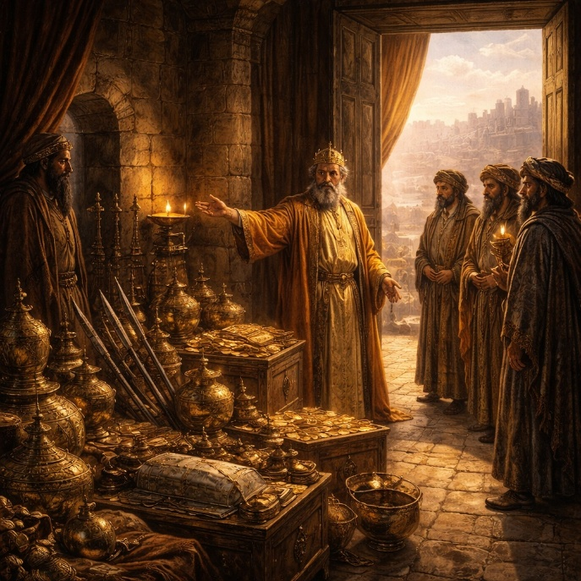
Isaiah 39 records a quiet but consequential failure following Hezekiah’s recovery. Envoys from Babylon arrive with gifts and letters, ostensibly to congratulate the king. Hezekiah welcomes them and, rather than exercising caution or humility, proudly displays his wealth, armory, and treasuries. Nothing is withheld. The chapter emphasizes that this moment is not driven by desperation or threat but by vanity and misplaced confidence. After deliverance and healing, Hezekiah shifts from dependence on God to self-display before foreign powers.

Isaiah confronts Hezekiah directly, asking what the visitors saw and where they came from. Hezekiah answers plainly, admitting that everything in his house was shown. Isaiah then delivers a sobering prophecy: the very wealth and descendants Hezekiah displayed will one day be carried away to Babylon. Some of his sons will become servants in a foreign palace. The judgment is not immediate, but it is certain. The chapter underscores that pride can invite future loss even when present circumstances seem secure.

Hezekiah’s response is restrained and revealing. He accepts the word of the LORD and notes that there will be peace and truth in his days. The statement is not overt rebellion, but it reflects limited concern beyond his own lifetime. Isaiah 39 closes the first major section of the book by shifting the horizon from Assyria to Babylon. It explains why exile will come—not because God failed to save, but because pride followed deliverance. The chapter serves as a bridge from historical rescue to future judgment, reminding the reader that trust must be sustained, not momentary. Blessing does not remove responsibility, and humility remains essential even after victory.

Isaiah 40

Opening Scripture Quote (KJV)
“Comfort ye, comfort ye my people, saith your God.”


Isaiah 40 marks a decisive turn from warning to comfort. The chapter opens with God’s command to speak tenderly to His people, announcing that hardship has been completed and that restoration is underway. A voice calls for preparation, portraying a straightened path through the wilderness as God comes to lead His people home. Human life is described as fragile and temporary, like grass that withers, while God’s word stands firm. This contrast establishes the foundation of hope: circumstances change and people fail, but God’s promises endure.

The chapter then lifts the focus to God’s unmatched greatness. He is portrayed as the Creator who measures the waters, weighs the mountains, and stretches out the heavens. Nations are insignificant by comparison, and rulers rise and fall at His will. Human wisdom cannot advise Him, and crafted idols are exposed as powerless substitutes. Isaiah emphasizes that God is not a distant force but the sovereign Lord who governs all creation with authority and precision. His power is vast, yet deliberate and ordered.

The final section addresses discouragement and weariness. God’s people question whether they have been forgotten, but Isaiah corrects this doubt by declaring that the everlasting God never grows tired or weak. He gives strength to the faint and renews those who wait for Him. Human strength fails, even at its peak, but reliance on the LORD produces endurance beyond natural limits. The chapter closes with a lasting image of renewal: those who trust God rise, persevere, and continue forward without collapse. Isaiah 40 establishes the tone for the next major section of the book—restoration rooted not in human resolve, but in the enduring power, faithfulness, and care of God.

Isaiah 41

Opening Scripture Quote (KJV)
“Keep silence before me, O islands; and let the people renew their strength: let them come near; then let them speak: let us come near together to judgment.”
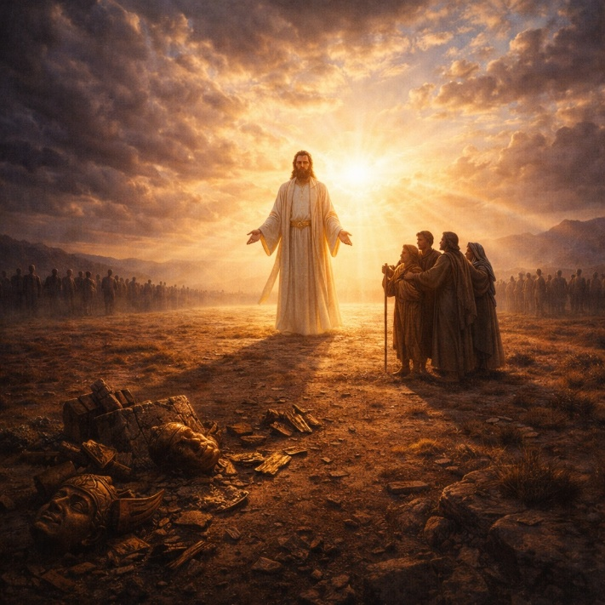
Isaiah 41 opens with a courtroom-like summons to the nations. God calls distant lands to silence and challenges them to consider history itself as evidence of His authority. He points to the rise of a powerful ruler from the east as something He Himself has directed from the beginning. The message is clear: world events do not unfold randomly or by human planning alone. God declares the end from the beginning, demonstrating that His control over nations precedes and surpasses all political power.

The focus then turns to Israel, contrasting fear with assurance. While the nations tremble and turn to idols for reassurance, Israel is reminded of its unique relationship with God. God speaks directly, calling Israel His servant, chosen and upheld. Repeatedly, He commands, “Fear thou not,” emphasizing presence, help, and strength. The chapter portrays God as both protector and sustainer—one who holds His people by the hand, strengthens them, and ensures that those who oppose them will ultimately fail. The imagery is intimate and steady, designed to replace anxiety with confidence rooted in God’s faithfulness.

The final section returns to the issue of idols and false gods. God challenges them to prove their power by declaring future events, but they are exposed as empty and incapable. In contrast, God affirms His ability to announce what is coming and to bring it to pass. The chapter closes by reaffirming that no rival power can match the LORD. Isaiah 41 reinforces a central theme of this section of the book: God alone governs history, sustains His people, and renders all substitutes meaningless. Strength comes not from alliances or crafted objects, but from trust in the One who calls, upholds, and delivers.

Isaiah 42

Opening Scripture Quote (KJV)
“Behold my servant, whom I uphold; mine elect, in whom my soul delighteth; I have put my spirit upon him: he shall bring forth judgment to the Gentiles.”

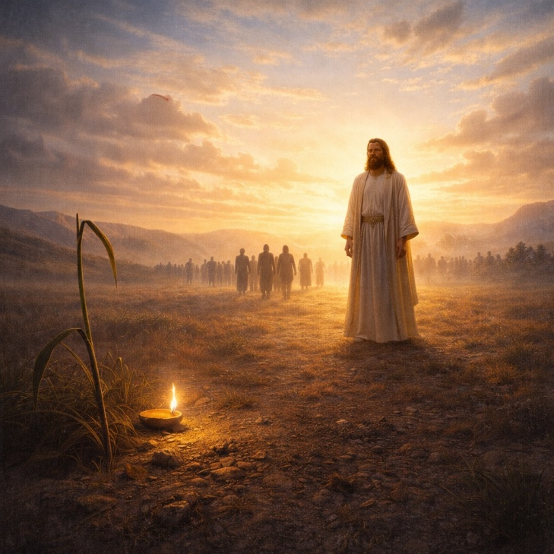
Isaiah 42 introduces a servant chosen and upheld by God, marking a new phase in God’s work of restoration. Unlike rulers who impose power through force, this servant acts with quiet faithfulness. He brings justice without shouting or crushing resistance. The imagery emphasizes gentleness and perseverance: bruised reeds are not broken, and dimly burning wicks are not extinguished. The servant’s mission is steady and deliberate, aimed at establishing justice on the earth rather than gaining attention or dominance. This section highlights God’s commitment to righteousness expressed through humility and endurance.

The chapter expands the servant’s role beyond Israel to the nations. He is appointed as a covenant for the people and a light to those in darkness. Liberation is central to this mission: prisoners are released, blind eyes are opened, and those confined in darkness are brought into light. This work reflects God’s creative power, the same power that formed the heavens and the earth. God declares His uniqueness and refuses to share His glory with idols, reinforcing that this restoration is entirely His work. What is announced is not speculative—God declares new things before they happen, underscoring His authority over history.

The final portion of the chapter shifts tone, confronting Israel’s failure to live as God’s servant. Though chosen and instructed, the people are described as blind and deaf to God’s purposes. Discipline has come, yet understanding has not followed. The contrast is sharp: God’s servant acts faithfully, but God’s people have not listened. Still, the chapter does not end in abandonment. God’s purposes continue despite human failure. Isaiah 42 holds together promise and accountability. God advances justice, light, and deliverance through His servant, while calling His people to recognize their condition and return to attentiveness. The chapter establishes a key theme for what follows: restoration comes through God’s chosen means, not human strength, and faithfulness is defined by obedience, humility, and trust.
Isaiah 43

Opening Scripture Quote (KJV)
“But now thus saith the LORD that created thee, O Jacob, and he that formed thee, O Israel, Fear not: for I have redeemed thee, I have called thee by thy name; thou art mine.”


Isaiah 43 speaks directly to Israel with assurance grounded in God’s prior actions. The chapter opens by anchoring identity in creation and redemption. Israel belongs to the LORD not because of merit, but because He formed, named, and redeemed them. Fear is addressed immediately, not as an abstract emotion but as a response to exile, threat, and loss. God promises presence through danger—waters and fire—indicating that hardship is not denied but will not be allowed to destroy. The emphasis is on ownership and protection: Israel’s survival rests on God’s commitment, not their strength.

The chapter then explains the purpose behind this protection. Israel exists to display God’s glory. God recounts past acts of deliverance and declares that He alone controls history. Other nations are powerless to challenge Him or reverse His will. God contrasts Himself with idols and false witnesses, asserting that He alone foretells events and brings them to pass. Israel is called as a witness, not because of flawless obedience, but because they have seen God act. The LORD declares, “I am he,” stressing continuity—He has always been God, and no force can deliver out of His hand or undo what He does.

The final portion of the chapter combines rebuke with hope. God acknowledges Israel’s failure in worship and obedience, noting that they have wearied Him with sin rather than honoring Him with sacrifice. Yet judgment is not the final word. God declares that He blots out transgressions for His own sake and will not remember their sins. Restoration is presented as a deliberate act of grace, not a reward. Isaiah 43 closes with the tension that defines much of the book: Israel has failed its calling, but God remains faithful to His purpose. Redemption, forgiveness, and renewal come because of who God is, ensuring that Israel’s story does not end in loss but in restored identity and hope.

Isaiah 44

Opening Scripture Quote (KJV)
“Yet now hear, O Jacob my servant; and Israel, whom I have chosen:”
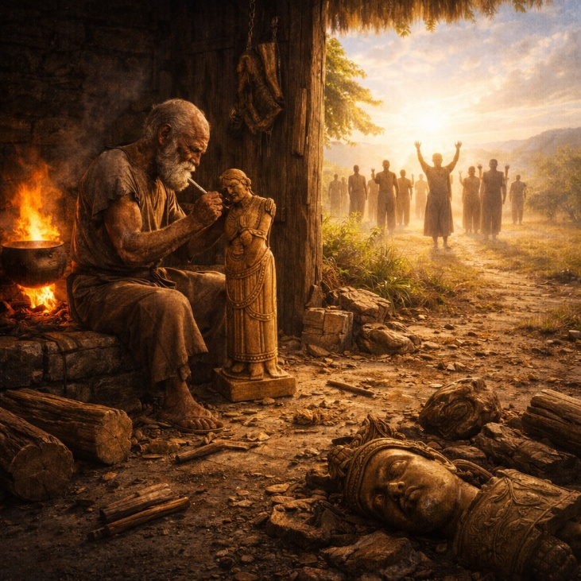
Isaiah 44 speaks assurance to Israel by grounding hope in God’s identity as Creator, Redeemer, and King. The chapter opens with reassurance to a people who have failed yet remain chosen. God emphasizes that Israel’s existence is not accidental or conditional; He formed them and has not forgotten them. Looking ahead, God promises renewal like water poured on dry ground. This imagery points to restored vitality, growth, and continuity, including future generations who will openly identify with the LORD. The tone is stabilizing and forward-looking, reinforcing belonging rather than rejection.

The chapter then moves decisively into a declaration of God’s uniqueness. The LORD identifies Himself as the first and the last, asserting exclusive authority over history and future events. He challenges anyone—human or divine—to demonstrate similar power or foresight. This section establishes a courtroom-like contrast between God and all rivals. God alone declares what is to come and brings it to pass. Israel is reminded that fear is unnecessary because nothing exists outside God’s control. The emphasis is not emotional comfort, but logical certainty rooted in God’s proven actions.

The final portion exposes the emptiness of idolatry with pointed clarity. Isaiah describes the process of crafting an idol from wood: part is used for fuel, part for warmth, and the rest shaped into a god. The absurdity is intentional. Those who worship idols are shown to be self-deceived, trusting something they themselves created. In contrast, God declares that He has blotted out Israel’s sins and redeemed them. The chapter closes with a call for creation itself to rejoice, because God has acted decisively on behalf of His people. Isaiah 44 reinforces a central truth: redemption rests on God’s action, not human invention. False supports collapse under scrutiny, but the LORD remains dependable, active, and present.

Isaiah 45

Opening Scripture Quote (KJV)
“Thus saith the LORD to his anointed, to Cyrus, whose right hand I have holden, to subdue nations before him; and I will loose the loins of kings, to open before him the two leaved gates; and the gates shall not be shut;”
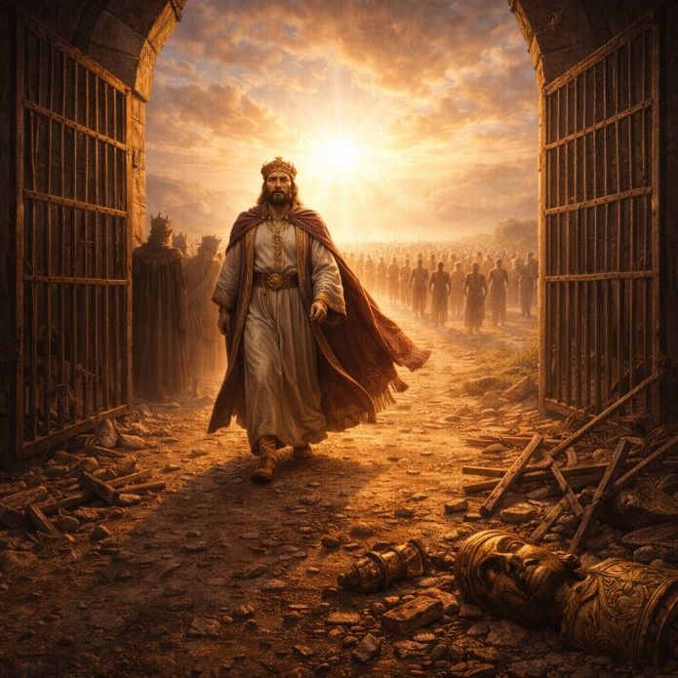
Isaiah 45 declares God’s absolute sovereignty over history by naming Cyrus, a foreign ruler, as His chosen instrument. God makes clear that Cyrus’s rise is not due to chance, skill, or local gods, but because the LORD Himself has grasped his hand and gone before him. Barriers fall, kings are humbled, and hidden wealth is revealed so that God’s purpose may stand. The chapter emphasizes that God acts for the sake of Israel, even when His chosen servant does not yet know Him. History moves according to God’s design, not human awareness.

The chapter then confronts human resistance to divine authority. Isaiah challenges those who question God’s actions, using the image of clay arguing with the potter. Creation has no standing to accuse its Creator. God asserts that He formed the earth with purpose, not chaos, and speaks truth plainly rather than in secrecy. This section reinforces that God’s will is both intentional and intelligible. What He declares, He accomplishes. Light and darkness, peace and calamity all fall within His rule. Nothing operates outside His authority, and nothing surprises Him.

The final portion expands into a universal call. God invites all nations to turn and be saved, declaring that He alone is God and that there is no other. Idols are exposed as powerless, unable to speak or save. God swears by Himself that every knee will bow and every tongue will acknowledge His righteousness. Salvation and strength are found only in the LORD, and shame belongs to those who oppose Him. The chapter closes with assurance for Israel: they will be justified and glory in the LORD. Isaiah 45 stands as one of the clearest affirmations in Scripture of God’s control over rulers, history, creation, and redemption. Deliverance does not depend on nationality, power, or insight, but on the unchallenged will of the one true God.

Isaiah 46

Opening Scripture Quote (KJV)
“Bel boweth down, Nebo stoopeth, their idols were upon the beasts, and upon the cattle: your carriages were heavy loaden; they are a burden to the weary beast.”
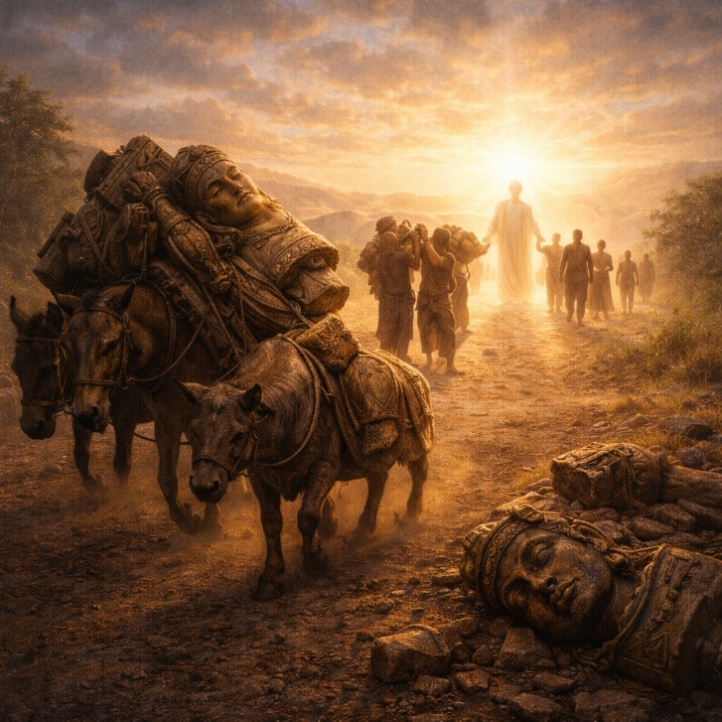
Isaiah 46 opens with a striking image of Babylon’s gods being carried away as heavy cargo. Bel and Nebo, once revered as powerful deities, are shown as lifeless objects strapped onto animals, dependent on human effort for movement and survival. Instead of protecting their worshipers, these idols become burdens that exhaust those who carry them. The scene reverses expectations: what was trusted for security now proves helpless. Isaiah uses this contrast to expose the emptiness of idolatry and the foolishness of relying on what cannot act, speak, or save.

The focus then shifts sharply to the LORD’s relationship with Israel. Unlike idols that must be carried, God declares that He has carried His people from birth and will continue to sustain them into old age. This comparison is central to the chapter. God is not a passive object of devotion but an active sustainer of life. He reminds Israel that no crafted image can compare to Him, because nothing else shares His power, permanence, or purpose. God alone declares the outcome of history from its beginning and ensures that His plans stand. What He intends, He brings to completion.

The chapter closes by addressing those who doubt or delay trusting God. The LORD calls them to remember who He is and to abandon stubborn resistance. He announces that deliverance is already in motion and will not be postponed. Salvation will come to Zion, and God’s glory will be displayed in Israel. Isaiah 46 reinforces a foundational truth of the book: false gods weigh people down, but the LORD carries His people. Human-made objects cannot guide history or secure the future, but God governs time, nations, and redemption with absolute authority. The chapter invites clear-eyed trust—not in what humans make, but in the God who acts, sustains, and fulfills His word.

Isaiah 47

Opening Scripture Quote (KJV)
“Come down, and sit in the dust, O virgin daughter of Babylon, sit on the ground: there is no throne, O daughter of the Chaldeans: for thou shalt no more be called tender and delicate.”

Isaiah 47 announces the complete humiliation of Babylon, portrayed as a proud queen forced into disgrace. Once exalted, luxurious, and secure, Babylon is commanded to leave her throne and sit in the dust like a captive. Images of grinding grain, uncovering nakedness, and forced labor communicate loss of status and exposure. The chapter emphasizes reversal: the city that ruled others will now be ruled, stripped of comfort, dignity, and power. This judgment is presented as certain and irreversible.

The chapter explains why this downfall occurs. Babylon acted with arrogance, cruelty, and false confidence. She showed no mercy, even to the aged, and assumed her dominance would last forever. Her pride rested on secrecy, power, and the belief that no one could see or challenge her actions. Isaiah exposes this mindset directly—Babylon trusted in wickedness, wisdom, and knowledge while dismissing accountability. Her claim, “I am, and none else beside me,” mirrors language reserved for God alone, highlighting the depth of her arrogance.

The final section dismantles Babylon’s false securities. Astrology, sorcery, and occult practices—sources of confidence and guidance—are exposed as useless. When judgment arrives, none of these systems can save her. Disaster comes suddenly and completely, without warning or remedy. The chapter closes with Babylon abandoned, her advisors scattered, unable to help. Isaiah 47 reinforces a core theme of Isaiah: pride invites collapse. Power built on self-exaltation and cruelty cannot endure. God alone governs history, and nations that elevate themselves as untouchable will ultimately be brought low.

Isaiah 48

Opening Scripture Quote (KJV)
“Hear ye this, O house of Jacob, which are called by the name of Israel, and are come forth out of the waters of Judah, which swear by the name of the LORD, and make mention of the God of Israel, but not in truth, nor in righteousness.”
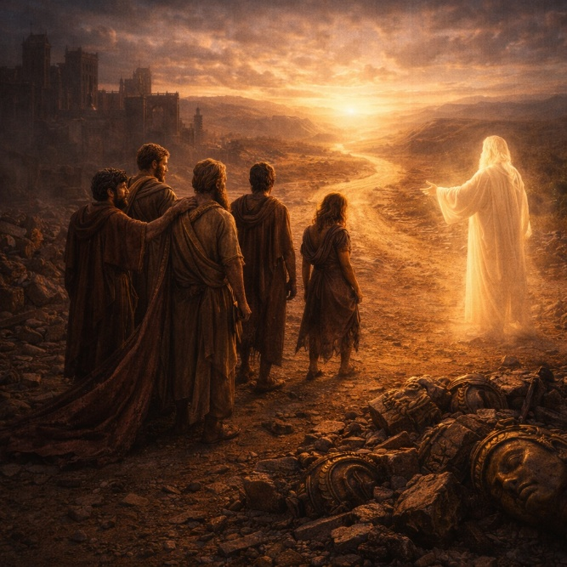
Isaiah 48 confronts Israel with an uncomfortable truth: they claim God’s name, but their loyalty has been stubborn and superficial. God exposes a pattern of resistance, explaining that He declared events long before they happened because He knew Israel would otherwise credit idols or human strength. Their history is marked by rigidity and self-will, described as iron sinews and a brass forehead. God’s foretelling was not to impress, but to remove excuses and reveal that He alone governs outcomes.

The chapter then clarifies why Israel has not been destroyed despite persistent rebellion. God restrains judgment for the sake of His own name. Deliverance is not earned by obedience but granted to preserve God’s reputation and purpose. Isaiah describes Israel as refined, but not with silver—refined in the furnace of affliction. Suffering has shaped them, though not perfected them. God emphasizes that He acts for His own glory and will not allow it to be transferred to idols or false powers. Redemption is rooted in who God is, not who Israel has proven to be.

The chapter concludes by calling Israel to listen and respond. God declares Himself the first and the last, Creator of heaven and earth, and the one who summons Cyrus to accomplish His will. Instruction and peace were always available, but Israel refused to walk in God’s ways. As a result, peace like a river was missed. Still, a clear invitation remains: leave Babylon and proclaim that the LORD has redeemed His servant. The final note is sobering—there is no peace for the wicked. Isaiah 48 closes this section of the book by drawing a firm line between deliverance and defiance. God is faithful, patient, and sovereign, but His salvation does not erase accountability. Blessing flows from listening and trust, not from heritage or habit.

Isaiah 49

Opening Scripture Quote (KJV)
“Listen, O isles, unto me; and hearken, ye people, from far; The LORD hath called me from the womb; from the bowels of my mother hath he made mention of my name.”
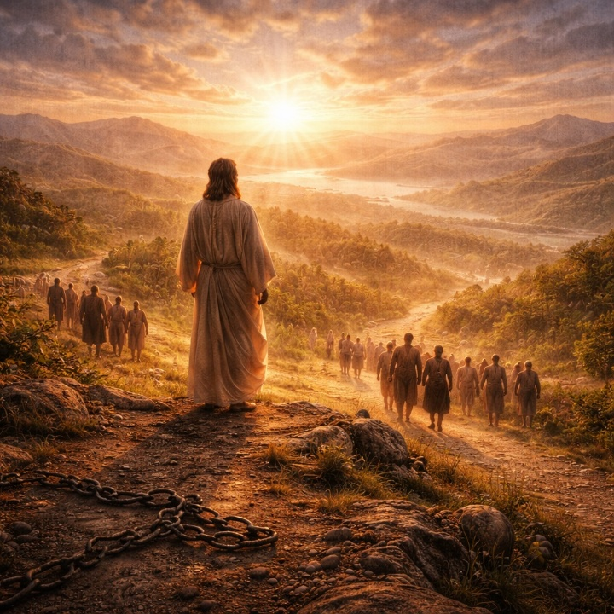
Isaiah 49 introduces a servant who speaks to the distant nations, declaring that his calling began before birth and was directed by the LORD Himself. The servant describes being shaped and prepared for a specific purpose, though his work initially appears unsuccessful. Despite this discouragement, God affirms that the servant’s labor is not wasted. His mission is not limited to restoring Israel alone; it extends outward to the nations. The chapter establishes that God’s plans may unfold beyond visible results, but they are never diminished or abandoned.

The focus then widens to God’s intention to restore and gather His people. The servant is appointed not only to raise up Israel but to be a light to the Gentiles, extending salvation to the ends of the earth. God promises release for captives, guidance for the lost, and provision along the way. The imagery is expansive and compassionate: people return from distant lands, sustained and protected by God’s care. Mountains become pathways, and barriers are removed. This section emphasizes God’s ability to reverse loss and bring scattered people home with dignity and purpose.

The chapter closes with reassurance to a people who feel forgotten. Zion voices fear that the LORD has abandoned her, but God responds with one of the strongest affirmations of faithfulness in the book. He declares that His care surpasses even a mother’s devotion to her child. Israel’s future is secure, inscribed before Him, and her restoration will be visible to all. Former oppressors will fall away, and God’s people will know that He alone is their Savior and Redeemer. Isaiah 49 affirms that God’s promises are not limited by geography, opposition, or time. His servant’s mission is certain, His compassion is enduring, and His restoration is both personal and global.

Isaiah 50

Opening Scripture Quote (KJV)
“Thus saith the LORD, Where is the bill of your mother’s divorcement, whom I have put away? or which of my creditors is it to whom I have sold you? Behold, for your iniquities have ye sold yourselves, and for your transgressions is your mother put away.”
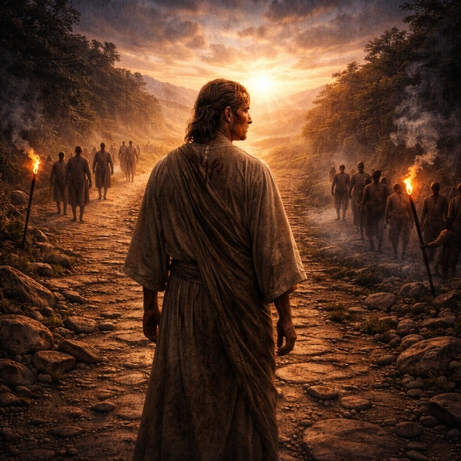
Isaiah 50 addresses Israel’s sense of abandonment by directly challenging the assumption that God has rejected His people. The LORD denies that separation occurred because of weakness or neglect on His part. Instead, Israel’s suffering is traced to its own disobedience. God affirms His continued power and willingness to save, reminding the people that He is fully capable of delivering them, just as He has done in the past. The opening of the chapter reframes the crisis: exile and hardship are not signs of divine failure, but consequences of human rebellion.

The chapter then introduces the voice of the obedient servant. This servant listens attentively to God and speaks with discipline and purpose, offering instruction that sustains the weary. Unlike Israel’s resistance, the servant responds faithfully, even when obedience leads to suffering. He does not resist humiliation or violence but submits without retaliation. The servant’s confidence rests not in circumstances but in God’s help. Though insulted and struck, he remains resolute, certain that God will vindicate him. This section emphasizes faithful obedience under pressure and presents trust in God as active endurance rather than escape from hardship.

The final section contrasts two responses to God. Those who fear the LORD and listen to His servant are called to trust God even when walking through darkness. Faith is portrayed as reliance without visible assurance. In contrast, those who generate their own light—symbolizing self-reliance and defiance—are warned that their chosen path leads to sorrow. The chapter closes with a sober reminder that false security brings real consequences. Isaiah 50 reinforces a central theme of this section of the book: God has not withdrawn His power or purpose. The question is not whether God is faithful, but whether His people will listen. Deliverance belongs to those who trust God’s word, while self-made solutions ultimately fail.

Isaiah 51

Opening Scripture Quote (KJV)
“Hearken to me, ye that follow after righteousness, ye that seek the LORD: look unto the rock whence ye are hewn, and to the hole of the pit whence ye are digged.”
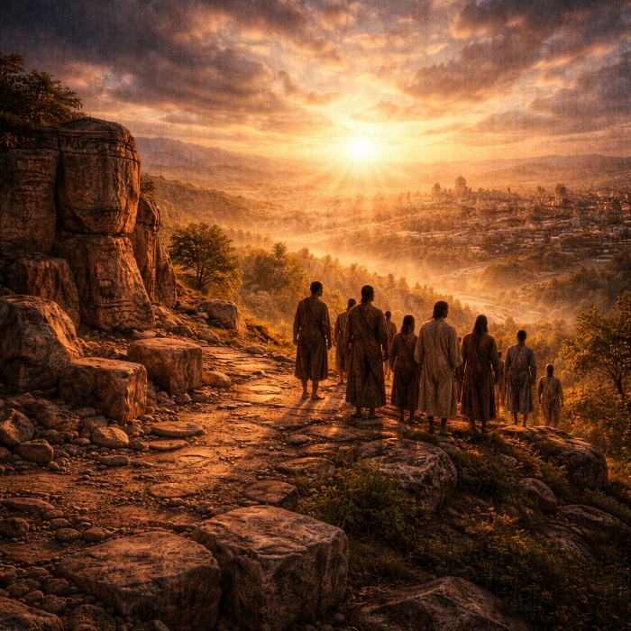
Isaiah 51 addresses a people seeking righteousness while living under pressure and loss. The chapter opens by calling them to remember their origins. God points them back to Abraham and Sarah, emphasizing that their existence as a people began with one man and one woman whom God blessed and multiplied. This reminder reframes their present weakness. Their survival and future do not depend on numbers, power, or circumstance, but on God’s proven ability to create life and hope from barrenness. Restoration is presented as intentional, not accidental.

The chapter then widens in scope, shifting from Israel’s past to God’s global purpose. God declares that His law and justice will reach the nations, bringing light and order. Human systems are described as temporary: the heavens will fade, the earth will wear out, and its inhabitants will pass away. In contrast, God’s salvation is enduring. This contrast establishes perspective. Fear of human opposition is misplaced because human power is brief, while God’s righteousness is permanent. The people are urged to stop fearing reproach and to trust what lasts.

The final section becomes more urgent and poetic. Israel cries out for God to act as He did in the past, recalling the defeat of chaos and the deliverance from bondage. God responds by reaffirming His identity as Creator and Sustainer. He places His words in the mouths of His people and promises comfort. Jerusalem is portrayed as having drunk deeply from judgment, staggering under its weight. Yet that cup is about to be removed. God will transfer it to those who oppressed His people. The chapter closes with reassurance: sorrow and oppression are not permanent conditions. Isaiah 51 presents hope rooted in memory, perspective, and promise. God’s past faithfulness guarantees future restoration, and His salvation remains steady even as the world itself changes.

Isaiah 52

Opening Scripture Quote (KJV)
“Awake, awake; put on thy strength, O Zion; put on thy beautiful garments, O Jerusalem, the holy city: for henceforth there shall no more come into thee the uncircumcised and the unclean.”

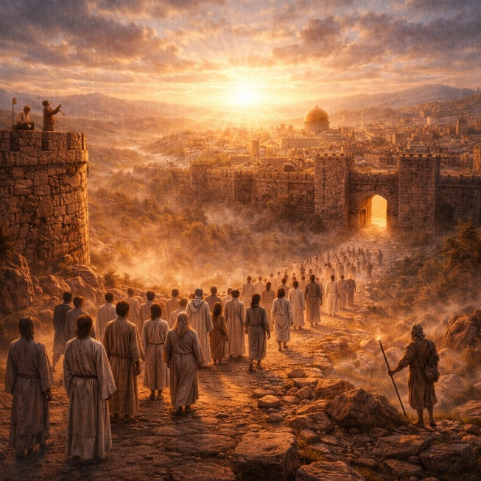
Isaiah 52 opens with a call to Jerusalem to awaken from humiliation and despair. The city is personified as having sat in the dust, bound and weakened, but is now commanded to rise, clothe itself in strength, and reclaim dignity. This awakening is not self-generated; it responds to God’s decisive action. The chapter recalls how Israel was previously oppressed without cause and emphasizes that their suffering did not benefit their oppressors. God declares that His name has been continually dishonored because of Israel’s captivity, and He now acts to reverse that condition. Deliverance is framed as restoration of identity, not merely escape from hardship.

The chapter then shifts to the announcement of salvation. Messengers are described running across mountains, proclaiming peace, good news, and God’s reign. Jerusalem’s watchmen lift their voices together as they see clearly that the LORD is returning to Zion. The imagery emphasizes visibility and certainty—this is not secret or symbolic deliverance, but public and unmistakable. God bares His holy arm before all nations, showing that salvation is both powerful and observable. What happens to Israel becomes a witness to the world, demonstrating God’s sovereignty and faithfulness.

The final section issues a call to separation and purity. Those leaving captivity are instructed to depart cleanly, without clinging to what defiled them. God’s presence will go before them and also guard their rear, emphasizing complete protection. The chapter closes by introducing the servant who will act wisely and be lifted up, though his path will involve astonishment and suffering. This transition prepares for the detailed focus of the next chapter without explaining it fully here. Isaiah 52 therefore functions as a hinge: it proclaims restored dignity, public redemption, and ordered departure, while signaling that salvation will be accomplished through a servant whose work will reshape expectations. The chapter underscores that God’s deliverance is intentional, visible, and rooted in His own authority.
Isaiah 53

Opening Scripture Quote (KJV)
“Who hath believed our report? and to whom is the arm of the LORD revealed?”

Isaiah 53 presents the suffering of the servant in stark and deliberate detail. The chapter opens by acknowledging disbelief—what is described seems unexpected and difficult to accept. The servant appears ordinary and unremarkable, lacking outward majesty or visible power. He is rejected and misunderstood, described as a man acquainted with grief. Instead of being honored, he is despised. The initial impression is weakness and failure, not triumph. This contrast establishes the central tension of the chapter: appearances do not reflect reality.

The focus then shifts to the purpose of the servant’s suffering. What others assumed was personal punishment is revealed to be substitution. He bears griefs not his own and carries sorrows belonging to others. The language emphasizes exchange—he is wounded for transgressions and bruised for iniquities that are not his. The chapter stresses human responsibility, stating that “all we like sheep have gone astray.” The servant accepts affliction silently, offering no resistance or protest. He is compared to a lamb led to slaughter, underscoring innocence and submission. Though cut off from the land of the living, his suffering is described as deliberate rather than accidental.

The final section moves from suffering to outcome. Despite being buried among the wicked and rich, the servant’s story does not end in defeat. His life becomes an offering for sin, and through his suffering many are accounted righteous. The LORD’s purpose prospers through him. The chapter closes with reversal and vindication. Because he bore sin and made intercession for transgressors, he is allotted a portion among the great. Isaiah 53 stands as one of the most concentrated portrayals of redemptive suffering in Scripture. It presents suffering not as meaningless tragedy, but as purposeful, bearing consequences on behalf of others. Rejection leads to restoration, and affliction becomes the path to justification.

Isaiah 54

Opening Scripture Quote (KJV)
“Sing, O barren, thou that didst not bear; break forth into singing, and cry aloud, thou that didst not travail with child: for more are the children of the desolate than the children of the married wife, saith the LORD.”

Isaiah 54 follows the suffering described in the previous chapter with a powerful promise of restoration and expansion. The imagery begins with a barren woman suddenly called to rejoice. What once symbolized shame and emptiness now becomes a sign of unexpected increase. The chapter urges enlargement—stretching tents, strengthening stakes, preparing for growth. The message is clear: desolation will not define the future. What seemed finished or fruitless will overflow. Restoration is not partial but expansive, reaching beyond previous limits.

The chapter then shifts to covenant language. Israel is portrayed as a wife who experienced abandonment, yet not permanent rejection. God describes His anger as momentary but His mercy as enduring. The separation was brief compared to everlasting kindness. This reassurance reframes exile and discipline as temporary within a larger relationship grounded in covenant faithfulness. God declares Himself Redeemer and Maker, emphasizing that His authority and compassion extend over all the earth. The comparison to the days of Noah reinforces permanence—just as the floodwaters would not return to destroy the earth, so God’s covenant of peace will not be removed.

The final section describes the security and beauty of restored Jerusalem. The city is pictured with foundations laid in precious stones and walls built with splendor. More important than physical strength is moral stability: righteousness will establish peace. Oppression and fear will be far removed. Though enemies may gather, they will not prevail because they are not sent by God. The chapter closes with a firm promise that no weapon formed against God’s servants will ultimately succeed. Isaiah 54 presents restoration as relational, structural, and secure. Shame gives way to honor, fear to stability, and loss to abundance. The foundation of this renewal is not human resilience, but God’s enduring covenant love.

Isaiah 55

Opening Scripture Quote (KJV)
“Ho, every one that thirsteth, come ye to the waters, and he that hath no money; come ye, buy, and eat; yea, come, buy wine and milk without money and without price.”

Isaiah 55 extends an open invitation grounded in grace rather than merit. The chapter begins with a call to those who are thirsty and unable to pay. Provision is offered freely—water, wine, and milk without cost. The emphasis is not on economic exchange but on response. The people are urged to listen carefully and to incline their ears. Satisfaction is found not in pursuing what fails to nourish, but in receiving what God provides. The invitation presents restoration as accessible and generous, not restricted to the worthy or powerful.

The chapter then connects this invitation to covenant promise. God speaks of an everlasting covenant rooted in the “sure mercies of David.” This recalls enduring faithfulness rather than temporary relief. The scope widens beyond Israel to include nations who will respond to God’s call. What once seemed exclusive becomes expansive. The chapter urges repentance, calling the wicked to forsake their way and the unrighteous their thoughts. Forgiveness is assured because God’s mercy is abundant. The central contrast appears here: human thoughts and plans are limited, but God’s ways are higher and beyond comparison. Restoration requires turning from self-direction to divine instruction.

The final section uses the imagery of rain and snow watering the earth. Just as precipitation fulfills its purpose by producing growth, so God’s word accomplishes what He intends. It does not return empty. The result is joy and peace; creation itself is pictured responding with celebration as mountains sing and trees clap their hands. Thorn and briar are replaced with lasting growth, signaling transformation at both personal and environmental levels. Isaiah 55 concludes this invitation with assurance: God’s promise is effective, generous, and purposeful. Renewal is not hypothetical—it is guaranteed by the character and word of God.

Isaiah 56

Opening Scripture Quote (KJV)
“Thus saith the LORD, Keep ye judgment, and do justice: for my salvation is near to come, and my righteousness to be revealed.”

Isaiah 56 opens with a call to practical righteousness. God urges His people to practice justice and uphold what is right because His salvation is near. Obedience is not abstract; it is expressed through integrity and faithful observance. The chapter emphasizes that blessing accompanies those who hold firmly to God’s covenant, including honoring the Sabbath and choosing what pleases Him. Faithfulness is presented as active loyalty rather than inherited status.

The chapter then broadens the scope of inclusion. Foreigners who join themselves to the LORD and commit to His covenant are promised a place within His house. Likewise, eunuchs—once excluded from full participation—are assured a lasting name and memorial better than sons and daughters. God’s house is declared to be “an house of prayer for all people.” This statement marks a widening of the covenant community beyond ethnic boundaries. Belonging is defined by devotion and obedience rather than lineage.

The final section shifts sharply in tone, addressing Israel’s leaders. Watchmen are described as blind, ignorant, and self-serving. Instead of guarding the people, they seek personal gain and indulge in complacency. Their failure contributes to moral decay and vulnerability. Isaiah 56 therefore holds two realities together: expansive mercy and necessary accountability. God’s salvation welcomes the faithful from every background, yet leadership and responsibility remain serious. The chapter affirms that justice and devotion prepare the way for salvation, while negligence and corruption invite decline. God’s covenant is open, but it demands integrity.

Isaiah 57

Opening Scripture Quote (KJV)
“The righteous perisheth, and no man layeth it to heart: and merciful men are taken away, none considering that the righteous is taken away from the evil to come.”


Isaiah 57 begins by addressing the death of the righteous and the lack of understanding surrounding it. While society overlooks their passing, God presents their removal as protection from coming harm. In contrast, those who pursue corruption and idolatry are exposed for their practices. The chapter describes spiritual unfaithfulness using vivid imagery of betrayal and misplaced devotion. High places, secret rituals, and alliances with foreign powers symbolize trust placed in anything but God. The tone is direct: persistent rebellion leads to moral and spiritual exhaustion.

The chapter continues by confronting Israel’s false confidence. The people pursue political and spiritual compromises, traveling far in search of security, yet never finding lasting rest. They fear human powers more than God and adjust their loyalty accordingly. Despite warnings, they persist without reflection. God declares that exposure will come, and false protections will fail. When crisis arrives, the idols and alliances trusted for safety will prove powerless.

Yet the chapter does not end with judgment alone. God declares His dwelling place as both high and holy, yet also with the contrite and humble. Restoration is offered to those who turn back sincerely. Though anger was real, it was not permanent. God promises healing, guidance, and renewed comfort for those who respond. Peace is extended to those near and far who return, but a final distinction remains: “There is no peace, saith my God, to the wicked.” Isaiah 57 balances accountability with mercy. It warns against persistent rebellion while affirming that humility opens the way to restoration. God’s holiness does not prevent compassion, but it does require repentance.

Isaiah 58

Opening Scripture Quote (KJV)
“Cry aloud, spare not, lift up thy voice like a trumpet, and shew my people their transgression, and the house of Jacob their sins.”

Isaiah 58 confronts the disconnect between outward religious practice and inward obedience. The people appear eager to seek God, observing fasts and religious rituals, yet they question why their efforts go unnoticed. God responds by exposing the inconsistency: while fasting, they continue injustice, conflict, and exploitation. Religious observance without ethical integrity is rejected. The chapter emphasizes that ritual does not replace righteousness. Devotion is measured not by visible austerity but by how people treat one another.

The chapter then defines the fast God chooses. True worship includes loosening the bonds of wickedness, freeing the oppressed, sharing bread with the hungry, housing the poor, and clothing the naked. Compassion and justice are central. When obedience reflects mercy, light breaks forth like dawn and healing follows. God’s presence accompanies those who align worship with action. Restoration is described as both personal and communal, with broken foundations rebuilt and paths restored for dwelling. Faith becomes tangible through care for others.

The final section addresses honoring the Sabbath as an expression of delight rather than burden. The Sabbath is not merely a restriction but a sign of trust and alignment with God’s purposes. When treated with reverence and joy, it becomes a source of blessing. Isaiah 58 concludes by linking obedience with renewal: when worship flows from justice and compassion, guidance and satisfaction follow. The chapter presents a clear standard—God values integrity over appearance, mercy over ritual, and justice over display. True devotion transforms both individual conduct and community life.
Isaiah 59

Opening Scripture Quote (KJV)
“Behold, the LORD’S hand is not shortened, that it cannot save; neither his ear heavy, that it cannot hear:”


Isaiah 59 begins by correcting a false assumption. The problem is not that God lacks power or attentiveness; it is that sin has created separation. The people’s wrongdoing has built a barrier between them and God. The chapter details widespread injustice—violence, dishonesty, and corruption are described as common practice. Truth has fallen in the streets, and fairness is absent from public life. The imagery presents a society unraveling from within, where personal conduct and public systems both reflect moral failure.

The middle section deepens the diagnosis. The people acknowledge confusion and instability, describing themselves as blind and groping in darkness. Efforts to secure peace produce only trouble. Justice is distant, and righteousness seems unreachable. The chapter emphasizes that the crisis is comprehensive—thoughts, words, and actions all contribute. This is not isolated wrongdoing but a culture shaped by deceit and exploitation. Recognition of guilt becomes the turning point, as confession replaces denial.

The final section shifts from human failure to divine action. Seeing that no one intervenes, God Himself acts. He puts on righteousness like armor and brings salvation through His own strength. Judgment falls on adversaries, and redemption is promised to those who turn from transgression. The chapter closes with a covenant promise: God’s Spirit and His words will remain with His people from generation to generation. Isaiah 59 presents both accountability and hope. Sin causes real separation and societal breakdown, but God’s power to save remains intact. Restoration comes not through human reform alone, but through divine intervention and covenant faithfulness.

Isaiah 60

Opening Scripture Quote (KJV)
“Arise, shine; for thy light is come, and the glory of the LORD is risen upon thee.”


Isaiah 60 opens with a call to rise and reflect divine light. Darkness covers the earth, yet the glory of the LORD rises upon Zion. The contrast is immediate and dramatic: while surrounding nations remain in shadow, Jerusalem becomes a center of illumination. This light is not self-generated; it is the visible presence of God transforming the city’s identity and purpose. Nations are drawn toward it, and kings respond to its brightness. The chapter establishes restoration not as private recovery but as public transformation visible to the world.

The middle section describes the gathering of wealth, people, and honor from distant lands. Sons and daughters return, caravans arrive, ships bring abundance, and foreign nations contribute to rebuilding. What once oppressed now serves. Gates remain open continually, symbolizing peace and secure prosperity. The language is expansive and triumphant, yet its foundation remains God’s action. Zion’s former affliction is replaced with dignity and strength. The city becomes known as the place of the LORD’s presence, reflecting both justice and blessing.

The final portion deepens the imagery from physical restoration to enduring stability. Violence and destruction are removed from within its borders. God Himself becomes the city’s everlasting light, replacing sun and moon as symbols of temporary illumination. Mourning ends, righteousness flourishes, and the people inherit the land securely. Growth multiplies from even the smallest beginning, because the LORD hastens it in His time. Isaiah 60 presents restoration as radiant, secure, and expansive. The chapter emphasizes that true glory comes from God’s presence, and when He rises upon His people, darkness cannot prevail.

Isaiah 61

Opening Scripture Quote (KJV)
“The Spirit of the Lord God is upon me; because the Lord hath anointed me to preach good tidings unto the meek; he hath sent me to bind up the brokenhearted, to proclaim liberty to the captives, and the opening of the prison to them that are bound;”

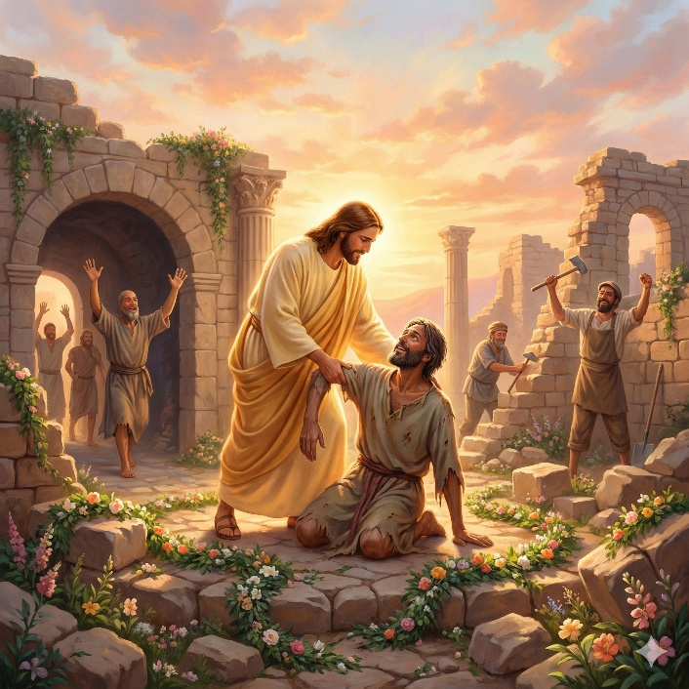
Isaiah 61 opens with a declaration of divine anointing and purpose. The speaker describes being empowered by the Spirit of the Lord to bring good news to the meek, healing to the brokenhearted, and freedom to captives. This mission includes proclaiming “the acceptable year of the Lord” and announcing comfort to those who mourn. The focus is on restoration after deep loss. Those who grieve in Zion are promised beauty instead of ashes, joy instead of mourning, and praise instead of heaviness. They will be called “trees of righteousness,” firmly planted to display the Lord’s glory.

The chapter moves from personal restoration to communal rebuilding. Ruins that have stood for generations will be repaired. Strangers will assist in tending flocks and fields, while the restored people are identified as “the Priests of the Lord” and “the Ministers of our God.” Instead of shame, they will receive double honor and lasting joy. The Lord affirms His love of judgment and His hatred of robbery and wrongdoing. He promises to direct their work in truth and establish an everlasting covenant with them. Their descendants will be recognized among the nations as a people blessed by the Lord.

The chapter concludes with a voice of rejoicing. The speaker expresses deep joy in the Lord, using the imagery of garments of salvation and a robe of righteousness. The comparison is made to a bridegroom adorned for marriage and a bride decorated with jewels, emphasizing beauty, celebration, and public honor. Just as the earth brings forth its plants and a garden causes seeds to grow, so the Lord will cause righteousness and praise to spring up before all nations. The chapter presents a complete picture of renewal: personal healing, national restoration, covenant faithfulness, and visible righteousness that extends beyond Israel to the wider world.

Isaiah 62

Opening Scripture Quote (KJV)
“For Zion's sake will I not hold my peace, and for Jerusalem's sake I will not rest, until the righteousness thereof go forth as brightness, and the salvation thereof as a lamp that burneth.”
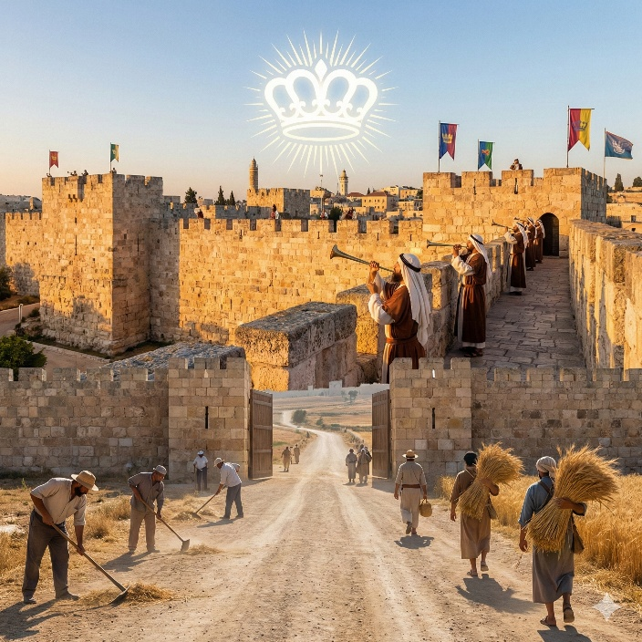
Isaiah 62 presents a determined commitment to the restoration and honor of Zion. The speaker declares that he will not remain silent until Jerusalem’s righteousness shines brightly and her salvation is clearly visible. The nations will witness her transformation, and kings will see her glory. She will receive “a new name” given by the Lord, marking a change in identity and status. Instead of being abandoned or desolate, she will be treasured and openly favored. The imagery of brightness and burning light emphasizes that this renewal will be public and unmistakable.

The chapter describes Zion as a crown of glory and a royal diadem in the hand of the Lord. Her former names of rejection will be replaced with names that signify delight and belonging. The relationship between the Lord and Jerusalem is portrayed in terms of covenant joy, like a bridegroom rejoicing over his bride. Watchmen are appointed on her walls, instructed never to keep silent day or night as they remind the Lord of His promises. Their continual intercession highlights vigilance and expectation, pressing toward the fulfillment of what has been spoken.

In the latter part of the chapter, the Lord swears by His own strength that the people will no longer lose the fruit of their labor to enemies. Those who gather the harvest will eat it in peace and praise the Lord within His courts. A call goes out to prepare the way, build up the highway, remove obstacles, and lift up a standard for the people. The proclamation reaches to the ends of the earth: salvation is coming, and reward is with Him. The restored people will be called “The holy people” and “The redeemed of the Lord,” and Jerusalem will be known as “Sought out, A city not forsaken.” The chapter centers on public vindication, covenant joy, and a permanent reversal of abandonment.

Isaiah 63

Opening Scripture Quote (KJV)
“Who is this that cometh from Edom, with dyed garments from Bozrah? this that is glorious in his apparel, travelling in the greatness of his strength? I that speak in righteousness, mighty to save.”

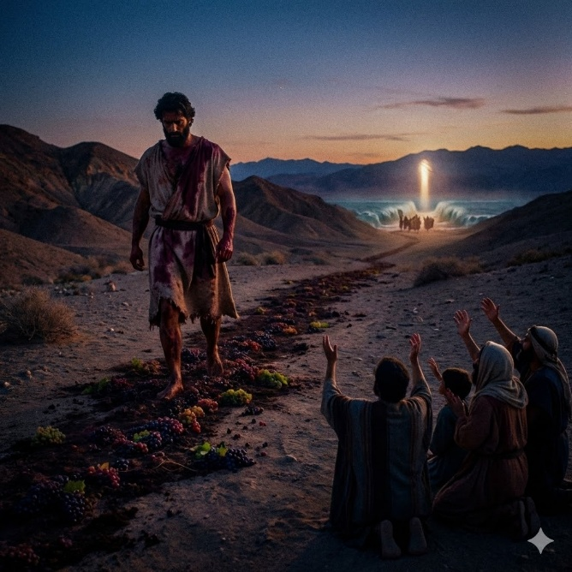
Isaiah 63 opens with a striking image of a powerful figure coming from Edom, his garments stained as though he has trodden a winepress. The dialogue reveals that he has acted alone, executing judgment upon the nations in anger and strength. The imagery is vivid and forceful: garments marked with red, a winepress trodden without assistance, and the day of vengeance paired with the year of redemption. Justice and salvation appear together. The one who speaks is described as righteous and mighty to save, yet also determined to carry out judgment when the time appointed has come.

The tone then shifts from judgment to remembrance. The speaker recalls “the lovingkindnesses of the Lord” and His many acts of mercy toward the house of Israel. God identified them as His people and became their Savior. In their affliction He was afflicted, and “the angel of his presence saved them.” He redeemed them, bore them, and carried them through former times. Yet the people rebelled and vexed His holy Spirit, turning Him from protector to adversary. Even so, they remembered the days of Moses, the deliverance through the sea, and the guidance of the Spirit who led them like a shepherd leading his flock.

The chapter closes as a communal prayer rising from distress. The people look down from heaven and ask where God’s zeal and strength now are. They appeal to Him as Father and Redeemer, acknowledging that though Abraham and Israel might not recognize them, the Lord remains their true Father. They confess their waywardness and the hardening of their hearts, asking Him to return for the sake of His servants. The chapter ends with a plea rooted in covenant identity, contrasting past glory with present desolation and seeking renewed mercy. Isaiah 63 therefore combines vivid judgment, remembered mercy, and earnest supplication.

Isaiah 64

Opening Scripture Quote (KJV)
“Oh that thou wouldest rend the heavens, that thou wouldest come down, that the mountains might flow down at thy presence,”
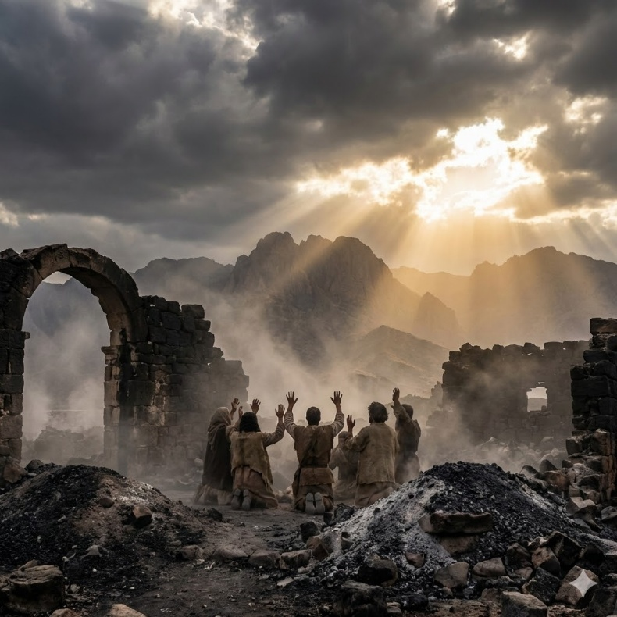
Isaiah 64 is a prayer that pleads for God to act decisively and visibly. The opening cry asks that the heavens be torn open and that the Lord come down in power, causing the mountains to shake. The imagery recalls past moments when God acted in ways that made nations tremble. The request is not merely for comfort, but for unmistakable intervention. The people long for God’s presence to be revealed so clearly that adversaries would recognize His name and authority. The chapter acknowledges that when God works, He does so on behalf of those who wait for Him.

The prayer moves into confession. It admits that God meets those who rejoice and practice righteousness, yet the people have sinned and continued in wrongdoing. Their condition is described in stark terms: “we are all as an unclean thing, and all our righteousnesses are as filthy rags.” Their iniquities have carried them away like the wind. There is an absence of spiritual urgency; few call upon God’s name or stir themselves to seek Him. As a result, they feel hidden from His face and consumed because of their sins. The tone is humble and direct, recognizing both personal and collective guilt.

The chapter concludes by appealing to God as Father and Creator. The people compare themselves to clay and Him to the potter, acknowledging that they are the work of His hands. They ask that He not be exceedingly angry or remember iniquity forever. The desolation of their holy cities and the ruined state of Jerusalem and the temple are laid before Him. What was once praised and beautiful has been burned and left in rubble. The final plea questions whether He will remain silent in the face of such devastation. Isaiah 64 stands as a candid prayer for mercy, grounded in confession and dependence on God’s sovereign power.

Isaiah 65

Opening Scripture Quote (KJV)
“I am sought of them that asked not for me; I am found of them that sought me not: I said, Behold me, behold me, unto a nation that was not called by my name.”

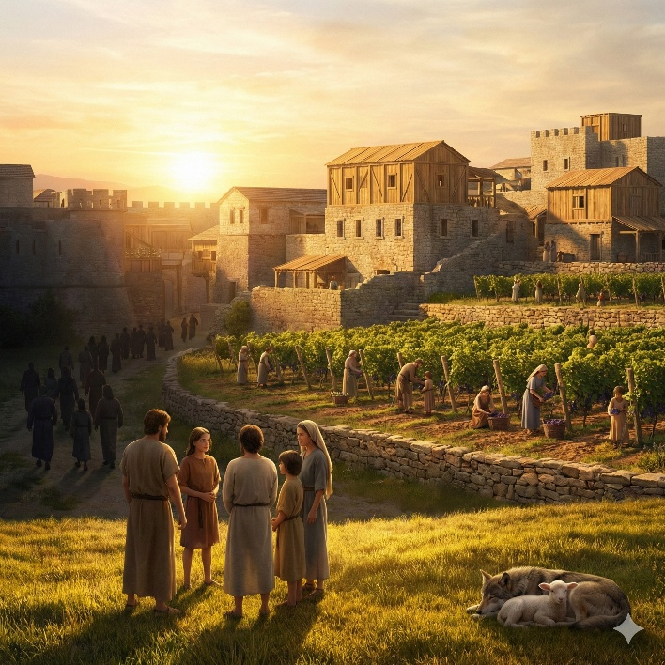
Isaiah 65 begins with the Lord describing how He revealed Himself to those who were not previously seeking Him, even to a nation not called by His name. At the same time, He stretches out His hands all day to a rebellious people who walk in ways that are not good, following their own thoughts. The chapter details behaviors that provoke Him: idolatrous practices, rituals in gardens, and reliance on false forms of spiritual security. The people claim holiness while engaging in actions that defile. In response, the Lord declares that He will not remain silent but will repay their iniquities. Judgment is portrayed as measured and deliberate, based on accumulated wrongdoing.

Yet the chapter also introduces a distinction between the rebellious and the faithful remnant. Using the image of new wine found in a cluster of grapes, the Lord says He will not destroy all for the sake of His servants. From Jacob will come a seed, and from Judah an inheritor of His mountains. Those chosen will possess the land, and places once barren will become pasturelands for His people. In contrast, those who forsake the Lord and forget His holy mountain will face sword and hunger, while His servants will eat, drink, and rejoice. The contrast is sharp: blessing for those who serve Him, shame for those who persist in rebellion.

The final portion of the chapter presents a vision of dramatic renewal. The Lord announces the creation of “new heavens and a new earth,” where former troubles will not be remembered. Jerusalem is described as a joy, and her people as a rejoicing. The sound of weeping will cease. Longevity, stability, and fruitful labor characterize this restored order; houses will be inhabited by their builders, and vineyards enjoyed by those who plant them. Harmony extends even to nature, where the wolf and the lamb feed together. The chapter closes with a picture of peace under divine rule, contrasting the consequences of rebellion with the enduring blessings of restoration.

Isaiah 66

Opening Scripture Quote (KJV)
“Thus saith the Lord, The heaven is my throne, and the earth is my footstool: where is the house that ye build unto me? and where is the place of my rest?”

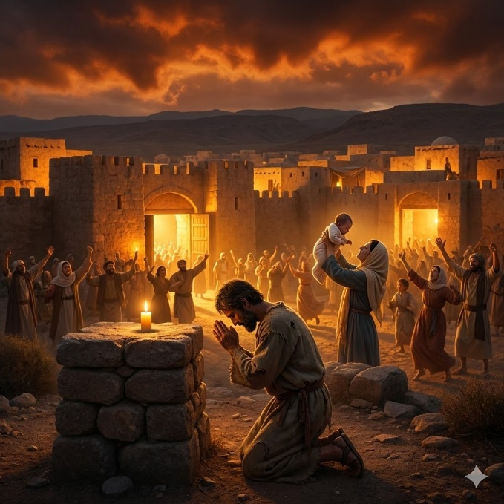
Isaiah 66 opens with a declaration of God’s sovereignty over heaven and earth. He questions the adequacy of any human-built structure to contain Him. While temples and offerings are outward expressions of worship, the Lord identifies the kind of person He truly regards: one who is poor and of a contrite spirit, and who trembles at His word. In contrast, those who perform sacrifices while persisting in disobedience are compared to those who commit grave offenses. The chapter exposes the emptiness of ritual without reverence and warns that self-chosen ways will bring consequences. God’s response to insincere worship is not approval but judgment.

The focus then shifts to Zion and the promise of sudden restoration. The imagery is striking: a woman giving birth before labor pains fully come, symbolizing rapid and unexpected renewal. Jerusalem is portrayed as a mother who brings forth children in a single day, a sign of divine intervention. Those who love her are called to rejoice and share in her comfort and abundance. Peace will flow to her like a river, and the glory of the nations like a stream. The Lord promises to extend comfort as a mother comforts her child, bringing joy to those who see this restoration. At the same time, His indignation will be revealed toward His enemies, and His coming will be marked by fire and judgment.

The chapter concludes with a global perspective. The Lord announces that He will gather all nations and tongues to see His glory. Some survivors will be sent as witnesses to distant lands, declaring His fame among those who have not heard of Him. From the nations, offerings will be brought to Jerusalem, and some will be taken as priests and Levites. The promise of “new heavens and a new earth” is reaffirmed, emphasizing enduring stability. Yet the closing image is sobering: a final distinction between the faithful and those who rebel, underscoring both the permanence of divine restoration and the seriousness of judgment. Isaiah 66 ends with a vision that spans sovereignty, renewal, and ultimate accountability.

