Jeremiah

The Book of Jeremiah records the ministry of the prophet Jeremiah during the final decades of the kingdom of Judah, leading up to and including the fall of Jerusalem to Babylon in 586 BC. Jeremiah was called to speak during a time of political instability, moral decline, and spiritual corruption. His message consistently warned that Judah’s persistent idolatry, injustice, and false confidence in the temple would bring judgment. Though he pleaded for repentance, the nation largely refused to listen. Leaders, priests, and prophets are repeatedly confronted for misleading the people with promises of peace when destruction was near. Jeremiah endured rejection, imprisonment, and public humiliation for delivering an unpopular message of coming exile.

A major theme of the book is covenant failure. Jeremiah explains that the people broke the covenant established with their ancestors by turning to other gods and neglecting justice. As a result, Babylon is portrayed as the instrument of divine judgment. The fall of Jerusalem is not presented as random tragedy but as the consequence of long-term rebellion. Yet the book is not only about judgment. In the midst of warnings, Jeremiah announces hope beyond exile. Most notably, he speaks of a “new covenant” in which God’s law would be written in the hearts of the people rather than only on stone. This promise signals restoration, forgiveness, and a renewed relationship after discipline has run its course.

The structure of Jeremiah includes sermons, symbolic actions, personal laments, historical narratives, and prophecies concerning surrounding nations. The prophet’s personal struggles are laid bare, revealing the emotional cost of his calling. He grieves over the suffering of his people even while affirming the certainty of judgment. The final chapters recount Jerusalem’s destruction and the aftermath, confirming that the warnings were fulfilled. Overall, the book presents a sobering account of accountability, the seriousness of covenant unfaithfulness, and the enduring possibility of restoration after judgment.
Jeremiah 1

Opening Scripture Quote (KJV)
“The words of Jeremiah the son of Hilkiah, of the priests that were in Anathoth in the land of Benjamin:”

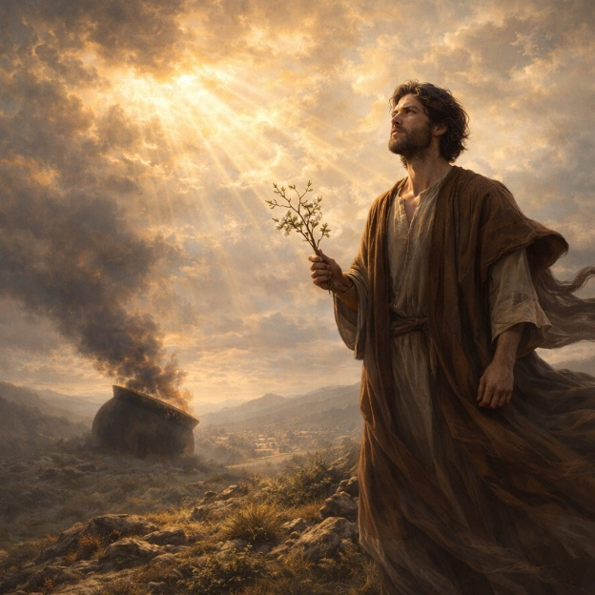
Jeremiah 1 introduces the prophet and establishes the historical setting of his ministry, which begins during the reign of Josiah and continues through the final kings of Judah. The chapter centers on Jeremiah’s divine calling. Before his birth, he was appointed to be “a prophet unto the nations.” When the word of the Lord comes to him, Jeremiah hesitates, describing himself as a child and unqualified to speak. He is immediately reassured that his authority will not come from personal ability but from the One who sends him. God promises presence, protection, and direction, instructing him to speak whatever he is commanded.

The chapter then presents two symbolic visions that define Jeremiah’s message. The first is a rod of an almond tree. The Lord explains that He is watching over His word to perform it, emphasizing certainty and fulfillment. The second vision is of a seething pot facing from the north. This image represents coming disaster that will pour out upon the land. The threat is not random; it is described as judgment against persistent wickedness, idolatry, and abandonment of the Lord. Kings, princes, priests, and people alike will be confronted.

Jeremiah is then strengthened for opposition. He is made “a defenced city, and an iron pillar, and brasen walls” against the whole land. The calling includes inevitable resistance, yet it also includes assurance: “I am with thee…to deliver thee.” The chapter closes with a clear mandate—Jeremiah must not be dismayed, and he must faithfully declare what he has been given. The foundation of the book is established: a reluctant but appointed prophet, a message of unavoidable judgment, and a promise of sustaining presence.

Jeremiah 2

2. Opening Scripture Quote (KJV)
“Moreover the word of the LORD came to me, saying,”

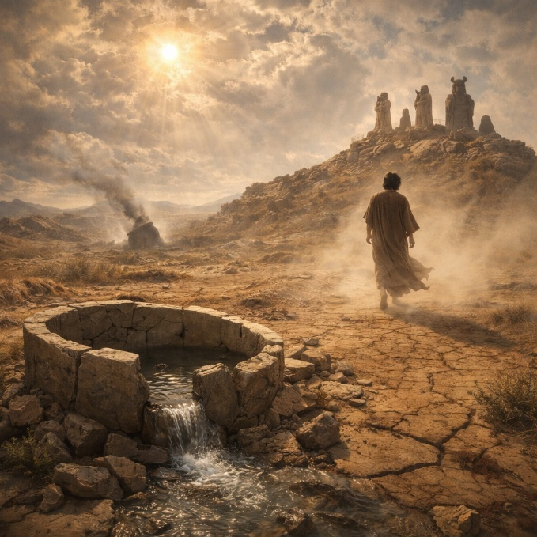
Jeremiah 2 presents a formal accusation against Judah, structured like a covenant lawsuit. The Lord recalls the early devotion of Israel in the wilderness, describing a time when the nation followed Him with trust and dependence. That former loyalty is contrasted with present corruption. The people have abandoned their God without cause and turned to idols that cannot profit. The central charge is summed up in a vivid image: “my people have committed two evils; they have forsaken me the fountain of living waters, and hewed them out cisterns, broken cisterns, that can hold no water.” The chapter frames this as both irrational and self-destructive.

The prophet then exposes the consequences of this departure. Foreign powers have oppressed the nation, and the people are confused about why calamity has come. Yet the text insists that the trouble is self-inflicted. By abandoning the source of life and protection, Judah has removed its own security. Political alliances with Egypt and Assyria are described as faithless substitutes for trust in the Lord. The imagery becomes increasingly severe: the nation is likened to a wild vine gone degenerate, a restless camel, and a wandering animal in heat. These comparisons emphasize unrestrained pursuit of other gods and misplaced dependence.

The chapter closes with a confrontation of denial and stubbornness. The people claim innocence, yet their guilt is said to be plainly visible. Attempts at reform without repentance are compared to washing with soap that cannot remove the stain. Even when discipline comes, they refuse correction. The overall message is clear: Judah’s suffering is not accidental but the result of covenant betrayal. The tone is both grieving and judicial, presenting a God who remembers former faithfulness but now declares accountability for deliberate abandonment.

Jeremiah 3

Opening Scripture Quote (KJV)
“They say, If a man put away his wife, and she go from him, and become another man's, shall he return unto her again? shall not that land be greatly polluted? but thou hast played the harlot with many lovers; yet return again to me, saith the LORD.”

Jeremiah 3 continues the charge of unfaithfulness using the imagery of marriage. The chapter opens with a question drawn from common law: if a divorced wife joins herself to another man, can she simply return? The comparison exposes Judah’s spiritual condition. The nation is described as having “played the harlot with many lovers,” turning to idols across hills and under trees. Yet, unlike ordinary law, the Lord extends an unexpected invitation—“return again to me.” The tone combines moral clarity with a surprising offer of restoration.

The chapter contrasts Judah with her northern sister, Israel. Israel had already been judged and carried away because of persistent idolatry. Judah witnessed this outcome but did not truly learn from it. Instead, she is accused of treachery, continuing similar practices while maintaining an outward appearance of loyalty. The difference between superficial reform and genuine repentance becomes central. Words alone are insufficient; the call is to acknowledge wrongdoing and turn back sincerely. The promise attached to repentance includes mercy and the removal of anger, for the Lord declares, “I am merciful.”

The latter portion of the chapter looks beyond immediate judgment toward future restoration. The people are invited to return as “backsliding children,” and the Lord promises to give shepherds who will feed them with knowledge and understanding. A time is described when the ark of the covenant will no longer be the central focus, because Jerusalem itself will be called “the throne of the LORD,” and nations will gather there. The chapter closes with a confession placed in the mouth of the people, admitting that salvation does not come from hills or multitudes of mountains but from the Lord. Jeremiah 3 therefore presents both exposure of betrayal and a pathway to renewal grounded in repentance and mercy.

Jeremiah 4

Opening Scripture Quote (KJV)
“If thou wilt return, O Israel, saith the LORD, return unto me: and if thou wilt put away thine abominations out of my sight, then shalt thou not remove.”


Jeremiah 4 begins with a renewed call to repentance. The chapter opens with conditional language: if Israel will truly return, remove abominations, and swear in truth and righteousness, blessing can follow. The emphasis is not on outward reform alone but on inward change. The command to “break up your fallow ground, and sow not among thorns” presents repentance as cultivation of the heart. Circumcision is described not merely as a physical sign but as something that must reach the heart. The warning is urgent because refusal will bring consequences that cannot be easily reversed.

The focus then shifts to an approaching disaster from the north. A lion is pictured rising from his thicket, symbolizing an invading power that will devastate the land. Cities will be laid waste, and people will flee in fear. Trumpets sound alarms, and watchmen announce danger. The judgment is portrayed as sweeping and unavoidable, yet not total annihilation. The reason for this calamity is repeated: persistent rebellion and refusal to know the Lord. Even in crisis, false assurances of peace have misled the people, deepening the shock when destruction arrives.

The final portion of the chapter becomes intensely vivid and personal. Jeremiah describes the coming devastation in language that echoes creation undone: the earth without form and void, the heavens without light, mountains trembling, and cities broken down. The imagery conveys chaos and desolation rather than simple military defeat. Yet within the severity, a boundary is stated—“yet will I not make a full end.” The chapter closes with a picture of the land mourning under darkened skies as enemies advance. Jeremiah 4 therefore combines an urgent call to heart-level repentance with a graphic portrayal of the consequences of refusal, underscoring both justice and restraint.

Jeremiah 5

Opening Scripture Quote (KJV)
“Run ye to and fro through the streets of Jerusalem, and see now, and know, and seek in the broad places thereof, if ye can find a man, if there be any that executeth judgment, that seeketh the truth; and I will pardon it.”


Jeremiah 5 opens with a striking challenge: search Jerusalem to find even one person who practices justice and seeks truth. The promise is extraordinary—if such a person can be found, the city would be spared. Yet the search reveals widespread dishonesty and spiritual emptiness. Though the people speak the Lord’s name, their oaths are false. Poverty is not the sole explanation; both common people and leaders are described as having broken restraint and rejected correction. The problem is not ignorance alone but refusal to respond to discipline. Reproof has fallen without effect.

The chapter then announces judgment through the imagery of wild animals and invading forces. A lion, a wolf, and a leopard represent dangers that stalk the rebellious nation. The reason given is persistent transgression and backsliding. The people have forgotten the One who gives rain in its season and sets boundaries for the sea. Instead of gratitude and reverence, injustice fills the land. Wicked individuals lie in wait like hunters, setting traps to catch others. Their houses are filled with deceitfully gained wealth. Leaders fail to defend the cause of the fatherless and the needy, allowing corruption to flourish unchecked.

In the closing verses, the Lord declares that a distant nation will come against Judah—a people whose language is not understood, strong and ancient, bringing destruction. Yet even here restraint appears: “Nevertheless in those days, saith the LORD, I will not make a full end with you.” The chapter ends with a sobering assessment: prophets prophesy falsely, priests rule by their own authority, and the people love it that way. The final question remains unanswered but piercing—what will be done in the end thereof? Jeremiah 5 therefore portrays a society deeply compromised at every level, warned of judgment yet not abandoned entirely.

Jeremiah 6

Opening Scripture Quote (KJV)
“O ye children of Benjamin, gather yourselves to flee out of the midst of Jerusalem, and blow the trumpet in Tekoa, and set up a sign of fire in Bethhaccerem: for evil appeareth out of the north, and great destruction.”
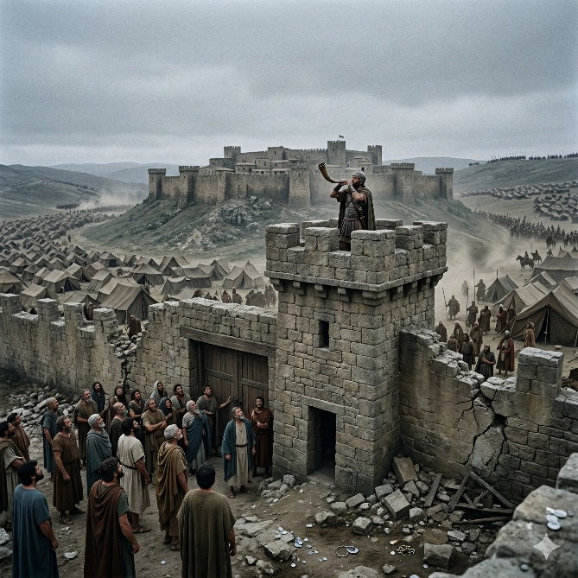
Jeremiah 6 continues the warning of invasion from the north, now described with increasing urgency. The people are told to prepare for flight as danger approaches. Jerusalem is compared to a pleasant and delicate woman who will be overrun. Shepherds with their flocks are pictured setting up tents around her, symbolizing encroaching armies preparing to divide the land. The invasion is deliberate and organized. The call to sanctify war and arise at noon underscores that the assault will not wait for convenient timing. The city that once felt secure is now surrounded.

The cause of this disaster is again traced to moral corruption. Violence and oppression are said to flow from within the city like water from a fountain. The people are urged to receive correction, yet they refuse to listen. The prophet describes a deep frustration: he is full of the fury of the Lord and weary of holding it in. From the least to the greatest, covetousness dominates society. Prophets and priests are accused of treating serious wounds lightly, declaring “Peace, peace” when there is no peace. Shame has disappeared; they are not even embarrassed by wrongdoing. The failure is systemic, affecting leadership and common people alike.

The chapter also presents a final appeal. The people are urged to stand in the old paths and ask for the good way, promising rest for their souls if they walk in it. They reject the offer. Watchmen have sounded the trumpet, but the warning is ignored. As a result, judgment is declared certain. Sacrifices from distant lands will not compensate for disobedience. The people are compared to rejected silver because the refining process has revealed only impurity. Jeremiah 6 closes with the image of testing and refining, concluding that refusal to respond to correction leaves nothing but rejection. The chapter emphasizes accountability, persistent warning, and the consequence of hardened resistance.

Jeremiah 7

Opening Scripture Quote (KJV)
“The word that came to Jeremiah from the LORD, saying,”

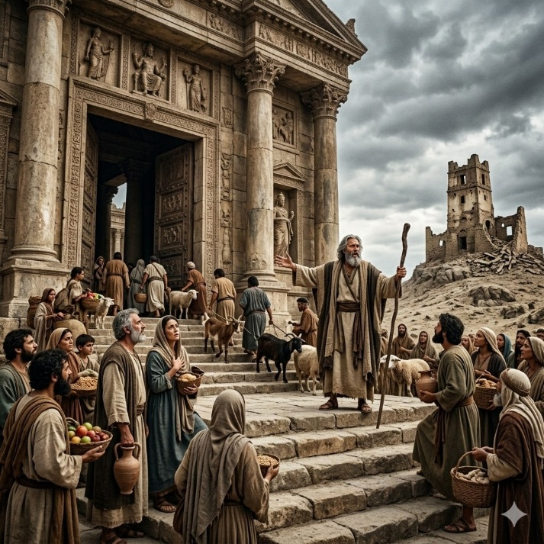
Jeremiah 7 records what is often called the “temple sermon.” The prophet is instructed to stand in the gate of the Lord’s house and proclaim a message to those who enter to worship. The central warning confronts a false confidence: the repeated claim, “The temple of the LORD, The temple of the LORD, The temple of the LORD, are these.” The people believed that the presence of the temple guaranteed safety. Jeremiah challenges this assumption, insisting that security depends not on sacred buildings but on amended ways and actions. Justice, care for the vulnerable, and the rejection of idolatry are presented as the true conditions for continued dwelling in the land.

The chapter exposes a pattern of hypocrisy. Theft, murder, adultery, false swearing, and burning incense to other gods continue, yet the people stand before the Lord as though protected. The temple is described as having become “a den of robbers,” a place misused as shelter for wrongdoing rather than a center of obedience. The example of Shiloh is invoked as a historical warning. Just as that former place of worship was abandoned because of wickedness, so Jerusalem is not immune. The message is clear: ritual sacrifice without obedience was never the primary command. From the beginning, the call was to hear and walk in God’s ways.

The latter part of the chapter intensifies the consequences. Because the people refuse correction, disaster is declared inevitable. Jeremiah is even told not to pray for the people concerning this judgment. Idolatrous practices, including offerings made to the “queen of heaven,” are named directly. The coming devastation will silence joy, destroy burial customs, and leave the land desolate. Jeremiah 7 therefore confronts misplaced religious confidence and emphasizes that covenant relationship requires obedience, not mere outward devotion. The chapter underscores that sacred symbols cannot shield a people who persistently reject instruction.

Jeremiah 8

Opening Scripture Quote (KJV)
“At that time, saith the LORD, they shall bring out the bones of the kings of Judah, and the bones of his princes, and the bones of the priests, and the bones of the prophets, and the bones of the inhabitants of Jerusalem, out of their graves:”
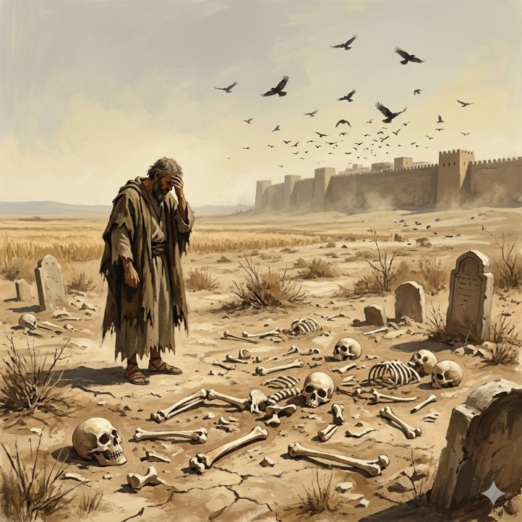
Jeremiah 8 continues the description of coming judgment with stark and unsettling imagery. The opening vision portrays graves opened and bones exposed before the sun, moon, and stars—the very heavenly bodies the people had worshiped. This scene symbolizes the humiliation of leaders and citizens alike. Honor in death will be replaced with disgrace. The chapter emphasizes that death will seem preferable to life for the survivors, highlighting the severity of the coming calamity. The imagery underscores that misplaced devotion brings shame rather than protection.

The focus then shifts to the stubborn refusal of the people to repent. Despite repeated warnings, they cling to deceit and refuse to return. Jeremiah compares them unfavorably to migrating birds that instinctively know their appointed times. Even natural creatures respond to ordered patterns, yet the people do not recognize the judgment of the Lord. The leaders are particularly criticized. Those who claim wisdom are exposed as having rejected the word of the Lord, making their wisdom meaningless. Prophets and priests again are accused of offering shallow reassurances, saying “Peace, peace” when no peace exists. Shame no longer restrains them; wrongdoing has become normalized.

The chapter closes with a deeply personal expression of grief. Jeremiah’s sorrow rises as he hears the cry of the people from afar, asking if the Lord is not in Zion. The response points to idolatry as the cause of abandonment. The famous question, “Is there no balm in Gilead; is there no physician there?” captures the sense of unresolved wound and unhealed suffering. Harvest has passed, summer has ended, and yet there is no deliverance. Jeremiah 8 therefore combines the certainty of judgment with the anguish of a prophet who mourns the consequences of persistent rebellion. The tone is both judicial and lamenting, presenting a nation warned yet unwilling to change.

Jeremiah 9

Opening Scripture Quote (KJV)
“Oh that my head were waters, and mine eyes a fountain of tears, that I might weep day and night for the slain of the daughter of my people!”

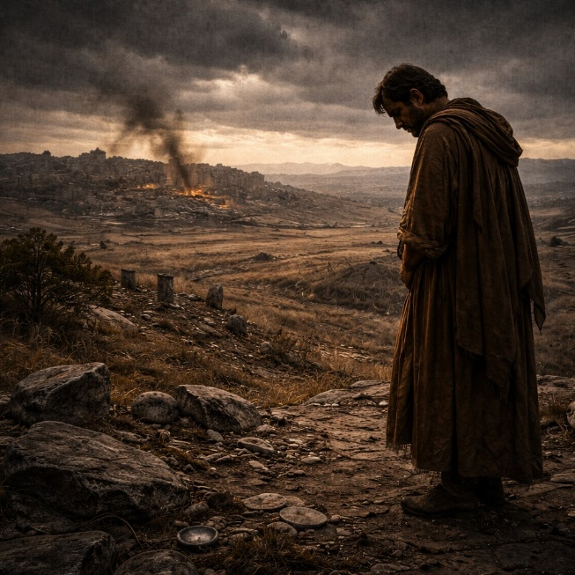
Jeremiah 9 opens with a cry of overwhelming grief. The prophet longs for unending tears because of the destruction coming upon his people. He expresses a desire to withdraw into the wilderness to escape a society marked by deceit and treachery. Truth has fallen in the land; people bend their tongues like bows to shoot lies. Trust between neighbors has eroded, and even close relationships are corrupted by dishonesty. The atmosphere described is one of moral collapse, where falsehood is not occasional but habitual.

The chapter continues by explaining the reason for judgment. The people refuse to know the Lord, choosing instead to walk in stubbornness and idolatry. Because of this, refining judgment is announced. The imagery of melting and testing metal reappears, emphasizing examination and exposure. Destruction will come upon Jerusalem and the cities of Judah, leaving them desolate. The sound of mourning will replace ordinary life. Women skilled in lamentation are called to raise their voices, for death will enter through windows and cut off both young and old. The scale of loss is described vividly, underscoring the seriousness of rebellion.

The chapter concludes with a corrective perspective on what truly matters. Human achievements—wisdom, strength, and riches—are declared insufficient grounds for boasting. Instead, the only legitimate glory is understanding and knowing the Lord, who exercises lovingkindness, judgment, and righteousness in the earth. This closing statement redirects attention from outward status to relational knowledge grounded in character and justice. Jeremiah 9 therefore combines deep personal sorrow, clear explanation of judgment, and a final reminder that true security lies not in human ability but in rightly knowing the Lord. The tone is mournful yet instructive, presenting both the cost of deceit and the standard by which genuine honor is measured.

Jeremiah 10

Opening Scripture Quote (KJV)
“Hear ye the word which the LORD speaketh unto you, O house of Israel:”

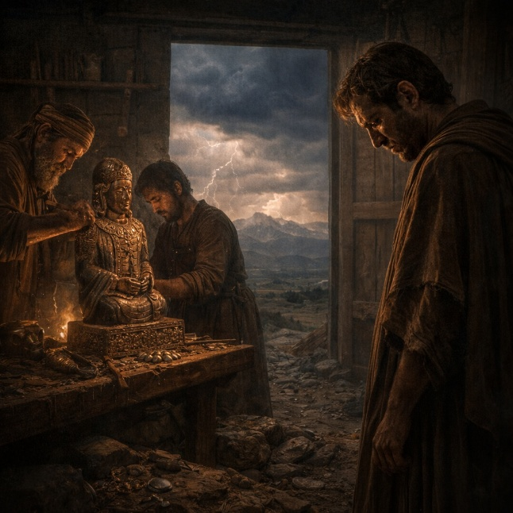
Jeremiah 10 contrasts the emptiness of idols with the living power of the Lord. The chapter begins with a warning not to learn the practices of surrounding nations or fear the signs of heaven as they do. The prophet describes how idols are made: a tree is cut from the forest, shaped by craftsmen, decorated with silver and gold, and fastened so it will not fall. These images appear impressive but have no life or power. They cannot speak, move, or bring harm or good. The description emphasizes the absurdity of trusting in something fashioned by human hands.

In contrast, the Lord is presented as incomparable. He is described as the true and living God, the everlasting King whose power causes the earth to tremble. Unlike idols, which are lifeless objects, the Lord created the heavens and the earth. The chapter points to the natural world as evidence of His authority: thunder, rain, lightning, and wind all respond to His command. While craftsmen become ashamed of their idols, the God of Israel is shown to be the source of all wisdom and creation. The comparison is absolute—one is the product of human effort, while the other is the origin of all existence.

The latter portion of the chapter turns toward the coming disaster and Jeremiah’s personal lament. The land will be laid waste, and the people scattered like travelers forced from their homes. Leaders who were supposed to guide the nation have acted foolishly and failed to seek the Lord, leaving the people vulnerable. Jeremiah responds with a prayer acknowledging that human paths are not fully directed by human strength. He asks for correction with justice rather than overwhelming wrath and calls for judgment upon the nations that devour the land. Jeremiah 10 therefore combines instruction against idolatry with recognition of divine sovereignty and a plea for measured discipline.

Jeremiah 11

Opening Scripture Quote (KJV)
“The word that came to Jeremiah from the LORD, saying,”
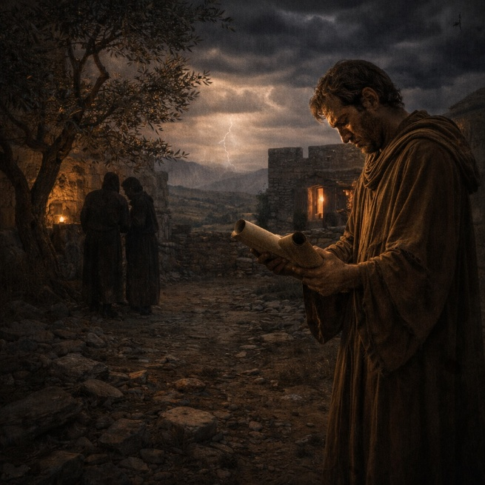
Jeremiah 11 focuses on the covenant relationship between the Lord and the people of Judah. The chapter begins with a command for Jeremiah to proclaim the words of the covenant that had been established with their ancestors when they were brought out of Egypt. That covenant required obedience: if the people listened to the Lord’s voice and followed His commands, they would remain His people and live securely in the land. Jeremiah affirms the covenant by responding, “Amen, O LORD,” acknowledging both its authority and its conditions.

Despite this long-standing agreement, the chapter declares that the people have broken the covenant repeatedly. They have returned to the sins of earlier generations who refused to hear the Lord’s words. Idolatry has spread widely, with altars raised to false gods throughout the cities of Judah and the streets of Jerusalem. Because of this persistent rebellion, disaster is pronounced. The people may cry out, but the warning is that their idols will not save them in the time of trouble. Jeremiah is even instructed not to pray for the people concerning this judgment, indicating that the consequences of their actions are now firmly established.

The chapter closes with a personal conflict involving Jeremiah’s hometown of Anathoth. The prophet learns that men from his own community have plotted against him because of the message he proclaims. He compares himself to a gentle lamb led to the slaughter, unaware at first of the plans against him. The Lord reveals the conspiracy and promises justice against those who seek his life. Their judgment will come through sword and famine, and none of the conspirators will escape. Jeremiah 11 therefore highlights the seriousness of covenant betrayal, the certainty of judgment for persistent disobedience, and the personal cost borne by a prophet who faithfully speaks the message entrusted to him.

Jeremiah 12

Opening Scripture Quote (KJV)
“Righteous art thou, O LORD, when I plead with thee: yet let me talk with thee of thy judgments: Wherefore doth the way of the wicked prosper? wherefore are all they happy that deal very treacherously?”
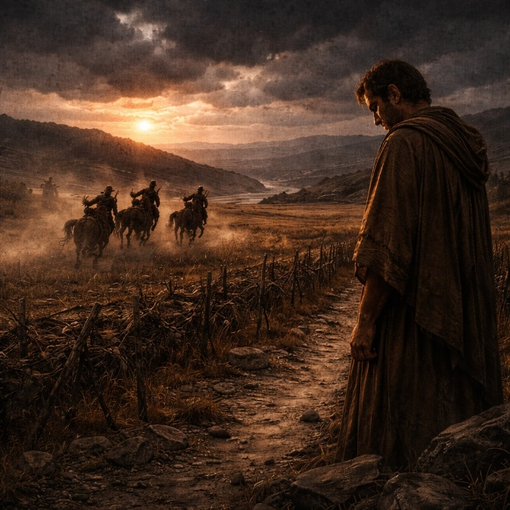
Jeremiah 12 begins with a personal complaint from the prophet. Jeremiah acknowledges that the Lord is righteous but struggles to understand why wicked people seem to prosper while those who speak truth face hardship. He observes that the treacherous appear secure and flourishing, like plants that take root and grow. Though these people speak about God with their lips, their hearts remain far from Him. Jeremiah contrasts their outward success with his own faithfulness and suffering, asking why injustice appears to go unpunished.

The Lord responds not by giving a simple explanation but by challenging Jeremiah’s endurance. If running with ordinary men has wearied him, how will he compete with horses? If he struggles in a peaceful land, how will he manage in the dangers of the Jordan’s swelling waters? The answer implies that greater trials lie ahead. Even Jeremiah’s own relatives and household will betray him, warning him not to trust their friendly words. The message is sobering: the path of a prophet includes increasing opposition, and faithfulness will require perseverance beyond what he has yet experienced.

The chapter then widens its focus from Jeremiah’s personal struggle to the condition of the land itself. The Lord describes His heritage as something abandoned because of the people’s hostility. The land is devastated, fields lie desolate, and enemies surround it. Shepherds who should have cared for the land have instead destroyed it. Yet the chapter ends with a note of possibility beyond judgment. The nations that plunder the land will also face discipline, but if they learn the ways of the Lord, they may be established among His people. Jeremiah 12 therefore moves from personal questioning to broader reflection on justice, endurance, and the future reshaping of nations under divine authority.

Jeremiah 13

Opening Scripture Quote (KJV)
“Thus saith the LORD unto me, Go and get thee a linen girdle, and put it upon thy loins, and put it not in water.”

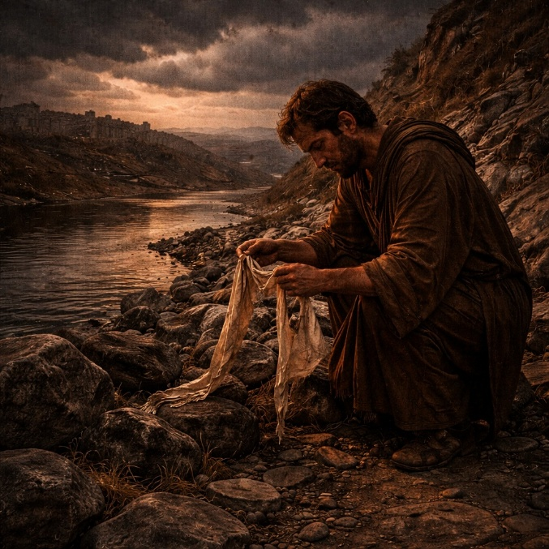
Jeremiah 13 opens with a symbolic action commanded by the Lord. Jeremiah is told to buy a linen girdle, wear it, and later hide it in a crevice near the Euphrates River. After many days he returns to retrieve it, only to find it ruined and useless. The object lesson illustrates the relationship between the Lord and the people of Judah. Just as a girdle clings closely to the waist of a person, the Lord intended Israel and Judah to remain close to Him, bringing honor and praise. Instead, their pride and refusal to listen have made them spiritually ruined, no longer fulfilling the purpose for which they were chosen.

The chapter then expands the message using another image—jars filled with wine. The people respond as though the statement is obvious, but the meaning is deeper. The Lord declares that the inhabitants of the land, including kings, priests, prophets, and citizens, will be filled with confusion and drunkenness of judgment. This figurative intoxication represents the coming collapse of leadership and stability. Rather than guiding the nation wisely, those responsible for its direction will stumble and fall. The result will be a devastating internal and external breakdown that cannot easily be repaired.

Jeremiah also calls the people to humility before disaster arrives. Pride is identified as a central cause of their downfall. The prophet urges them to give glory to the Lord before darkness overtakes them, but the warning is largely ignored. Jeremiah responds with sorrow, declaring that he will weep in secret because of the people’s pride. The chapter closes with vivid imagery of shame and exposure, describing rulers and citizens alike being brought low. Jerusalem’s sin is portrayed as deeply ingrained, raising the rhetorical question of whether a person can easily change what has become habitual. Jeremiah 13 therefore combines symbolic action, prophetic warning, and deep lament over the destructive power of pride and persistent disobedience.

Jeremiah 14

Opening Scripture Quote (KJV)
“The word of the LORD that came to Jeremiah concerning the dearth.”

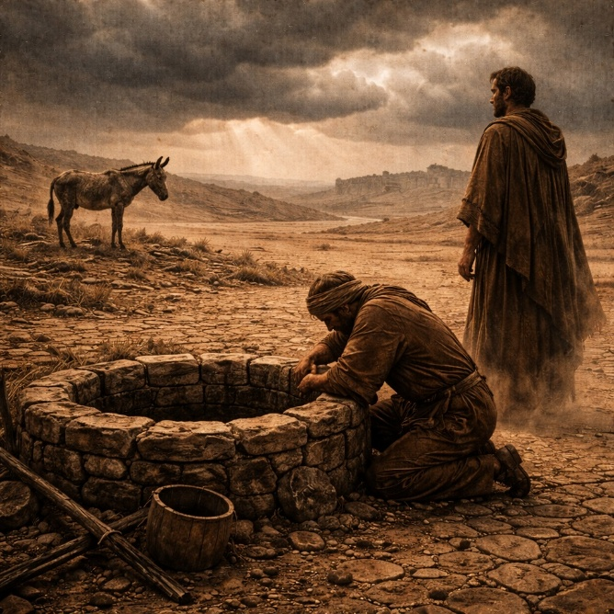
Jeremiah 14 describes a severe drought that devastates the land of Judah. The drought is not presented merely as a natural disaster but as a sign of deeper spiritual consequences. The ground is cracked and dry, and the people suffer from lack of water. Nobles send servants to search for wells, but they return empty-handed. Farmers cover their heads in shame because the earth yields nothing. Even wild animals suffer; deer abandon their young and wild donkeys gasp for air in the barren hills. The entire landscape reflects the weight of the crisis, showing how the land itself mourns under the effects of judgment.

In response to the suffering, Jeremiah offers a prayer of confession and appeal. He acknowledges the sins of the people and asks the Lord to act for the sake of His name. Though the nation has turned away many times, Jeremiah pleads for mercy and restoration. The prophet recognizes that true help cannot come from idols or foreign powers but only from the Lord who created the heavens and controls the rain. His prayer expresses both humility and hope, asking God not to abandon the people completely despite their failures.

However, the Lord declares that the people have persistently loved to wander and have not restrained themselves from wrongdoing. Because of this continued rebellion, judgment will not be reversed simply through prayer or ritual offerings. The Lord warns Jeremiah not to intercede for the people, stating that famine, sword, and pestilence will come. False prophets who promise peace are also condemned, for they mislead the people with comforting but untrue messages. The chapter closes with Jeremiah’s grief over the suffering he foresees. He mourns the deep wounds of the nation while still turning toward the Lord as the only source of hope. Jeremiah 14 therefore portrays both the physical devastation of drought and the spiritual consequences that lie behind it.

Jeremiah 15

Opening Scripture Quote (KJV)
“Then said the LORD unto me, Though Moses and Samuel stood before me, yet my mind could not be toward this people: cast them out of my sight, and let them go forth.”

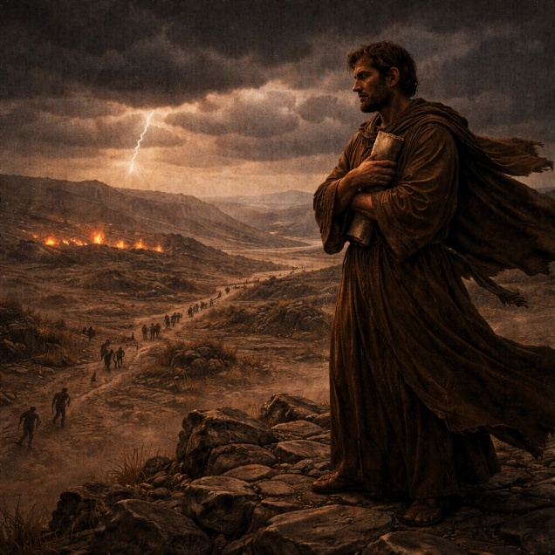
Jeremiah 15 begins with a stark declaration that the time for intercession has passed. Even if great figures such as Moses or Samuel were to plead for the people, the Lord states that judgment would still proceed. The nation’s persistent rebellion has reached a point where consequences cannot be avoided. Different forms of destruction are described—death, sword, famine, and captivity—symbolizing the many ways the coming disaster will unfold. The people will become an object of horror among the nations, and the devastation of Jerusalem will leave many grieving over the loss of their children and homes.

The chapter explains that this judgment is tied especially to the legacy of earlier wrongdoing. The influence of King Manasseh’s idolatry is mentioned as a source of lasting corruption that spread throughout the land. Because the people have not turned away from these practices, their suffering will multiply. The imagery used throughout the chapter conveys overwhelming loss: mothers bereaved, cities emptied, and enemies advancing without resistance. The tone emphasizes the seriousness of long-standing disobedience and the consequences that accumulate over time when warnings are ignored.

Amid these declarations, Jeremiah expresses his own anguish and isolation. He laments the burden of being a prophet whose message brings conflict rather than peace. Yet he also recalls the joy he once felt in receiving the words of the Lord, describing them as nourishment and delight. The Lord responds with encouragement and correction, promising to strengthen Jeremiah if he remains faithful. The prophet is told to separate what is precious from what is worthless and to stand firm against opposition. The chapter ends with reassurance that, although Jeremiah will face hostility, the Lord will protect and deliver him. Jeremiah 15 therefore combines unavoidable judgment with a personal reaffirmation of the prophet’s calling and endurance.

Jeremiah 16

Opening Scripture Quote (KJV)
“The word of the LORD came also unto me, saying,”

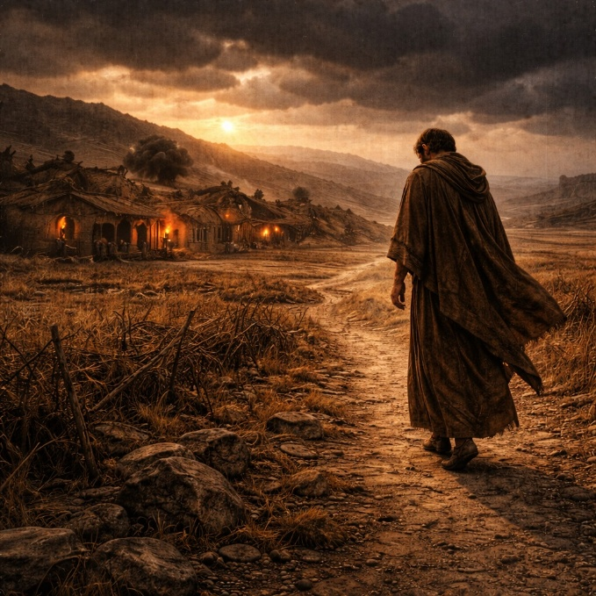
Jeremiah 16 begins with unusual instructions given to the prophet about his personal life. Jeremiah is told not to marry or have children in the land. This command is not merely personal but symbolic. The coming judgment will be so severe that children born into that generation would face death through famine, disease, and violence. By remaining unmarried, Jeremiah’s life becomes a living sign of the devastation that lies ahead. The prophet is also instructed not to enter houses of mourning or feasting, demonstrating that ordinary cycles of celebration and grief will soon be disrupted by overwhelming loss.

The chapter explains that this coming disaster is rooted in the long history of rebellion among the people. Their ancestors turned away from the Lord and followed other gods, and the present generation has continued in even greater stubbornness. Because of this persistent disobedience, the land will be emptied and the people scattered into foreign lands where they will serve other gods day and night. The exile is portrayed not only as punishment but also as a clear demonstration of the consequences of abandoning the covenant relationship that once defined the nation.

Yet Jeremiah 16 also contains a promise that extends beyond judgment. The future will include a restoration so significant that people will no longer refer only to the ancient deliverance from Egypt. Instead, they will speak of a new gathering when the Lord brings His people back from the lands where they were scattered. The chapter closes with recognition that nations will one day acknowledge the emptiness of idols and the truth of the Lord’s power. Jeremiah 16 therefore combines symbolic action, explanation of judgment, and a forward-looking promise that exile will not be the final chapter in the story.

Jeremiah 17

Opening Scripture Quote (KJV)
“The sin of Judah is written with a pen of iron, and with the point of a diamond: it is graven upon the table of their heart, and upon the horns of your altars;”

Jeremiah 17 begins with a vivid description of how deeply the sins of Judah are embedded within the people. Their wrongdoing is portrayed as permanently engraved on their hearts and on the altars where idolatrous worship takes place. The imagery suggests that their rebellion is not superficial but deeply rooted in their character and habits. Because of this entrenched disobedience, the nation will lose its treasures and inheritance, and the people will be forced into exile. The chapter emphasizes that the consequences of persistent idolatry and injustice will extend beyond temporary hardship to the loss of stability and homeland.

The message then shifts to a contrast between two ways of living. Those who trust in human strength and turn their hearts away from the Lord are compared to a barren shrub in a desert, unable to thrive even when good conditions appear. In contrast, those who trust in the Lord are likened to a tree planted by waters, sending out roots by the river and remaining strong even during drought. This contrast highlights the difference between reliance on unstable human systems and dependence on divine guidance. The chapter also declares that the human heart is deceitful and difficult to fully understand, but the Lord searches the heart and examines motives, giving each person according to their ways.

The chapter concludes with both personal reflection and instruction concerning the Sabbath. Jeremiah prays for healing and deliverance, affirming that the Lord is his true hope despite the mockery he faces from others. He asks not to be put to shame while those who oppose him face the consequences of their actions. Finally, the people are instructed to honor the Sabbath by refraining from carrying burdens through the city gates. If they obey, Jerusalem will continue to flourish with kings and citizens entering its gates. If they refuse, the city will face destruction by fire. Jeremiah 17 therefore blends warnings about deeply rooted sin, teaching about trust and the human heart, and a final call to obedience that could preserve the city’s future.

Jeremiah 18

Opening Scripture Quote
“The word which came to Jeremiah from the LORD, saying,”

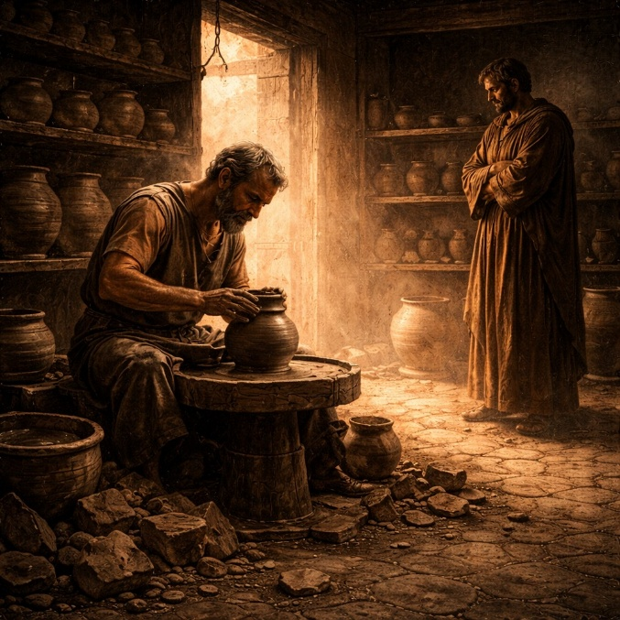
Jeremiah 18 begins with the Lord instructing the prophet to visit a potter’s house. There Jeremiah observes the craftsman shaping a vessel on the wheel. When the clay becomes flawed in the potter’s hands, the potter reshapes it into another vessel according to his purpose. This scene becomes a powerful illustration of the relationship between the Lord and the nation of Israel. Just as a potter has authority over the clay, the Lord declares that He has authority over nations and peoples. The message emphasizes that God can reshape or redirect the future of a nation depending on its response to His warnings.

The Lord explains that if He announces judgment against a nation but the people turn from their evil, He may withhold the disaster He intended. Likewise, if He promises blessing but the people turn to wrongdoing, that blessing may be withdrawn. The principle highlights the moral responsibility of the nation and the dynamic nature of the relationship between divine warning and human response. Jeremiah is told to deliver this message to the people of Judah and the inhabitants of Jerusalem, urging them to turn from their evil ways and correct their actions before judgment becomes unavoidable.

However, the response from the people is one of stubborn rejection. They dismiss the warning and declare that they will continue following their own plans. The chapter describes how their actions are unnatural and shocking, like abandoning a reliable source of water for dangerous paths. Because of this persistent rebellion, the land will become desolate and travelers will be astonished at its destruction. The chapter concludes with Jeremiah facing hostility from those who resent his message. Instead of repenting, some begin plotting against him. Jeremiah responds with a prayer asking the Lord to remember their opposition and the harm they intend against him. Jeremiah 18 therefore combines a clear illustration of divine authority with a sobering account of human resistance to correction.

Jeremiah 19

Opening Scripture Quote
“Thus saith the LORD, Go and get a potter's earthen bottle, and take of the ancients of the people, and of the ancients of the priests;”

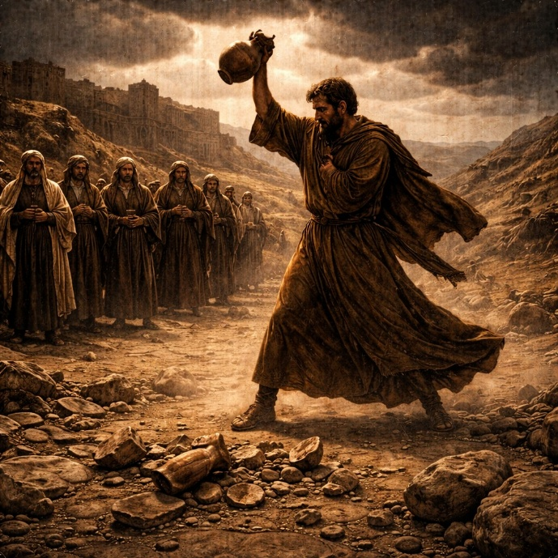
Jeremiah 19 begins with the Lord instructing Jeremiah to carry out a symbolic act using a clay vessel. The prophet is told to take some of the elders of the people and the priests and go to the Valley of Hinnom near the entrance of the city. There he is to proclaim a message of warning concerning the coming judgment upon Jerusalem. The location is significant because it had become a place where idolatrous practices occurred, including the burning of offerings to foreign gods. By bringing respected leaders to witness the event, the message is meant to be publicly understood as a serious declaration from the Lord.

The prophet explains that the city has filled the land with innocent blood and has turned to worshiping gods unknown to their ancestors. The people have built high places for false worship and even sacrificed their own children in fire. Because of these actions, the Lord declares that the place will no longer be known by its former name but will instead be called the Valley of Slaughter. The chapter describes a coming catastrophe in which the city will face siege, famine, and devastation. The suffering will be so severe that ordinary life will collapse and the land will become a place of horror and astonishment to those who pass by.

To conclude the message, Jeremiah breaks the earthen bottle in the presence of those who have gathered. The shattered vessel becomes a dramatic symbol of the coming destruction. Just as a clay jar cannot be restored once it is broken, the judgment upon the city will be decisive and irreversible. Afterward, Jeremiah returns to the temple court and continues proclaiming the same warning to the people of Jerusalem. The chapter emphasizes the seriousness of persistent rebellion and the certainty of consequences when repeated warnings are ignored. Through the symbolic act of the broken vessel, Jeremiah communicates that the nation’s refusal to turn back has brought them to a point where judgment can no longer be delayed.

Jeremiah 20

Opening Scripture Quote
“Now Pashur the son of Immer the priest, who was also chief governor in the house of the LORD, heard that Jeremiah prophesied these things.”

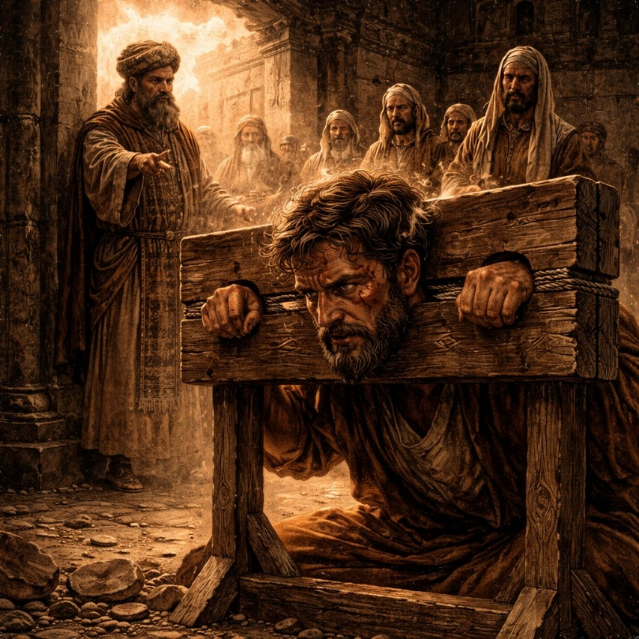
Jeremiah 20 begins with a confrontation between the prophet and a religious leader named Pashur, who served as a chief official in the temple. After hearing Jeremiah’s warnings of judgment against Jerusalem, Pashur reacts with hostility. He strikes Jeremiah and has him placed in the stocks at the upper gate of Benjamin near the temple. This public punishment is meant to humiliate and silence the prophet. Instead of stopping Jeremiah’s message, however, the event becomes another occasion for him to speak the word of the Lord. When Jeremiah is released the next day, he announces that Pashur’s name will be changed to signify terror, and he predicts that Pashur and his friends will witness the defeat of Judah and eventually go into captivity.

The chapter continues with Jeremiah declaring that the people who oppose him will face the consequences of their actions. He describes how the nation will fall before its enemies and how Jerusalem’s wealth and treasures will be carried away. These predictions reinforce the warnings already given in earlier chapters about the approaching invasion and exile. Yet Jeremiah’s words are not spoken from emotional distance. The conflict with Pashur highlights the personal cost of delivering an unpopular message. Jeremiah faces ridicule, rejection, and violence from those who hold power in the community.

The latter part of the chapter reveals Jeremiah’s inner struggle with his calling. He laments that the message entrusted to him has made him an object of constant mockery. At times he wishes he could remain silent, but he describes the word of the Lord as a burning fire within him that cannot be contained. Even when discouraged, he continues speaking because he cannot escape the responsibility of his role. The chapter ends with a deeply emotional reflection in which Jeremiah expresses anguish over the hardship his life has brought him. Jeremiah 20 therefore presents both the external persecution faced by the prophet and the internal conflict that comes with faithfully proclaiming a difficult message.

Jeremiah 21

Opening Scripture Quote
“The word which came unto Jeremiah from the LORD, when king Zedekiah sent unto him Pashur the son of Melchiah, and Zephaniah the son of Maaseiah the priest, saying,”

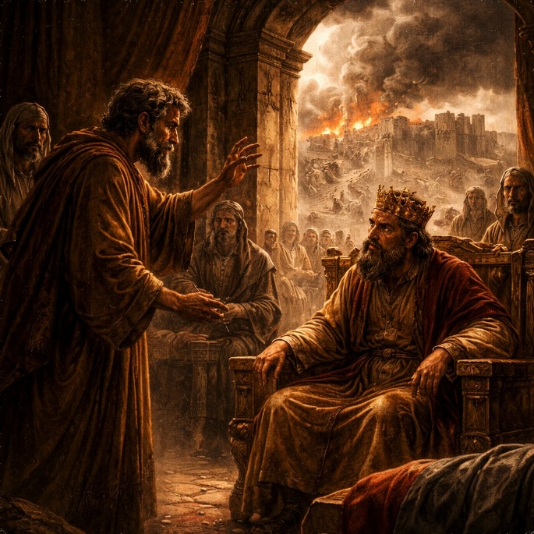
Jeremiah 21 takes place during a time of crisis as Babylon’s army threatens Jerusalem. King Zedekiah sends messengers to Jeremiah asking him to seek the Lord on behalf of the city. The king hopes that God might perform a miracle similar to earlier deliverances in Israel’s history and cause the Babylonian forces to withdraw. The request reveals the desperation of the leadership as the siege approaches. However, Jeremiah delivers a message that is the opposite of what the king hopes to hear. Instead of promising rescue, the prophet declares that the Lord Himself will oppose the city because of its persistent rebellion.

The message explains that the weapons of Judah will fail and that the defenders of the city will not succeed against the invading army. According to the prophecy, the Lord will fight against Jerusalem with anger and fury, allowing Babylon to capture the city. Disease, famine, and violence will spread among the inhabitants. Even the king and his officials will not escape the consequences. Jeremiah warns that those who remain in the city will face destruction, while those who surrender to the Babylonian forces will preserve their lives. This stark choice highlights the seriousness of the moment and the inevitability of the coming judgment.

The chapter ends with a broader call directed toward the royal house of David. The rulers are reminded that they are responsible for administering justice and protecting those who are oppressed. If they fail to act with righteousness, judgment will come upon the palace and the city itself. The message stresses that the Lord examines the actions of leaders and holds them accountable for how they govern. Jeremiah 21 therefore presents a sobering warning during a national emergency. Rather than offering reassurance, the prophet announces that the crisis unfolding around Jerusalem is the result of long-standing injustice and disobedience, and that the consequences cannot be avoided.

Jeremiah 22

Opening Scripture Quote
“Thus saith the LORD; Go down to the house of the king of Judah, and speak there this word,”

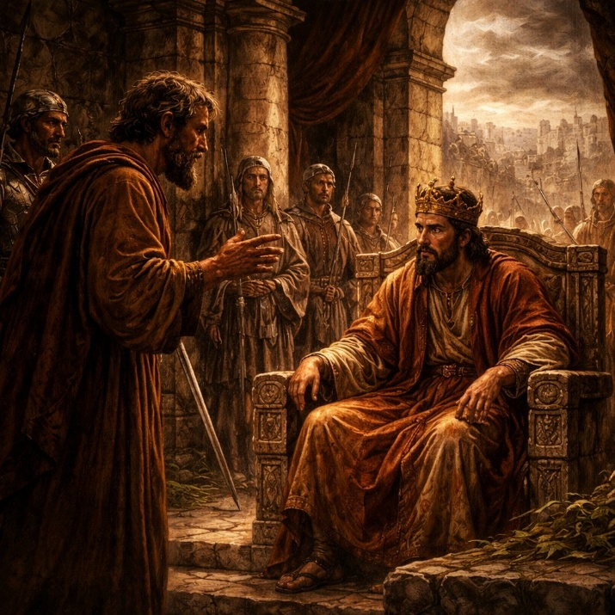
Jeremiah 22 delivers a message directly to the royal house of Judah, calling its leaders to act with justice and righteousness. The kings are instructed to defend the oppressed, protect the vulnerable, and avoid violence and corruption. The Lord makes it clear that the stability of the kingdom is tied to how its leaders govern. If they uphold justice, the throne of David will continue to be established, and the city will remain secure. However, if they refuse to listen, the royal palace itself will become desolate. The warning emphasizes that leadership carries responsibility and that failure at the top affects the entire nation.

The chapter then turns to specific judgments against individual kings of Judah. Shallum, also known as Jehoahaz, is described as one who will not return from captivity but will die in the land where he has been taken. Jehoiakim is condemned for building his palace through unjust means, exploiting workers without paying them, and pursuing selfish ambition instead of righteousness. His reign is contrasted with that of his father, who had acted with justice and care for the poor. Because of Jehoiakim’s actions, he will not receive the honor of a proper burial, and his legacy will end in disgrace.

The final portion addresses Coniah, also known as Jehoiachin, declaring that he will be cast out and taken into exile along with his mother. Despite his position, he will be treated as rejected and removed from power. The chapter ends with a statement that none of his descendants will prosper on the throne of David in Judah. Jeremiah 22 therefore highlights the accountability of leadership, showing that even kings are subject to judgment when they abandon justice. The chapter reinforces the broader theme that authority does not exempt individuals from consequences, and that the future of the nation is closely tied to the character and actions of its rulers.

Jeremiah 23

Opening Scripture Quote
“Woe be unto the pastors that destroy and scatter the sheep of my pasture! saith the LORD.”
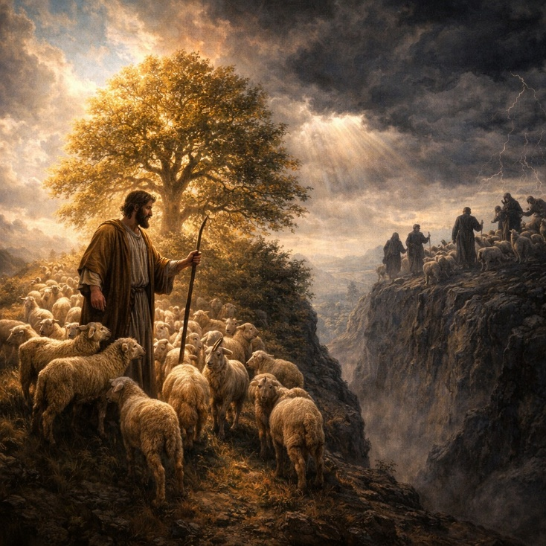
Jeremiah 23 begins with a strong rebuke against the leaders of Judah, described as shepherds who have failed in their responsibility. Instead of caring for the people, they have scattered and harmed them. The Lord declares that these leaders will be held accountable for their actions. In contrast, He promises to gather the scattered people and appoint faithful shepherds who will properly care for them. This section introduces a future hope, including the promise of a righteous Branch from the line of David who will reign wisely and bring justice and safety to the land.

The chapter then turns to a sharp critique of false prophets. These individuals claim to speak in the name of the Lord but instead spread deception, encouraging people to continue in wrongdoing. They offer false assurances of peace and safety, even when judgment is imminent. Jeremiah describes how their messages come from their own imagination rather than from the Lord. The contrast is made between true and false messages, emphasizing that a genuine word from the Lord carries weight and truth, while false words are empty and misleading. The Lord declares that He is not distant but fully aware of the actions and words of these prophets.

The final portion reinforces the seriousness of misrepresenting the word of the Lord. The message is compared to fire and a hammer that breaks rock, showing its power and authority. Those who falsely claim divine messages are warned that they will face consequences for misleading the people. The chapter ends by emphasizing that the people must distinguish between true and false words and not treat the Lord’s message lightly. Jeremiah 23 therefore combines judgment against unfaithful leaders with a promise of future restoration under a righteous ruler, while also stressing the importance of truth and integrity in those who claim to speak for God.

Jeremiah 24

Opening Scripture Quote
“The LORD shewed me, and, behold, two baskets of figs were set before the temple of the LORD, after that Nebuchadrezzar king of Babylon had carried away captive Jeconiah the son of Jehoiakim king of Judah, and the princes of Judah, with the carpenters and smiths, from Jerusalem, and had brought them to Babylon.”
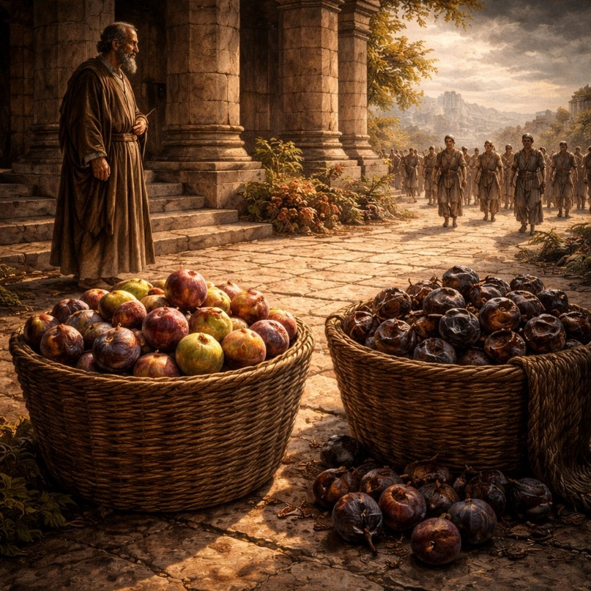
Jeremiah 24 presents a vision given to the prophet involving two baskets of figs placed before the temple. One basket contains very good figs, ripe and desirable, while the other holds very bad figs that are spoiled and cannot be eaten. This simple image is used to communicate a deeper message about the people of Judah during a time of upheaval. The vision occurs after a group of leaders and skilled workers has already been taken into exile by Babylon, setting the context for understanding the meaning of the two contrasting groups.

The good figs represent those who have been carried away into captivity. Although their situation appears negative from a human perspective, the Lord declares that He regards them favorably. He promises to watch over them for good, to bring them back to the land in the future, and to restore their relationship with Him. This group will be given a heart to know the Lord, and they will return with sincerity. The message reveals that the exile, while difficult, will serve a purpose in refining and restoring a faithful remnant.

In contrast, the bad figs symbolize those who remain in Jerusalem or flee to other lands such as Egypt. Despite their apparent security, they are described as destined for disaster because they continue in rebellion. The Lord declares that they will face sword, famine, and pestilence until they are removed from the land. The chapter highlights a reversal of expectations: those who seem fortunate are actually in danger, while those who appear to be suffering are being prepared for restoration. Jeremiah 24 therefore emphasizes the importance of perspective, showing that true security depends not on immediate circumstances but on one’s standing before the Lord.

Jeremiah 25

Opening Scripture Quote
“The word that came to Jeremiah concerning all the people of Judah in the fourth year of Jehoiakim the son of Josiah king of Judah, that was the first year of Nebuchadrezzar king of Babylon;”

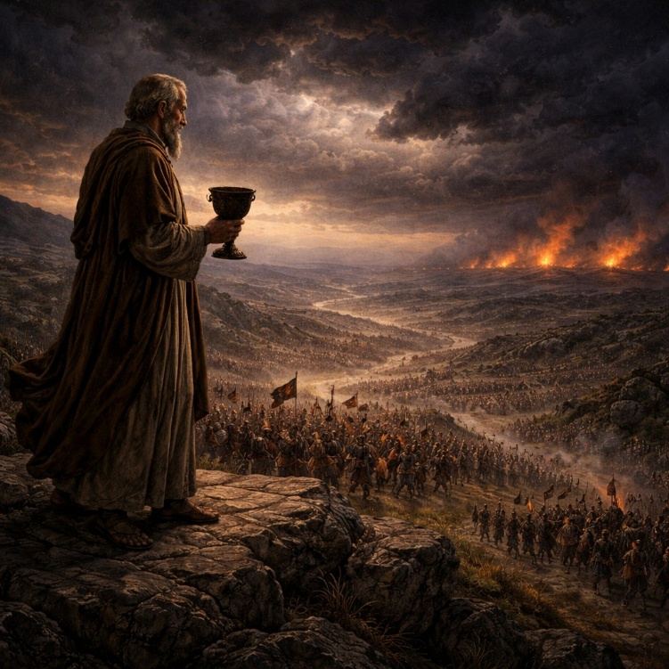
Jeremiah 25 marks a turning point as the prophet reflects on years of warning that have gone unheeded. For over two decades, Jeremiah has spoken persistently to the people of Judah, calling them to turn from their evil ways. Despite these repeated warnings, the people have refused to listen. As a result, the Lord declares that judgment will now come through the rising power of Babylon. Nebuchadnezzar is identified as the instrument who will bring devastation upon the land, leading to destruction, desolation, and exile. The chapter makes clear that this outcome is not sudden but the result of long-standing disobedience.

A specific time frame is given for the coming exile: the people will serve the king of Babylon for seventy years. This period represents a defined season of judgment during which the land will lie desolate and the normal rhythms of life will cease. However, the message also includes a future development beyond this period. After the seventy years are completed, Babylon itself will be judged for its actions. The empire that carried out judgment will not escape accountability, showing that all nations remain subject to the authority of the Lord.

The chapter concludes with a broader vision of judgment extending beyond Judah to many nations. Jeremiah is given the image of a cup filled with the wine of wrath, which he must symbolically offer to various kingdoms. Each nation is compelled to drink, representing the spread of turmoil, war, and destruction across the region. The imagery conveys that the coming upheaval will not be limited to one people but will affect the wider world. The chapter ends with a powerful portrayal of widespread devastation, as the consequences of human rebellion unfold on a large scale. Jeremiah 25 therefore combines a historical warning, a defined period of exile, and a sweeping vision of judgment that reaches far beyond Judah alone.

Jeremiah 26

Opening Scripture Quote
“In the beginning of the reign of Jehoiakim the son of Josiah king of Judah came this word from the LORD, saying,”
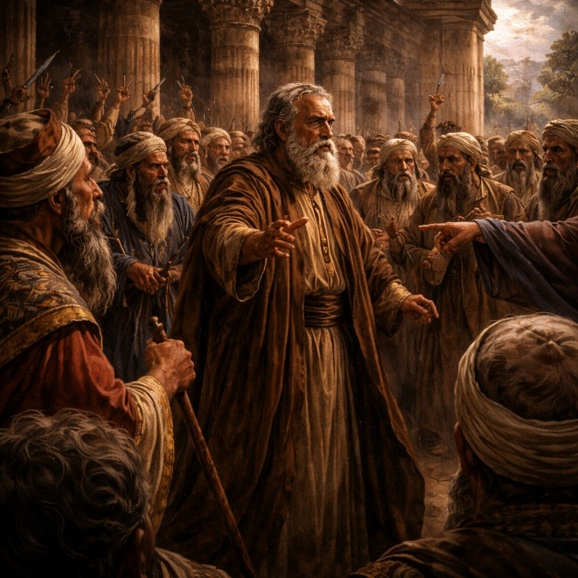
Jeremiah 26 recounts a moment when the prophet is commanded to stand in the court of the Lord’s house and deliver a warning to all who come to worship. He is instructed not to hold back a single word. The message is direct: if the people do not turn from their evil ways, the temple and the city will become like Shiloh, a place once honored but later abandoned. This declaration challenges the people’s confidence in the temple as a guarantee of safety. The warning is clear that continued disobedience will lead to destruction, regardless of the presence of sacred structures.

The response from the priests, prophets, and people is immediate and hostile. They seize Jeremiah and declare that he deserves to die for speaking against the city and the temple. A formal hearing takes place before the officials of Judah, where Jeremiah defends himself by explaining that he has spoken only what the Lord commanded. He urges them to amend their ways, stating that repentance could still prevent disaster. Some of the elders recall earlier prophets, such as Micah, who delivered similar warnings without being executed, arguing that killing Jeremiah would bring innocent blood upon them.

The chapter concludes with a contrast between outcomes. Jeremiah is protected and spared, largely through the support of certain officials who recognize the legitimacy of his message. However, another prophet named Urijah, who also spoke similar words, is pursued by the king, captured, and put to death. This contrast highlights the danger faced by those who speak truth and the inconsistent responses of those in power. Jeremiah 26 therefore presents a scene of confrontation, legal defense, and narrow escape, emphasizing both the risk of faithful proclamation and the possibility that warning, if heeded, could still lead to change.

Jeremiah 27

Opening Scripture Quote (KJV)
“In the beginning of the reign of Jehoiakim the son of Josiah king of Judah came this word unto Jeremiah from the LORD, saying,”

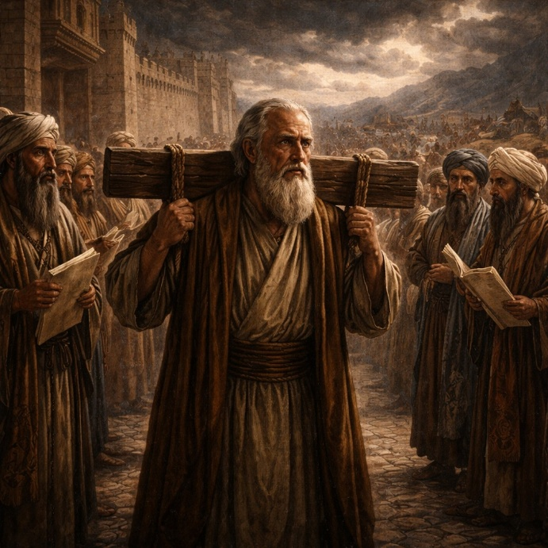
Jeremiah 27 presents a symbolic message delivered through the image of a yoke. The Lord instructs Jeremiah to make bonds and yokes and place them upon his own neck as a visible sign. He is then told to send similar yokes to neighboring kings through their messengers who have gathered in Jerusalem. These nations include Edom, Moab, Ammon, Tyre, and Zidon. The message is clear: all these lands have been given into the hand of Nebuchadnezzar king of Babylon. The yoke represents submission to Babylon’s rule, which is described as part of the Lord’s sovereign plan.

The chapter explains that resisting Babylon will bring destruction. Any nation that refuses to submit will face sword, famine, and pestilence until it is consumed. In contrast, those who accept the yoke and serve Babylon will remain in their land and continue living there. This instruction runs against expectations, as it calls for submission rather than resistance. Jeremiah emphasizes that the authority given to Babylon comes from the Lord, who has power over all nations and determines their rise and fall. The message reframes the political situation as an act of divine judgment rather than merely human conflict.

Jeremiah also warns against listening to false prophets, diviners, and dreamers who promise that the vessels of the temple will soon be returned and that Babylon’s power will quickly end. These messages are described as deceptive and dangerous because they encourage rebellion. Instead, Jeremiah urges both the kings and the people of Judah to submit and live. He warns that even the remaining items in the temple will eventually be taken to Babylon and remain there until the Lord brings them back in His appointed time. Jeremiah 27 therefore stresses submission to divine authority, warns against false hope, and presents a difficult but clear path for survival during a time of judgment.

Jeremiah 28

Opening Scripture Quote
“And it came to pass the same year, in the beginning of the reign of Zedekiah king of Judah, in the fourth year, and in the fifth month, that Hananiah the son of Azur the prophet, which was of Gibeon, spake unto me in the house of the LORD, in the presence of the priests and of all the people, saying,”
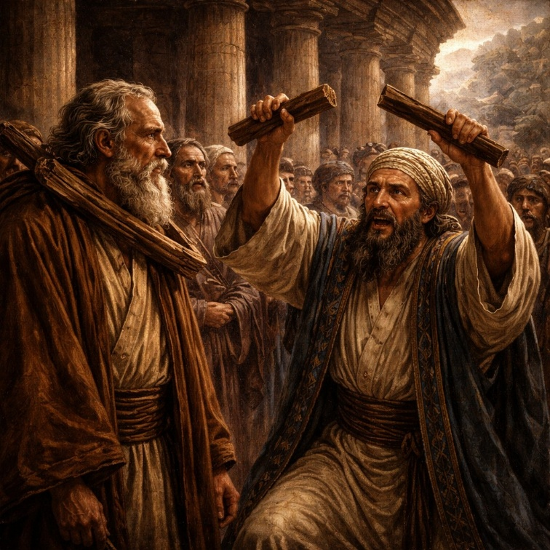
Jeremiah 28 records a direct confrontation between Jeremiah and a prophet named Hananiah. In the temple, before priests and people, Hananiah declares that the Lord will soon break the power of Babylon. He claims that within two years the yoke of Nebuchadnezzar will be removed, the temple vessels will be returned, and the exiles will come back to Jerusalem. His message offers hope and immediate relief, directly contradicting Jeremiah’s earlier warnings that the people must submit to Babylon as part of God’s plan.

Jeremiah initially responds with caution rather than immediate confrontation. He expresses agreement with the desire for peace but reminds the people of a key principle: true prophets are proven by the fulfillment of their words. Historically, prophets who spoke of peace were validated only when their predictions came to pass. In contrast, many earlier prophets had warned of judgment and calamity. The exchange emphasizes that the truth of a message is not determined by how appealing it sounds but by whether it aligns with what God actually declares and ultimately fulfills.

The conflict intensifies when Hananiah takes the wooden yoke from Jeremiah’s neck and breaks it, symbolically rejecting the message of submission to Babylon. In response, Jeremiah later returns with a stronger word from the Lord. The wooden yoke will be replaced with an iron yoke, signifying an even firmer and unavoidable domination by Babylon. Jeremiah declares that Hananiah has caused the people to trust in a lie, and he prophesies that Hananiah will die within the year. The chapter concludes with the fulfillment of this word, as Hananiah dies that same year. Jeremiah 28 therefore highlights the danger of false reassurance, the test of true prophecy, and the certainty that God’s word will stand despite opposition.
Jeremiah 29

Opening Scripture Quote
“Now these are the words of the letter that Jeremiah the prophet sent from Jerusalem unto the residue of the elders which were carried away captives, and to the priests, and to the prophets, and to all the people whom Nebuchadnezzar had carried away captive from Jerusalem to Babylon;”


Jeremiah 29 contains a letter sent by the prophet to the people of Judah who had already been taken into exile in Babylon. Instead of promising a quick return, the message instructs them to settle into their new surroundings. They are told to build houses, plant gardens, marry, and raise families. The people are also commanded to seek the peace and prosperity of the city where they have been taken, recognizing that their well-being is tied to its stability. This guidance shifts their focus from immediate escape to long-term endurance within the situation they are facing.

The chapter also warns against false prophets who claim that the exile will be short. These voices offer reassurance that contradicts the message Jeremiah has delivered. The Lord makes it clear that such claims are deceptive and should not be trusted. A specific timeline is given: the exile will last seventy years. Only after that period will the Lord bring the people back to their land. This establishes a clear expectation and reinforces the need for patience. The message emphasizes that the current circumstances are part of a larger plan, not an accident or temporary setback.

Alongside this instruction, the chapter includes a promise of future restoration. The Lord declares that He has plans for the people that will lead to a hopeful outcome. When they seek Him sincerely, they will find Him, and He will gather them from all the places where they have been scattered. The chapter ends with a warning against certain individuals who have spoken falsely, showing that misleading others carries serious consequences. Jeremiah 29 therefore combines practical instruction for life in exile, a warning against false hope, and a long-term promise of return and restoration grounded in a renewed relationship with the Lord.

Jeremiah 30

Opening Scripture Quote (KJV)
“The word that came to Jeremiah from the LORD, saying,”

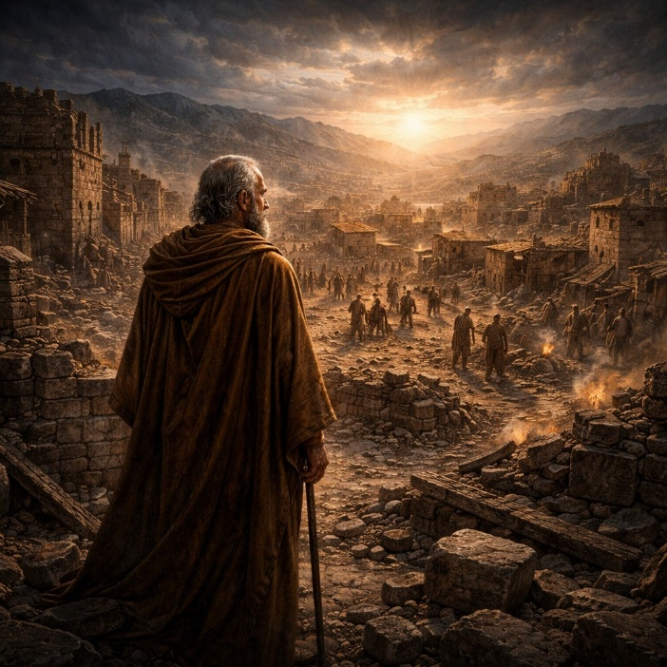
Jeremiah 30 shifts in tone from warning to restoration, as the prophet is instructed to write the words he receives in a book for future generations. The chapter begins by announcing that a time is coming when the Lord will restore the fortunes of both Israel and Judah. Although the people are facing distress, the promise looks ahead to a reversal of their condition. The chapter describes a coming period of intense trouble, often portrayed as a time of fear and pain unlike any before it. Yet this distress is not the end, but part of a larger process leading to deliverance.

The chapter explains that the yoke of oppression will eventually be broken. Foreign domination will come to an end, and the people will once again serve the Lord and a ruler from the line of David. This restoration includes freedom from captivity and a return to security in their land. While their enemies will be judged and brought to an end, the people themselves will not be completely destroyed. Instead, they will be corrected with measure, reflecting both justice and restraint. The message balances discipline with preservation, showing that judgment is not meant to erase the people but to refine and restore them.

The latter part of the chapter emphasizes healing and rebuilding. Though the nation’s condition is described as beyond human remedy, the Lord declares that He will restore health and repair their wounds. The city will be rebuilt, and life will return with joy, thanksgiving, and stability. The community will grow, and its leaders will arise from within. The chapter concludes with a reaffirmation of the covenant relationship, declaring that the people will belong to the Lord and He will be their God. Jeremiah 30 therefore presents a future marked by renewal, where suffering gives way to restoration and lasting security.

Jeremiah 31

Opening Scripture Quote
“At the same time, saith the LORD, will I be the God of all the families of Israel, and they shall be my people.”
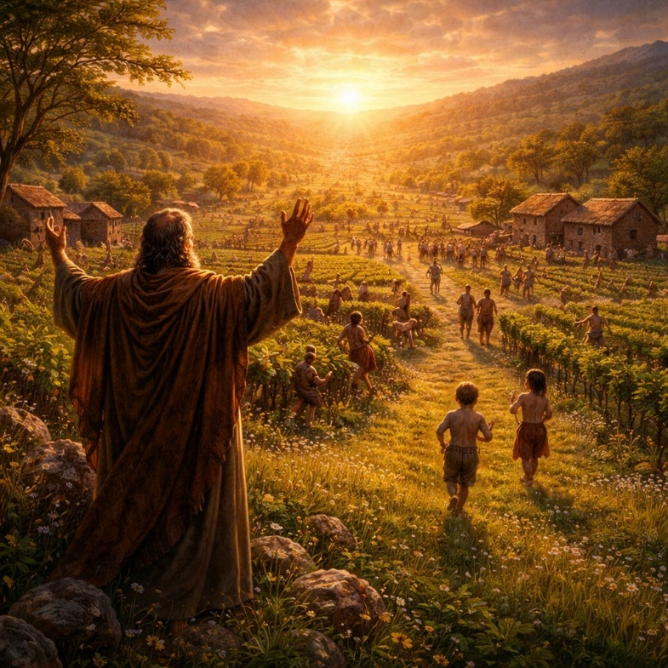
Jeremiah 31 continues the theme of restoration, expanding the promise to include all the families of Israel. The chapter describes a future in which the people who survived hardship will find renewed favor and peace. Joy replaces sorrow as the people return to their land, rebuilding their lives with singing, celebration, and prosperity. The imagery is vivid—vineyards planted, gatherings restored, and communities flourishing again. The chapter emphasizes that the Lord’s commitment to His people remains steady despite their past failures.

A central portion of the chapter addresses both grief and hope. The sorrow of loss is acknowledged through the image of mourning, yet it is followed by a promise that this grief will not last forever. The people are assured that their future includes restoration and that their children will return from distant lands. The message shifts from collective renewal to a deeper transformation, where responsibility and understanding become more personal. The idea is introduced that individuals will no longer rely solely on inherited patterns but will be accountable for their own actions.

The chapter reaches its highest point with the promise of a new covenant. Unlike the earlier covenant, which the people broke, this new relationship will be internal rather than external. The law will be written within them, and their relationship with the Lord will be direct and enduring. Forgiveness is emphasized, with past wrongdoing no longer held against them. The chapter concludes by affirming the permanence of this promise, comparing it to the fixed order of creation. Jeremiah 31 therefore presents a vision of renewal that goes beyond physical return, pointing toward a lasting transformation of the people and their relationship with the Lord.

Jeremiah 32

Opening Scripture Quote (KJV)
“The word that came to Jeremiah from the LORD in the tenth year of Zedekiah king of Judah, which was the eighteenth year of Nebuchadrezzar.”

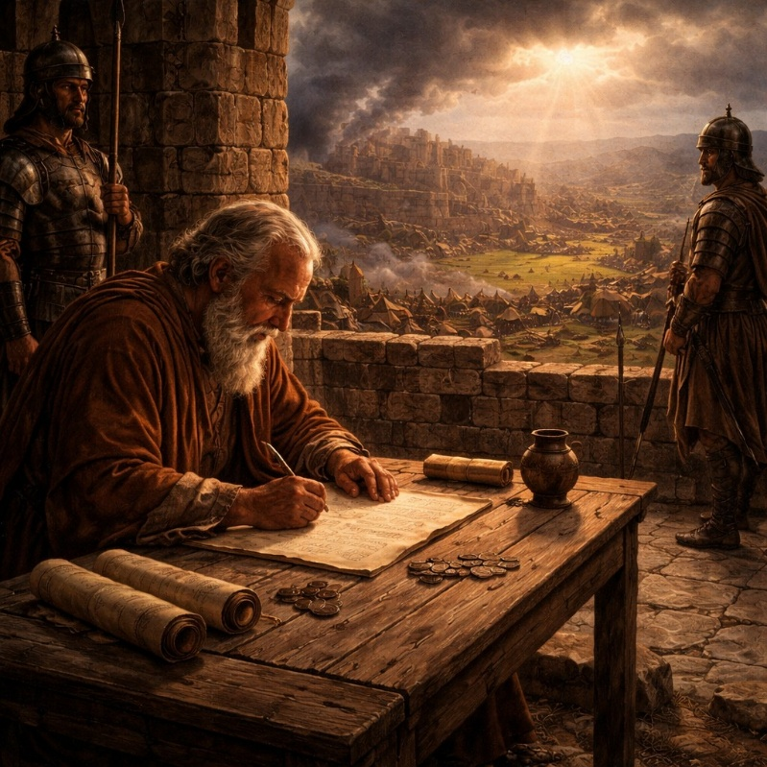
Jeremiah 32 takes place during the siege of Jerusalem, when the city is surrounded by Babylonian forces and the outcome appears certain. Jeremiah is confined in the court of the prison because of his prophecies that the city will fall. In this setting of crisis, the Lord instructs Jeremiah to perform a surprising action: he is to buy a field from his cousin in Anathoth. The purchase is carried out formally, with witnesses, deeds, and sealed documents, even though the land is about to be overtaken by enemy forces. This act serves as a sign that, despite the immediate destruction, the land will one day be restored and owned again.

After completing the purchase, Jeremiah prays, acknowledging the greatness and power of the Lord while also expressing confusion. He recounts the history of the people, their deliverance from Egypt, and their continued disobedience that has led to the current crisis. The prophet recognizes that the siege and suffering are the result of long-standing rebellion. Yet he struggles to understand why he was instructed to buy land in a place that is about to be captured. His prayer reflects both faith in God’s power and uncertainty about the meaning of the command.

The Lord responds by reaffirming His authority over all creation, declaring that nothing is too difficult for Him. He confirms that the city will indeed be given into the hands of the Babylonians because of the people’s persistent wrongdoing. However, the message does not end with destruction. The Lord promises a future gathering and restoration, where the people will return to the land and live securely. A renewed relationship will be established, marked by a lasting covenant and a unified heart to follow Him. The purchase of the field becomes a symbol of this future hope, demonstrating that even in the midst of judgment, restoration is certain. Jeremiah 32 therefore combines historical crisis, personal questioning, and a clear promise of eventual renewal.

Jeremiah 33

Opening Scripture Quote (KJV)
“Moreover the word of the LORD came unto Jeremiah the second time, while he was yet shut up in the court of the prison, saying,”
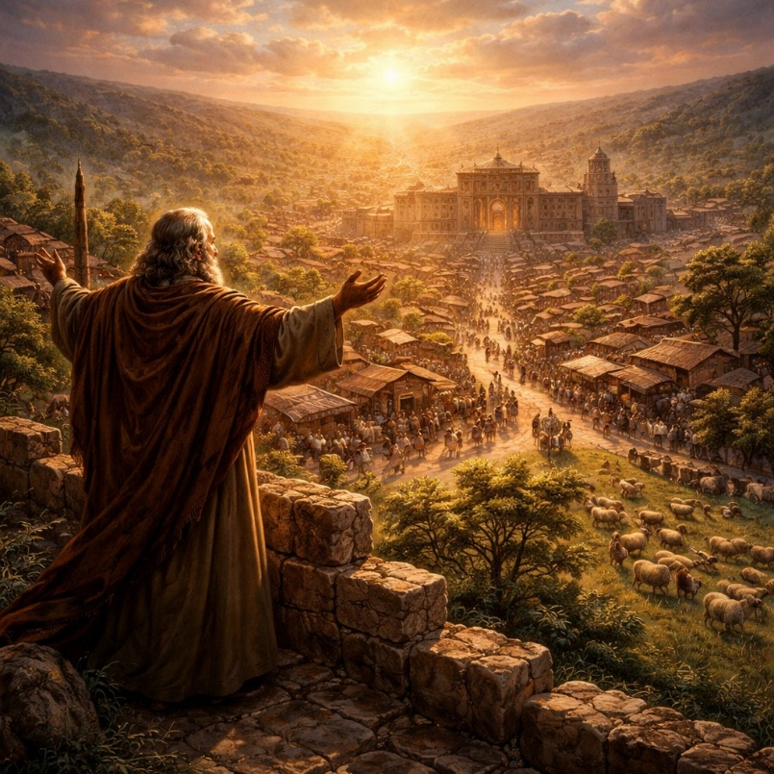
Jeremiah 33 continues the message of hope while the prophet remains confined during the siege of Jerusalem. The chapter begins with an invitation from the Lord for Jeremiah to call upon Him, with the promise that He will reveal great and hidden things. At the same time, the immediate situation is described as one of devastation. The city is under attack, its houses are being torn down for defense, and many are facing death. The contrast between present destruction and future promise sets the tone for the chapter, emphasizing that the current crisis does not cancel what is to come.

The Lord then declares that healing and restoration will follow the period of judgment. The city that is now filled with fear and loss will again become a place of peace, truth, and abundance. Joyful sounds will return—voices of celebration, marriage, and thanksgiving. The land, which has become desolate, will once again be inhabited and productive. Shepherds will count their flocks, and normal life will be restored. The message reinforces that the devastation is temporary and that renewal will be both physical and communal.

The final portion of the chapter reaffirms the enduring nature of the promises made to David and to the priestly line. A righteous branch from David’s line will bring justice and security, and the continuity of leadership and worship is assured. These promises are described as certain and unbreakable, compared to the fixed patterns of day and night. The chapter closes by emphasizing that the restoration of the people and the city is not uncertain but guaranteed. Jeremiah 33 therefore presents a clear assurance that, despite present destruction, lasting restoration and stability will come through the faithfulness of the Lord.

Jeremiah 34

Opening Scripture Quote (KJV)
“The word which came unto Jeremiah from the LORD, when Nebuchadnezzar king of Babylon, and all his army, and all the kingdoms of the earth of his dominion, and all the people, fought against Jerusalem, and against all the cities thereof, saying,”

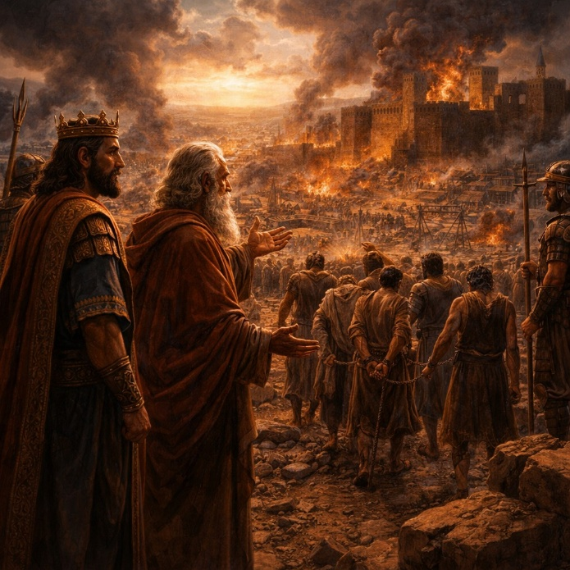
Jeremiah 34 takes place during the siege of Jerusalem as Babylon’s forces surround the city. The chapter begins with a message directed specifically to King Zedekiah. Jeremiah tells him that the city will be handed over to the king of Babylon and burned. Zedekiah himself will not escape but will be captured and taken into exile. However, he is also given a limited assurance that he will not die violently but will die in peace and be honored with burial rites. This message combines certainty of judgment with a measured outcome for the king, showing that even within consequences there are distinctions.

The chapter then shifts to a covenant made among the people of Jerusalem concerning the release of Hebrew servants. In accordance with earlier law, they agree to free those who had been held in servitude. Initially, the people obey and release their servants, demonstrating a temporary return to what is right. However, this action does not last. Soon after, they reverse their decision and force the freed individuals back into bondage. This reversal exposes a deeper pattern of inconsistency and disregard for covenant commitments, even when the people appear to respond correctly for a moment.

The Lord responds by declaring that this act of breaking the covenant will bring further judgment. The people who failed to uphold their promise will face sword, famine, and pestilence. The imagery recalls the seriousness of covenant agreements, emphasizing that their actions were not merely social failures but violations of a commitment made before God. The chapter concludes with a reaffirmation that Jerusalem will fall to Babylon and be destroyed. Jeremiah 34 therefore highlights both the certainty of the city’s downfall and the failure of the people to sustain obedience, even when given an opportunity to act rightly.

Jeremiah 35

Opening Scripture Quote (KJV)
“The word which came unto Jeremiah from the LORD in the days of Jehoiakim the son of Josiah king of Judah, saying,”

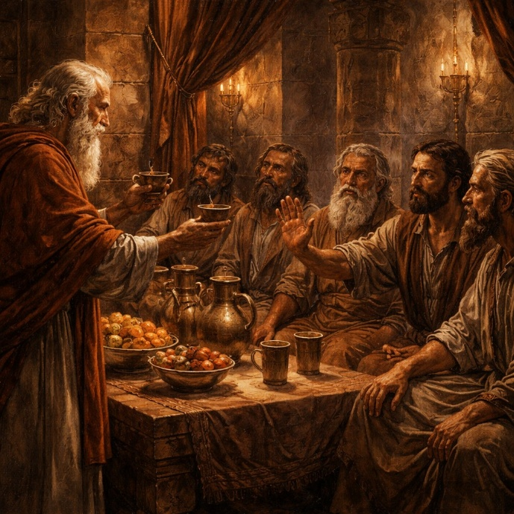
Jeremiah 35 presents a contrast between obedience and disobedience through the example of a group known as the Rechabites. The Lord instructs Jeremiah to bring this family into a chamber of the temple and offer them wine to drink. When presented with the opportunity, they refuse, explaining that their ancestor Jonadab had commanded them not to drink wine, build houses, plant vineyards, or settle permanently. They have faithfully kept these instructions for generations, even under changing circumstances. Their response demonstrates a strong commitment to the commands they received.

The Lord uses the Rechabites as a comparison to the people of Judah. While the Rechabites have consistently obeyed the voice of their ancestor, the people of Judah have repeatedly ignored the words spoken to them by the Lord through His prophets. Despite ongoing warnings and calls to change their ways, the nation has refused to listen or respond. This contrast highlights the seriousness of their disobedience, showing that loyalty and consistency are possible, yet the people have chosen otherwise. The example of the Rechabites becomes a living illustration of what obedience looks like.

Because of this continued refusal to listen, the Lord declares that the judgment already announced will come upon Judah and Jerusalem. However, the Rechabites are given a promise in contrast to the coming consequences for the nation. Their faithfulness will be honored, and they will continue to have a lasting place before the Lord. The chapter ends by reinforcing the principle that obedience brings stability and blessing, while persistent disregard for instruction leads to judgment. Jeremiah 35 therefore uses a real-life example to clearly illustrate the difference between faithfulness and rebellion.

Jeremiah 36

Opening Scripture Quote (KJV)
“And it came to pass in the fourth year of Jehoiakim the son of Josiah king of Judah, that this word came unto Jeremiah from the LORD, saying,”

Jeremiah 36 describes how the words of the prophet are written down and publicly read. The Lord instructs Jeremiah to record all the messages he has spoken over the years concerning Israel, Judah, and the surrounding nations. Since Jeremiah is restricted and cannot go to the temple himself, he dictates the words to Baruch, who writes them on a scroll. Baruch is then sent to read the scroll aloud in the temple on a day when many people are gathered. The purpose is to give the people another opportunity to hear the warnings and turn from their wrongdoing.

As the message is read, it gains attention and concern among the officials. Baruch is brought before them and reads the scroll again in their presence. Realizing the seriousness of what has been written, they advise that both Jeremiah and Baruch should hide for their safety. The officials then bring the scroll to King Jehoiakim. As the king hears the words, he reacts with rejection rather than repentance. Piece by piece, he cuts the scroll and throws it into the fire until it is completely destroyed. This act symbolizes a deliberate refusal to accept the message and a rejection of the warning it contains.

Despite the king’s attempt to eliminate the message, the word of the Lord continues. Jeremiah is instructed to take another scroll and rewrite everything that was burned, along with additional words of judgment against the king. The chapter ends by reinforcing that destroying the written message does not cancel its truth or its consequences. Jeremiah 36 therefore highlights the preservation of the message despite opposition, the rejection of warning by leadership, and the certainty that the word of the Lord remains effective regardless of human response.

Jeremiah 37

Opening Scripture Quote (KJV)
“And king Zedekiah the son of Josiah reigned instead of Coniah the son of Jehoiakim, whom Nebuchadnezzar king of Babylon made king in the land of Judah.”

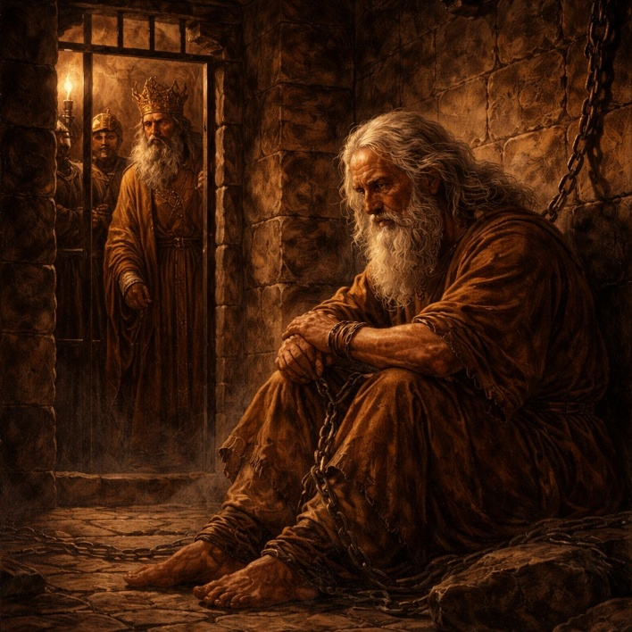
Jeremiah 37 takes place during the final stages of Jerusalem’s siege. King Zedekiah sends messengers to Jeremiah asking him to pray to the Lord on behalf of the people. Despite this request, the king and the people do not truly listen to or follow the Lord’s words. At this moment, the Babylonian army temporarily withdraws from Jerusalem to deal with an approaching Egyptian force. This brief relief raises hope among the people that the threat may be ending, but Jeremiah delivers a message that contradicts this expectation. He declares that the Babylonian army will return and ultimately capture and burn the city.

As Jeremiah attempts to leave the city, he is stopped at the gate and accused of deserting to the Babylonians. Although the accusation is false, he is arrested, beaten, and placed in prison. The harsh treatment reflects the growing hostility toward Jeremiah and his message. Even though he has consistently spoken what he believes to be true, he is viewed as a traitor rather than a prophet. The situation highlights the tension between political fear and the rejection of unwelcome truth.

Later, King Zedekiah secretly brings Jeremiah out to ask him again for a word from the Lord. Jeremiah’s answer remains unchanged: the king will be handed over to the king of Babylon. Jeremiah also pleads not to be returned to the harsh prison conditions. The king grants a limited request, allowing Jeremiah to remain in a less severe place under guard while being given daily bread as long as supplies last. Jeremiah 37 therefore portrays a moment of false hope, continued warning, unjust treatment of the prophet, and a king who seeks guidance but fails to act on it.

Jeremiah 38

Opening Scripture Quote (KJV)
“Then Shephatiah the son of Mattan, and Gedaliah the son of Pashur, and Jucal the son of Shelemiah, and Pashur the son of Malchiah, heard the words that Jeremiah had spoken unto all the people, saying,”

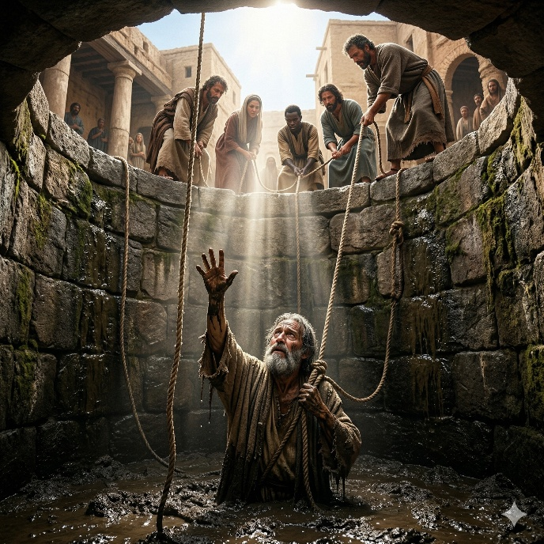
Jeremiah 38 describes the increasing hostility toward the prophet during the siege of Jerusalem. Jeremiah continues to deliver a message that those who remain in the city will die by sword, famine, or pestilence, but those who surrender to the Babylonians will live. This message is seen by some officials as weakening the morale of the people. They accuse Jeremiah of discouraging the soldiers and the citizens rather than seeking their welfare. As a result, they persuade King Zedekiah to allow them to act against him, and Jeremiah is taken and lowered into a cistern where there is no water, only mud, leaving him to sink and face death.

The situation changes when an official named Ebed-melech, an Ethiopian serving in the king’s house, learns of what has been done. He approaches the king and speaks out against the treatment of Jeremiah, arguing that leaving him in the cistern will lead to his death. The king grants permission for Ebed-melech to rescue the prophet. Using old cloths and cords to protect him, they carefully lift Jeremiah out of the pit. This act of intervention highlights both the danger Jeremiah faced and the presence of individuals willing to act with courage and compassion even in a tense environment.

Later, King Zedekiah secretly calls for Jeremiah and asks again for a word from the Lord. Jeremiah agrees to speak on the condition that he will not be put to death and that the king will listen. He repeats the same message: surrendering to the Babylonians will spare the city and the king’s life, while refusing will lead to destruction. The king expresses fear of those who have already defected and hesitates to act. Jeremiah urges him to obey, but the outcome remains uncertain. Jeremiah 38 therefore presents a moment of severe danger for the prophet, a rescue that preserves his life, and a final opportunity for the king to respond before the city’s fate is sealed.

Jeremiah 39

Opening Scripture Quote (KJV)
“In the ninth year of Zedekiah king of Judah, in the tenth month, came Nebuchadrezzar king of Babylon and all his army against Jerusalem, and they besieged it.”

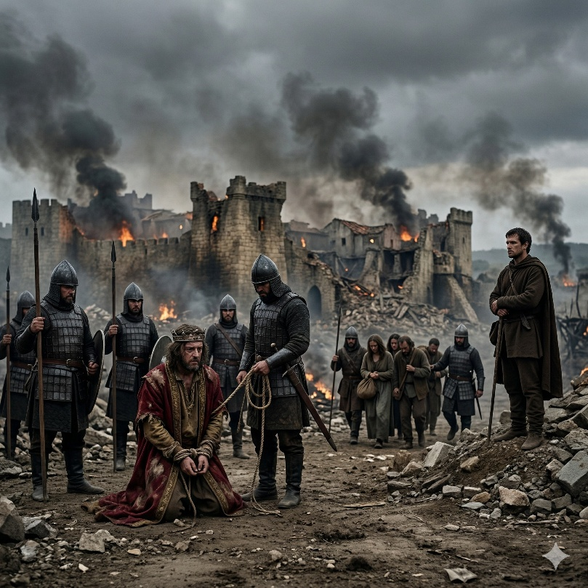
Jeremiah 39 records the fall of Jerusalem after a prolonged siege by the Babylonian army. The city is finally breached, and Babylonian officials take control at the gate. King Zedekiah attempts to flee by night, escaping through a gate near the king’s garden. However, he is captured in the plains of Jericho and brought before the king of Babylon. There, he is forced to witness the execution of his sons and the nobles of Judah before being blinded and taken into captivity. The account presents a decisive end to the resistance of Jerusalem and the collapse of its leadership.

Following the capture of the city, the Babylonians burn Jerusalem, including its houses and important structures, and break down its walls. Many of the people are carried away into exile, leaving only some of the poorest individuals in the land. These remaining inhabitants are given vineyards and fields, marking a shift in the social structure of the land. The destruction fulfills the warnings that had been given repeatedly through Jeremiah, showing that the outcome is not unexpected but the result of long-standing disobedience and rejection of earlier messages.

In contrast to the general destruction, Jeremiah himself is treated differently. The king of Babylon gives instructions that he is to be protected and allowed to live where he chooses. He is released from confinement and entrusted to officials who ensure his safety. The chapter also includes a message concerning Ebed-melech, who had helped Jeremiah earlier. He is promised deliverance because of his trust and actions. Jeremiah 39 therefore portrays the fulfillment of judgment upon the city, the downfall of its king, and the preservation of those who acted faithfully, even within a time of widespread destruction.

Jeremiah 40

Opening Scripture Quote (KJV)
“The word that came to Jeremiah from the LORD, after that Nebuzar-adan the captain of the guard had let him go from Ramah, when he had taken him being bound in chains among all that were carried away captive of Jerusalem and Judah, which were carried away captive unto Babylon.”

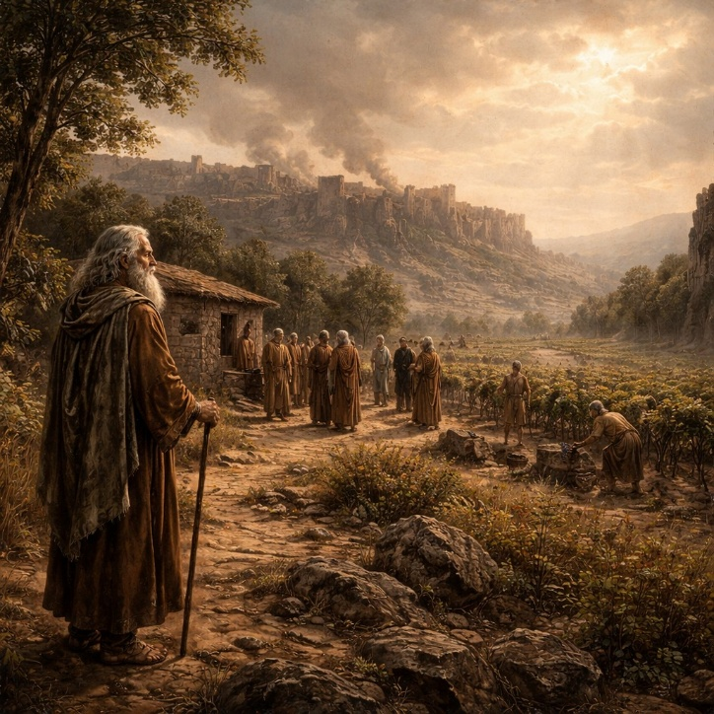
Jeremiah 40 takes place immediately after the fall of Jerusalem, as the aftermath of destruction begins to unfold. Jeremiah is found among the captives being led away in chains but is recognized by the Babylonian captain, Nebuzar-adan. He acknowledges that the disaster has come because of the people’s disobedience to the Lord and gives Jeremiah a choice: he may go to Babylon under protection or remain in the land. Jeremiah chooses to stay and is placed under the care of Gedaliah, who has been appointed governor over the remaining people in Judah. This marks a shift from siege and destruction to a fragile attempt at stability.

Gedaliah establishes his base at Mizpah and encourages those who remain in the land to serve the Babylonians peacefully. People who had scattered during the invasion begin to return, gathering around him and resuming agricultural work. The land, though devastated, starts to show signs of recovery as vineyards and fields are tended once again. Gedaliah’s leadership offers a temporary sense of order and hope, suggesting that life can continue even under foreign rule if the people act wisely and cooperate.

However, tension remains beneath the surface. Johanan and other leaders warn Gedaliah of a plot against his life by Ishmael, a member of the royal line. Gedaliah refuses to believe the warning, choosing trust over suspicion. This decision leaves the situation uncertain and unstable. Jeremiah 40 therefore portrays a brief moment of calm after destruction, where rebuilding begins but is overshadowed by unresolved threats and fragile leadership.

Jeremiah 41

Opening Scripture Quote (KJV)
“Now it came to pass in the seventh month, that Ishmael the son of Nethaniah the son of Elishama, of the seed royal, and the princes of the king, even ten men with him, came unto Gedaliah the son of Ahikam to Mizpah; and there they did eat bread together in Mizpah.”
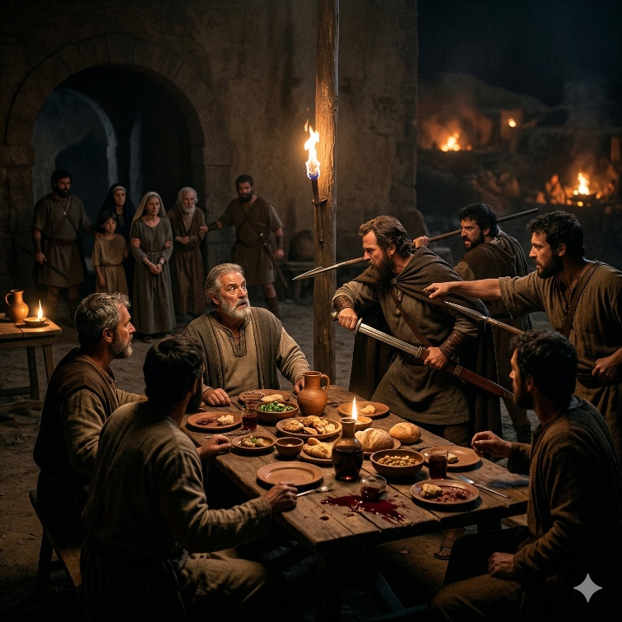
Jeremiah 41 describes the violent collapse of the fragile peace that had begun after the fall of Jerusalem. Ishmael, a member of the royal line, comes to Mizpah with a group of men and shares a meal with Gedaliah, the governor appointed by Babylon. During this gathering, Ishmael and his companions rise up and assassinate Gedaliah, along with the Jews and Babylonian soldiers who are with him. The attack is sudden and calculated, eliminating the leadership that had been working to stabilize the region.

After the murder, Ishmael continues his violence by killing a group of men who arrive from surrounding areas, apparently coming to worship. Their outward signs of mourning suggest they are seeking peace, yet Ishmael attacks them as well, sparing only a few who offer provisions. He then gathers captives from Mizpah, including women, children, and others left under Gedaliah’s authority, and begins to lead them away toward the land of Ammon. The events reveal a breakdown of order and trust, as acts of betrayal and violence replace the brief stability that had been forming.

Johanan and the remaining leaders respond by pursuing Ishmael to rescue the captives. They overtake him near a pool, and when the captives see Johanan’s forces, they turn back and are freed. Ishmael, however, escapes with a small group and flees. The chapter ends with the rescued group settling temporarily, uncertain of what to do next. They fear retaliation from the Babylonians because of Gedaliah’s assassination. Jeremiah 41 therefore portrays a rapid descent into chaos following a moment of hope, marked by betrayal, violence, and renewed uncertainty about the future.

Jeremiah 42

Opening Scripture Quote (KJV)
“Then all the captains of the forces, and Johanan the son of Kareah, and Jezaniah the son of Hoshaiah, and all the people from the least even unto the greatest, came near,”

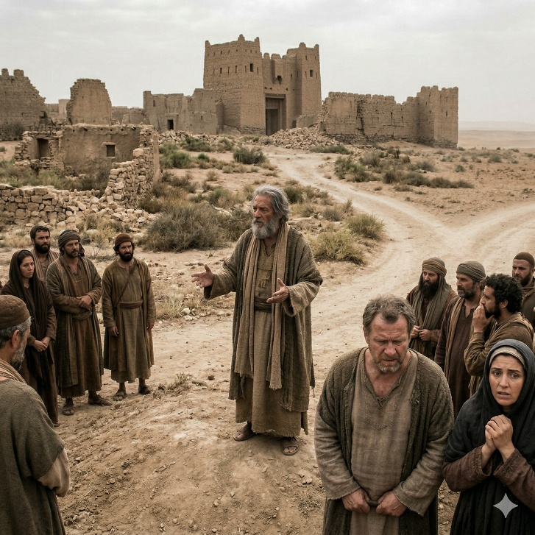
Jeremiah 42 records a moment of apparent humility as the remaining leaders and people of Judah approach Jeremiah seeking guidance from the LORD. After the fall of Jerusalem and the chaos that followed, they ask Jeremiah to pray on their behalf and promise to obey whatever answer God gives, whether favorable or not. Their request appears sincere, and they acknowledge their vulnerable position, asking for direction about where they should go and what they should do. Jeremiah agrees to seek the LORD and assures them that he will faithfully deliver whatever word is given, without withholding anything.

After ten days, Jeremiah returns with a clear message from the LORD. The instruction is direct: the people are to remain in the land of Judah and not go down into Egypt. God promises that if they stay, He will build them up, plant them, and protect them from the king of Babylon. Their fear of Babylon is addressed directly—God tells them not to be afraid, assuring them of His presence and deliverance. The message emphasizes that stability and safety are found in obedience to God’s command, not in fleeing to what appears to be a more secure or familiar place.

At the same time, a warning is given if they choose to disobey. If they go to Egypt seeking safety from war, famine, and destruction, those very things will follow them there. The place they believe will protect them will instead become the location of their downfall. Jeremiah makes it clear that this is not a neutral decision but a decisive test of obedience. The chapter closes with a direct reminder that they had asked for God’s guidance and promised to obey it. Their responsibility is now clear—they have received the answer. Jeremiah 42 highlights the tension between seeking God’s will and actually following it. It shows that true obedience is not measured by asking for guidance, but by submitting to the answer when it is given, even when it contradicts human fear and reasoning.

Jeremiah 43

Opening Scripture Quote (KJV)
“And it came to pass, that when Jeremiah had made an end of speaking unto all the people all the words of the LORD their God, for which the LORD their God had sent him to them, even all these words,”

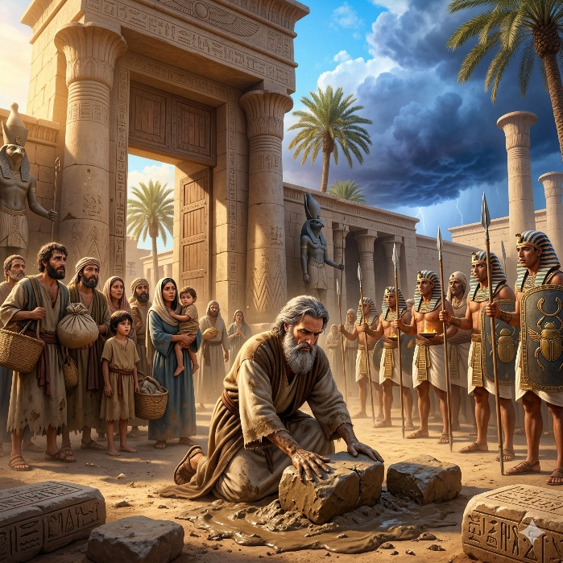
Jeremiah 43 records the response of the remaining people after hearing the Lord’s instruction through Jeremiah. Instead of accepting the message, the leaders accuse Jeremiah and Baruch of speaking falsely. They claim that the warning not to go to Egypt is a deception meant to deliver them into Babylonian hands. This rejection shows a continued pattern of distrust and resistance, even after the destruction of Jerusalem and the chaos that followed. Despite seeking guidance earlier, the people now refuse to accept the answer given.

The leaders, including Johanan, decide to go to Egypt anyway, taking the entire group with them. Jeremiah and Baruch are forced to go along, even though their message had clearly warned against this course of action. The people settle in various locations in Egypt, demonstrating their determination to rely on their own judgment rather than the instruction they had received. This move reflects a shift away from the land and a continued refusal to trust the direction given by the Lord.

Once in Egypt, Jeremiah delivers another symbolic message. He is instructed to take large stones and hide them in the clay at the entrance of Pharaoh’s house in Tahpanhes. This act serves as a sign that the king of Babylon will extend his power even into Egypt. The place they have chosen as a refuge will not provide safety. Instead, it will become another location where Babylon’s influence reaches. Jeremiah 43 therefore highlights the consequences of rejecting guidance, showing that fleeing from one threat does not escape the larger reality of judgment when the underlying issue remains unresolved.

Jeremiah 44

Opening Scripture Quote (KJV)
“The word that came to Jeremiah concerning all the Jews which dwell in the land of Egypt, which dwell at Migdol, and at Tahpanhes, and at Noph, and in the country of Pathros, saying,”
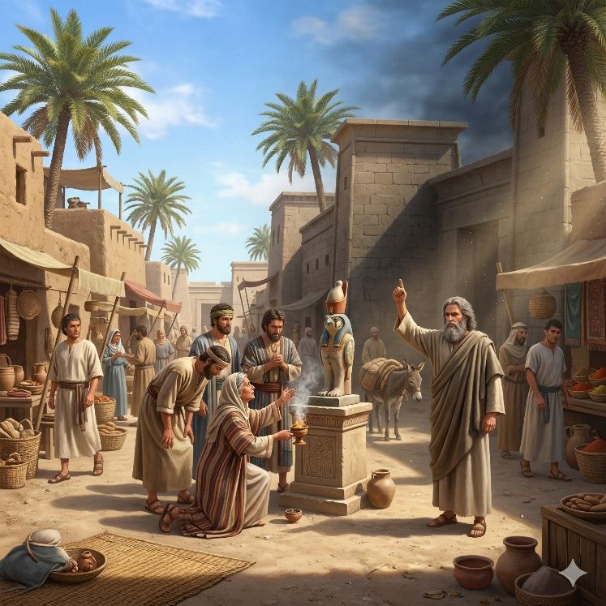
Jeremiah 44 addresses the group of Judeans who have settled in Egypt after fleeing the destruction of Jerusalem. The prophet reminds them of the devastation that came upon Judah and Jerusalem because of their persistent idolatry. The cities were destroyed and left desolate because the people provoked the Lord with their actions, refusing repeated warnings to turn from their ways. Jeremiah emphasizes that the same patterns of behavior are continuing in Egypt, showing that the change in location has not led to a change in conduct.

The people respond by openly rejecting Jeremiah’s message. They insist that they will continue their practices, particularly the offerings made to the “queen of heaven.” They argue that when they engaged in these practices in the past, they experienced prosperity and security, and that hardship came when they stopped. This response reveals a complete reversal of the prophet’s message, as they interpret their history in a way that justifies their actions rather than recognizing the reasons for their downfall. The exchange highlights a deep resistance to correction and a determination to continue in familiar patterns.

Jeremiah delivers a final warning, declaring that the people in Egypt will not escape the consequences of their actions. Just as judgment came upon Jerusalem, it will also come upon them in the place where they now live. Very few will survive, and those who do will return to Judah as a small remnant. The chapter concludes with a sign given to confirm that the message will come to pass, reinforcing that the outcome is certain. Jeremiah 44 therefore presents a clear example of refusal to listen, the persistence of established behavior, and the inevitability of consequences when warnings continue to be ignored.

Jeremiah 45

Opening Scripture Quote (KJV)
“And this is the word that Jeremiah the prophet spake unto Baruch the son of Neriah, when he had written these words in a book at the mouth of Jeremiah, in the fourth year of Jehoiakim the son of Josiah king of Judah, saying,”

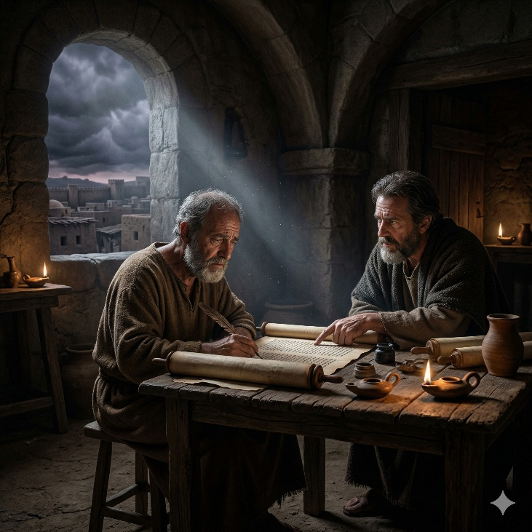
Jeremiah 45 is a short but personal chapter centered on Baruch, the scribe who had faithfully written Jeremiah’s words. Instead of addressing the nation as a whole, the chapter turns to one man carrying the strain of the prophet’s message and the burden of living through a time of national collapse. Baruch is weary. He speaks of sorrow added to sorrow and of finding no rest. His complaint is not presented with mockery, but with honesty. The chapter shows that those who serve in difficult callings can become exhausted, discouraged, and overwhelmed by what they must witness and carry.

The Lord’s answer to Baruch is direct and sobering. God reminds him that what He has built He is now breaking down, and what He has planted He is now plucking up, referring to the coming judgment on the land. In that setting, Baruch is asked a piercing question: should he seek “great things” for himself? The point is not that personal hopes are always wrong, but that the time and circumstance matter. Judah is moving toward disaster because of persistent rebellion, and Baruch must understand the scale of what is happening. Private ambition cannot be the focus when divine judgment is falling on an entire people. The chapter calls for humility and realism in the face of God’s larger purposes.

Yet the message is not without mercy. Although judgment is coming broadly, Baruch is given a specific promise: his life will be preserved wherever he goes. He will not escape trouble entirely, but he will be spared within it. That makes the chapter both severe and compassionate. It does not offer comfort by denying the crisis, but by giving a limited and meaningful assurance in the middle of it. Jeremiah 45 speaks to the tension between disappointment and faithfulness. It recognizes human grief, corrects self-centered longing, and shows that even in a time of destruction, God still sees the individual servant and speaks personally to his fear.

Jeremiah 46

Opening Scripture Quote (KJV)
“The word of the LORD which came to Jeremiah the prophet against the Gentiles;”


Jeremiah 46 turns from Judah to Egypt and announces that the Lord rules not only over His own people but over the nations as well. The chapter opens with the great Egyptian army preparing for battle, fully armed and confident as it moves toward confrontation at Carchemish. Horses, chariots, and soldiers fill the scene with power and noise, yet the outcome is not determined by military strength. Egypt’s advance becomes a retreat. The warriors are described as terrified and driven backward, showing that human confidence can collapse in a moment when God has appointed defeat. The chapter presents a strong contrast between appearance and reality: what seems unstoppable on earth is easily overturned by the Lord.

The chapter describes this defeat as more than a political event. It is portrayed as a day belonging to the Lord GOD of hosts, a day of judgment in which the sword devours. Egypt had long been a symbol of worldly power, ancient stability, and national pride, but Jeremiah 46 shows that even such a kingdom stands under divine authority. Later in the chapter, Egypt is pictured again in its beauty and self-importance, yet danger is already coming from the north. Babylon is the instrument of that coming blow. The language moves from battlefield terror to the humiliation of a proud nation that cannot heal itself. Egypt may gather allies, apply remedies, and multiply its forces, but none of it can finally stop the sentence that has gone out against it.

Yet the chapter does not end by leaving everything in darkness. After the message against Egypt, the closing verses speak to Jacob, telling God’s people not to fear. They too have been scattered and disciplined, but unlike the nations under final judgment, Israel is given a promise of preservation. The Lord says He will make a full end of the nations where His people were driven, but not a full end of them. Correction will come, and it will be just, but destruction will not be the final word. That closing shift is important. Jeremiah 46 shows both the breadth of God’s rule and the distinction of His covenant mercy. Egypt’s downfall warns against trusting earthly strength, while the promise to Jacob shows that the Lord’s discipline of His people is joined to His intention to preserve them.

Jeremiah 47

Opening Scripture Quote (KJV)
“The word of the LORD that came to Jeremiah the prophet against the Philistines, before that Pharaoh smote Gaza.”

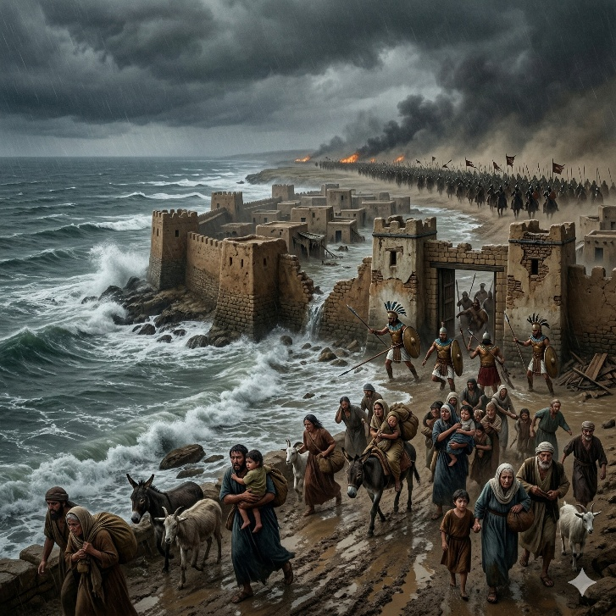
Jeremiah 47 is a message of judgment against the Philistines, one of Judah’s long-standing neighboring enemies. The chapter opens with the image of waters rising out of the north, becoming an overflowing flood that sweeps through the land, its cities, and its people. This picture gives the prophecy a sense of force and inevitability. The threat is not small or local. It is overwhelming, like a flood no one can stop. The Philistine cities, including Gaza, Ashkelon, and the remaining coastal strongholds, are caught in a coming disaster that will leave the people helpless. Fathers are described as too weak with fear even to care for their children, which shows how complete the panic and collapse will be.

The chapter presents this invasion as the Lord’s work, not merely the action of a stronger army. Babylon is the historical power behind the destruction, but Jeremiah describes the event in a deeper way: the Lord is spoiling the Philistines. Their allies cannot save them, and their famous coastal cities cannot shield them. Mourning, baldness, and cutting are used as signs of grief and ruin. The language of the chapter is short and sharp, fitting the speed and violence of the judgment it announces. Even places with long histories and strong defenses are exposed as fragile when the Lord appoints their downfall. The chapter makes clear that no nation stands outside His authority, whether large or small, near or far.

The closing words focus on the sword of the Lord, and the prophet asks how long it will go on before it is quiet. But the answer is that it cannot rest while the Lord has given it a charge. That gives the chapter its final weight. This is not random destruction or blind warfare. The judgment has direction, purpose, and an appointed target. Jeremiah 47 shows the Philistines facing the end of their security and strength because the Lord has spoken against them. The chapter is brief, but it powerfully portrays the terror of coming judgment and the certainty of God’s command over nations, armies, and events.

Jeremiah 48

Opening Scripture Quote (KJV)
“Against Moab thus saith the LORD of hosts, the God of Israel; Woe unto Nebo! for it is spoiled: Kiriathaim is confounded and taken: Misgab is confounded and dismayed.”
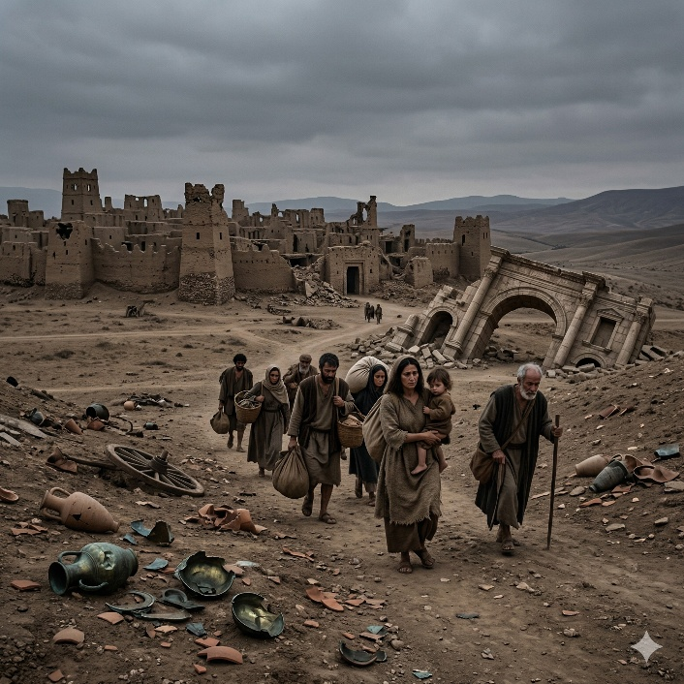
Jeremiah 48 delivers a detailed judgment against Moab, describing the nation’s downfall with urgency and intensity. The chapter opens with the destruction of its cities, naming them one by one to emphasize that no part of the land will escape. Confidence in strength, wealth, and reputation is stripped away as Moab’s defenses collapse. The tone is both declarative and mournful, portraying a once-secure nation suddenly overwhelmed. The judgment is not random but directed, revealing that Moab’s apparent stability cannot withstand the authority of the LORD.

The prophecy then exposes the root cause of Moab’s downfall: pride and self-reliance. Moab is described as having been at ease, settled and undisturbed, which led to complacency and arrogance. This ease fostered a false sense of security, as if its position could not be shaken. When judgment comes, it is portrayed like a careful pouring out, leaving nothing untouched. The imagery of broken vessels, shattered strength, and fleeing people reinforces the completeness of the collapse. Even the land itself is affected—vineyards, cities, and strongholds all fall into ruin. The chapter repeatedly highlights that Moab’s confidence was misplaced, resting in what it had built rather than in God.

Despite the severity of the judgment, the chapter includes expressions of sorrow. The tone shifts at moments to lament, as if mourning accompanies the destruction. This reveals that judgment is not described with indifference but with awareness of loss. Moab’s people are shown fleeing, weeping, and seeking refuge without success. The chapter concludes with a final note that looks beyond immediate judgment, stating that Moab’s captivity will be restored in the latter days. This closing statement does not erase the judgment but places it within a broader framework where restoration remains possible. Jeremiah 48 presents a full picture: the certainty of judgment against pride, the depth of resulting loss, and the distant but real possibility of renewal under God’s authority.

Jeremiah 49

Opening Scripture Quote (KJV)
“Concerning the Ammonites, thus saith the LORD; Hath Israel no sons? hath he no heir? why then doth their king inherit Gad, and his people dwell in his cities?”

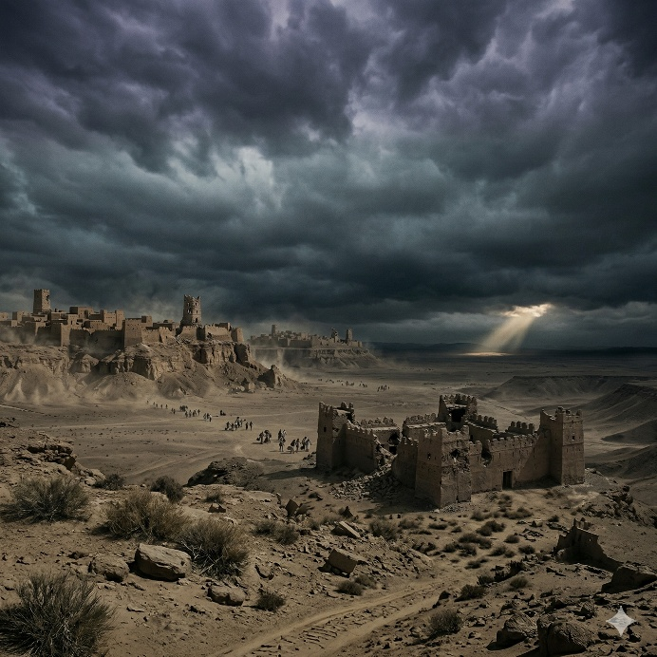
Jeremiah 49 delivers a series of judgments against surrounding nations, beginning with the Ammonites. The charge is that they have taken possession of Israel’s land, assuming permanence where they had no rightful claim. God declares that their cities will be overthrown and their confidence shaken. Rabbah, their capital, will become desolate, and their people will be driven out. Yet even within judgment, a future restoration is mentioned, showing that the purpose is not only to remove injustice but to set a limit on it.

The prophecy then turns to Edom, where pride rooted in natural defenses and perceived wisdom becomes the focus. Edom’s strongholds in the heights give a false sense of security, but they will not prevent its downfall. Its wisdom will fail, and its strength will collapse. The judgment is described as thorough, leaving the land emptied and its people scattered. Similar messages follow for Damascus, Kedar, and Hazor—each nation facing fear, confusion, and destruction. What unites these oracles is the exposure of misplaced trust, whether in geography, wealth, alliances, or reputation. Each nation is shown to be vulnerable despite its perceived advantages.

The chapter concludes with a prophecy against Elam, extending the scope even farther. God declares that He will break their strength and scatter them among the nations. The language emphasizes both dispersion and loss of power. Yet, as with some earlier sections, a future restoration is promised in the latter days. Jeremiah 49 presents a consistent pattern: judgment against pride, misuse of power, and false security, followed by the possibility of restoration. The chapter reinforces that no nation stands outside God’s authority. Power, position, and distance offer no protection when they are used in opposition to justice. At the same time, the inclusion of restoration shows that judgment serves a broader purpose, ultimately pointing beyond destruction to the possibility of renewal.

Jeremiah 50

Opening Scripture Quote (KJV)
“The word that the LORD spake against Babylon and against the land of the Chaldeans by Jeremiah the prophet.”

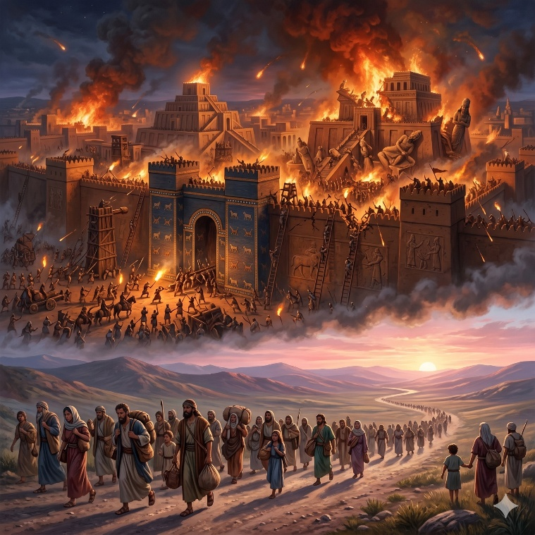
Jeremiah 50 is a long prophecy announcing the fall of Babylon, the empire that had conquered Judah and carried many of its people away. The chapter begins with a public declaration that Babylon’s gods are put to shame and its power will not stand. A nation from the north will come against it, and the land will become desolate. But this message is not only about Babylon’s collapse. It is also about the return of Israel and Judah. The chapter pictures them coming together with tears, seeking the Lord and asking the way to Zion. Their earlier condition had been like lost sheep, scattered and devoured by stronger powers. Now the Lord speaks of restoration, covenant renewal, and a return to the place from which they had been driven.

The chapter makes clear that Babylon’s judgment is deserved. It had been used as an instrument against Judah, but it acted with pride, cruelty, and self-exalting confidence. Babylon is described as arrogant against the Lord, secure in its strength, rich in spoil, and careless in its pride. Because of that, its walls, warriors, and treasures will not save it. The language is forceful and sweeping: the city will be invaded, emptied, and brought low. Yet the chapter is not merely political. It presents Babylon’s fall as moral and spiritual judgment. The Lord is repaying what Babylon has done. This reverses the terror it once inspired. The oppressor that seemed untouchable is now exposed as answerable to God.

Alongside this judgment stands one of the chapter’s most important themes: Israel’s future is not finished. The people have sinned, wandered, and suffered, yet the Lord still claims them. He is called their Redeemer, and He is strong. He will plead their cause, give rest to the land, and deal with those who troubled them. Even the search for Israel’s iniquity ends with mercy, because God says He will pardon those whom He reserves. That promise gives the chapter its balance. Babylon falls not only because empires rise and fall, but because the Lord remembers justice and keeps covenant mercy. Jeremiah 50 therefore joins judgment and restoration: a proud kingdom is brought down, and a scattered people are called home under the care of their strong Redeemer.

Jeremiah 51

Opening Scripture Quote (KJV)
“Thus saith the LORD; Behold, I will raise up against Babylon, and against them that dwell in the midst of them that rise up against me, a destroying wind;”


Jeremiah 51 continues the long judgment against Babylon and presents its fall as certain, thorough, and deserved. The chapter opens with the Lord raising a “destroying wind” against the city, showing that Babylon’s ruin is not accidental or merely political. The empire that once crushed nations and carried Judah into exile will itself be attacked, shaken, and emptied. Its land, warriors, and strongholds will fail before the judgment appointed for it. The imagery is large and forceful: threshing, seas, winds, arrows, and burning all combine to show a power once feared by the world now facing unstoppable collapse. Babylon had seemed permanent, but this chapter declares that no empire stands secure when God has spoken against it.

A central theme in Jeremiah 51 is that Babylon is judged for violence, pride, and idolatry. It had been like a golden cup in the Lord’s hand, used in history, yet it became swollen with its own greatness and filled the earth with destruction. Because of that, the Lord calls for repayment. Nations are summoned, kings are stirred up, and Babylon’s idols, walls, and gates are all exposed as powerless. The chapter repeatedly contrasts Babylon’s appearance of glory with its true condition before God. It is rich, fortified, and famous, yet already marked for ruin. Even its broad walls and high defenses cannot protect it. The message is not simply that power fades, but that arrogant power that exalts itself against the Lord will be brought down.

At the same time, the chapter contains a word for God’s people. They are told to flee from Babylon and not be cut off in its iniquity. Israel and Judah have not been forgotten, even though they have suffered deeply. The Lord remains their God, and Babylon’s fall is linked to His faithfulness to His people as well as His justice against oppression. The chapter closes with a symbolic act: a scroll of Babylon’s judgment is tied to a stone and cast into the Euphrates, showing that Babylon will sink and not rise from the disaster coming upon it. That ending gathers the chapter’s message into one vivid image. Babylon’s power is heavy, proud, and doomed to sink, while the word of the Lord stands firm. Jeremiah 51 is therefore a chapter of final reversal: the oppressor falls, idols fail, and God’s judgment proves stronger than the mightiest kingdom of the age.

Jeremiah 52

Opening Scripture Quote (KJV)
“Zedekiah was one and twenty years old when he began to reign, and he reigned eleven years in Jerusalem. And his mother's name was Hamutal the daughter of Jeremiah of Libnah.”

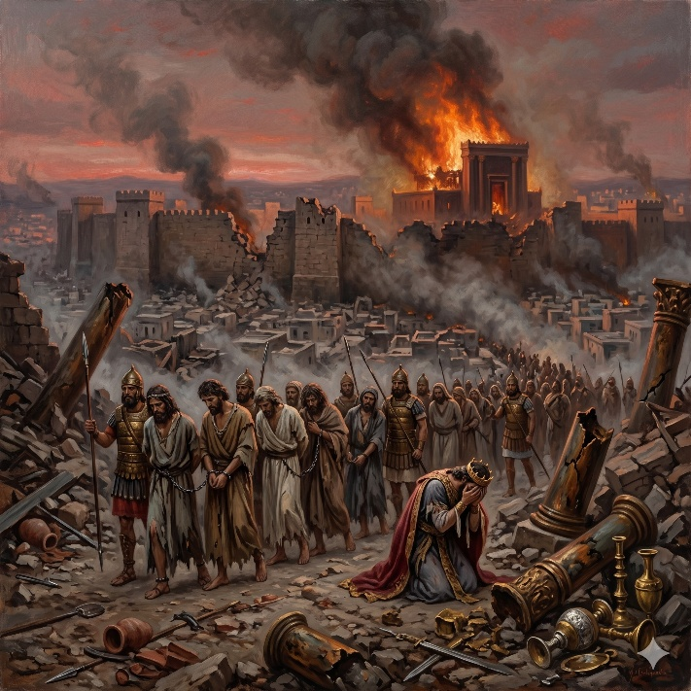
Jeremiah 52 closes the book with a historical account of Jerusalem’s fall, the destruction of the temple, and the exile of the people. The chapter begins with King Zedekiah, whose reign ended in rebellion against the king of Babylon. Because of Judah’s persistent sin and refusal to heed the word of the Lord, the city came under siege. Famine grew severe, the defenses finally broke, and Zedekiah fled by night, only to be captured. His sons were slain before his eyes, then his eyes were put out, and he was carried in chains to Babylon. The chapter presents these events without softening them. The fall of Jerusalem is shown as complete political collapse, personal tragedy, and the fulfillment of long-declared judgment.

The destruction that follows is described in sobering detail. The house of the Lord, the king’s house, and the houses of Jerusalem were burned. The walls were broken down, and many of the people were carried away captive, while only some of the poorest remained in the land. The chapter gives special attention to the temple furnishings, including the pillars, bases, sea, and vessels that were broken or taken away. That detail matters because it emphasizes not only military defeat but the loss of the center of national worship and identity. What had once stood as a visible sign of Judah’s place before God was now stripped, shattered, and removed. Jeremiah 52 therefore serves as a witness that the judgment spoken throughout the book truly came to pass in the visible world.

Yet the chapter does not end with fire and ruin alone. In its final section, it records that Jehoiachin king of Judah was lifted up from prison in Babylon and treated kindly by Evil-merodach. His prison garments were changed, and he was given a regular allowance and a place above other captive kings. This closing note is small beside the destruction that fills the chapter, but it is important. It suggests that Judah’s story is not utterly erased, even in exile. The kingdom has fallen, the city is ruined, and the people are scattered, yet a living line remains and a measure of mercy appears at the end. Jeremiah 52 closes the book by confirming both the severity of judgment and the quiet persistence of hope beyond it.

